**S.P.Mandali’s**

**Ramnarain Ruia Autonomous College**

**Matunga, Mumbai-400019**

**Project Report**

**On**

**“ONLINE GAS BOOKING SYSTEM”**

**Under the Guidance of**

**“Mrs. Edith Michael.”**

**Project By**

**“Mr.PRATIK ANIL BHOSALE.”**

**TYBSC**

**Department of Computer Science**

**2017-18**

**ACKNOWLEDGEMENT**

I would like to express my thanks to the people who have helped me most throughout my project.

I sincerely thank to my project guide teacher “**Edith Ma’am**” for guidance and encouragement in carrying out this project work.

Special thanks of mine goes to my colleagues who helped me out in testing/debugging the project and with whom I exchanged lot of interesting ideas, thoughts and which made it possible to complete my project.

I am highly indebted to Ruia College for their guidance and constant supervision as well as for keeping me track regarding the project & also for their support in completing the project.

At last but not least I wish to avail myself of this opportunity, express a sense of gratitude and love to my friends and my beloved parents for their manual support, strength and help for everything.

Pratik A. Bhosale.

**INDEX**

|  |  |  |
| --- | --- | --- |
| **SR. NO.** | **NAME OF TOPIC** | **PAGE NO.** |
|  | **Preliminary Investigation** | **5-12** |
|  | Organizational Overview | 6 |
|  | Description Of System | 7 |
|  | Limitation Of Present System | 7 |
|  | Proposed System | 8 |
|  | Advantage of Proposed System | 8 |
|  | Feasibility Study | 9 |
|  | Stakeholders | 10 |
|  | Technology Used | 10 |
|  | Gantt Chart | 11 |
|  | **System Analysis** | **13-49** |
|  | Fact Finding Techniques | 14 |
|  | Event Table | 15 |
|  | Use Case Diagram | 18 |
|  | Use Case Scenario | 21 |
|  | Activity Diagram | 27 |
|  | Class Diagram | 37 |
|  | Sequence Diagram | 39 |
|  | State Diagram | 45 |

|  |  |  |
| --- | --- | --- |
|  | **System Design** | **50-54** |
|  | Design Class Diagram | 51 |
|  | Component Diagram | 52 |
|  | Package Diagram | 53 |
|  | Deployment Diagram | 54 |
|  | **System Coding** | **55-163** |
|  | Sitemap | 56 |
|  | List of Tables | 58 |
|  | Design Patterns | 61 |
|  | Program Desrciption | 62 |
|  | Screen Layout | 63 |
|  | **SYSTEM IMPLEMENTATION & CODING** | **79-164** |
|  | Client Side | 79 |
|  | Admin side | 145 |
|  | **Future Enhancements** | **165** |
|  | **References & Bibilography** | **166** |

**PRELIMINARY INVESTIGATION**

* **Topics Ahead : -**
* Organizational Overview
* Description of Existing System
* Limitation of current System
* Proposed System
* Advantages Of Proposed System
* Feasibility Study
* Stakeholders
* Technology Used
* Gantt Chart
* **ORGANIZATIONAL OVERVIEW**

This is an online gas booking system for customers that allows them to order gas cylinders whenever required. Users can now directly order gas cylinder and can also make payment instead of using conventional approach of ordering through phone.

The conventional system takes long time for processing request and users have no other option but to wait. This project eliminates all these drawbacks. There will be customer login and admin login. Admin has the control of all the users account and their details. There will be 12 cylinders initially allotted to all customer accounts along with their cost that are valid only for one year, and would require more then he will get notification.

The final part of the project is for generating the report of Customer details and his requirements. This includes the total evaluation of City gas agency **[ONLINE GAS BOOKING SYSTEM].**

* **DESCRIPTION OF SYSTEM:-**
* In a Current System User can book gas through only register phone number.
* They did not get notification about subsidy.
* Users have to wait long time for processing request.
* Low speed of websites.
* **LIMITATION OF CURRENT SYSTEM:-**
* Booking can be done only through register mobile number.
* User cannot identify the exact amount for each cylinder.
* User is not aware of how much cylinders are remaining.
* User did not get subsidy notification.

* **PROPOSED SYSTEM:-**
* This website open 24*7 to receive booking.
* In this system online booking can be done.
* No hassle of travelling to gas agency or constant follow with the distributor.
* There is no need for users and agency to maintain gas records manually. They can view the details through their account.
* This system saves time, efforts and cost.
* **ADVANTEGES OF PROPOSED SYSTEM:-**
* Safe and convenient method of booking.
* Simply good Customer Service.
* In this System User can get subsidy notification.
* In this System can easily maintain the record.
* This system saves time, efforts and cost.
* Simplified login.
* User Friendliness.
* Data security.
* Online payment can be done.

* **FEASIBILITY STUDY:-**

Feasibility study consideration of all possible ways to provide solution to given problem. The proposed should satisfy all the user requirements and should be flexible enough so that future changes can be easily done by future upcoming requirements.

1. **Economic Feasibility:**

* The project doesn’t need much money for development. The maintenance of the system is also economically feasible.

1. **Technical Feasibility:**

* The project is technically feasible as there isn’t any difficulty to get required resources. All the technology used is simple.

1. **Operational Feasibility:**

* The system requires minimum knowledge and understanding of the computer. The system can be easily used by the user.

* **STAKEHOLDERS:-**

1. **ADMIN:-**

* Admin can update data in system.
* Admin updates the websites and checks the feedback and registration from the user.

1. **CUSTOMER:-**

* User can view information about cylinder subsidy.
* User can read the info about gas Services & feel the feedback form.

* **PROJECT REQUIREMENTS:-**
* Hardware requirements.
* No Specific Hardware Requirement.
* Software Requirements
* Browser:-Mozilla Firefox, Google chrome etc.
* **Front End:-ASP.NET[c#]**
* **Back End:-SQL SERVER 2012.**
* **GANTT CHART:-**

|  |  |  |  |  |  |  |  |  |  |  |  |  |  |  |  |  |  |  |  |  |  |  |
| --- | --- | --- | --- | --- | --- | --- | --- | --- | --- | --- | --- | --- | --- | --- | --- | --- | --- | --- | --- | --- | --- | --- |
| Phase Title | June | | | | | July | | | | | | August | | | | | | September | | | | |
|  | **1** | **2** | **3** | **4** | **5** | **1** | **2** | **3** | **4** | | **5** | **1** | **2** | | **3** | **4** | **5** | **1** | **2** | **3** | **4** | **5** | |
| Project Approval |  |  |  |  |  |  |  |  |  | |  |  |  | |  |  |  |  |  |  |  |  | |
|  |  |  |  |  |  |  |  |  | |  |  |  | |  |  |  |  |  |  |  |  | |
|  |  |  |  |  |  |  |  |  | |  |  |  | |  |  |  |  |  |  |  |  | |
| Preliminary Investigation |  |  |  |  |  |  |  |  |  | |  |  |  | |  |  |  |  |  |  |  |  | |
|  |  |  |  |  |  |  |  |  | |  |  |  | |  |  |  |  |  |  |  |  | |
|  |  |  |  |  |  |  |  |  | |  |  |  | |  |  |  |  |  |  |  |  | |
| System Analysis and Design | | | | | | | | | | | | | | | | | | | | | | |
| Event Table |  |  |  |  |  |  |  |  |  |  | |  | |  |  |  |  |  |  |  |  |  | |
|  |  |  |  |  |  |  |  |  |  | |  | |  |  |  |  |  |  |  |  |  | |
|  |  |  |  |  |  |  |  |  |  | |  | |  |  |  |  |  |  |  |  |  | |
| Class Diagram |  |  |  |  |  |  |  |  |  |  | |  | |  |  |  |  |  |  |  |  |  | |
|  |  |  |  |  |  |  |  |  |  | |  | |  |  |  |  |  |  |  |  |  | |
|  |  |  |  |  |  |  |  |  |  | |  | |  |  |  |  |  |  |  |  |  | |
| Use Case Diagram |  |  |  |  |  |  |  |  |  |  | |  | |  |  |  |  |  |  |  |  |  | |
|  |  |  |  |  |  |  |  |  |  | |  | |  |  |  |  |  |  |  |  |  | |
|  |  |  |  |  |  |  |  |  |  | |  | |  |  |  |  |  |  |  |  |  | |
| Use Case Specification |  |  |  |  |  |  |  |  |  |  | |  | |  |  |  |  |  |  |  |  |  | |
|  |  |  |  |  |  |  |  |  |  | |  | |  |  |  |  |  |  |  |  |  | |
|  |  |  |  |  |  |  |  |  |  | |  | |  |  |  |  |  |  |  |  |  | |
| Sequence Diagram |  |  |  |  |  |  |  |  |  |  | |  | |  |  |  |  |  |  |  |  |  | |
|  |  |  |  |  |  |  |  |  |  | |  | |  |  |  |  |  |  |  |  |  | |
|  |  |  |  |  |  |  |  |  |  | |  | |  |  |  |  |  |  |  |  |  | |
| Activity Diagram |  |  |  |  |  |  |  |  |  |  | |  | |  |  |  |  |  |  |  |  |  | |
|  |  |  |  |  |  |  |  |  |  | |  | |  |  |  |  |  |  |  |  |  | |
|  |  |  |  |  |  |  |  |  |  | |  | |  |  |  |  |  |  |  |  |  | |
| State Chart Diagram |  |  |  |  |  |  |  |  |  |  | |  | |  |  |  |  |  |  |  |  |  | |
|  |  |  |  |  |  |  |  |  |  | |  | |  |  |  |  |  |  |  |  |  | |
|  |  |  |  |  |  |  |  |  |  | |  | |  |  |  |  |  |  |  |  |  | |

|  |  |  |  |  |  |  |  |  |  |  |  |  |  |  |  |  |  |  |  |  |  |  |  |  |
| --- | --- | --- | --- | --- | --- | --- | --- | --- | --- | --- | --- | --- | --- | --- | --- | --- | --- | --- | --- | --- | --- | --- | --- | --- |
| Phase Title | October | | | | | November | | | | | December | | | | | Januray | | | | | February | | | |
|  | **1** | **2** | **3** | **4** | **5** | **1** | **2** | **3** | **4** | **5** | **1** | **2** | **3** | **4** | **5** | **1** | **2** | **3** | **4** | **5** | **1** | **2** | **3** | **4** |
| System Design & Coding |  |  |  |  |  |  |  |  |  |  |  |  |  |  |  |  |  |  |  |  |  |  |  |  |
|  |  |  |  |  |  |  |  |  |  |  |  |  |  |  |  |  |  |  |  |  |  |  |  |
|  |  |  |  |  |  |  |  |  |  |  |  |  |  |  |  |  |  |  |  |  |  |  |  |
| Testing |  |  |  |  |  |  |  |  |  |  |  |  |  |  |  |  |  |  |  |  |  |  |  |  |
|  |  |  |  |  |  |  |  |  |  |  |  |  |  |  |  |  |  |  |  |  |  |  |  |
|  |  |  |  |  |  |  |  |  |  |  |  |  |  |  |  |  |  |  |  |  |  |  |  |
| Implementation |  |  |  |  |  |  |  |  |  |  |  |  |  |  |  |  |  |  |  |  |  |  |  |  |
|  |  |  |  |  |  |  |  |  |  |  |  |  |  |  |  |  |  |  |  |  |  |  |  |
|  |  |  |  |  |  |  |  |  |  |  |  |  |  |  |  |  |  |  |  |  |  |  |  |

|  |  |  |  |  |  |
| --- | --- | --- | --- | --- | --- |
|  | Actual Time of Completion |  | Expected Time of Completion |  | Break |

**SYSTEM ANALYSIS**

* **TOPICS AHEAD:-**
* Fact Finding Techniques
* Event Table
* Use Case Diagram
* Use Case Scenario
* Activity Diagram
* Class Diagram
* Sequence Diagram /Collaboration Diagram
* State Diagram
* **FACT FINDING USING QUESTIONAIRES:**

1. Currently, how the data is stored?
2. When the data is updated?
3. What kind of data is stored in the system?
4. Who can use the system?
5. How the system works?

* **EVENT TABLE :-**

A table that lists events in rows and key places of information about each event in column.

* **Event:-**

It causes a system to do something.

* **Source:-**

An external Agent or Actor that supplies Data to the system.

* **Trigger:-**

An occurrence that tells the system that an event has occurred, either the arrival of data needing processing or of a point in time.

* **Activity:-**

Behavior that the system performs when an event occurs.

* **Response:-**

An output,produced by the system that goes to a destination.

* **Destination:-**

An external Agent or Actor that receives data from the system.

* **Event table :- CUSTOMER**

|  |  |  |  |  |  |  |
| --- | --- | --- | --- | --- | --- | --- |
| **Sr.**  **No.** | **Event** | **Trigger** | **Source** | **Activity** | **Response** | **Destination** |
| 1. | Customer create an account | Creating new account | customer | Created new account | Display account details | customer |
| 2. | Customer wants to login | Request to login | customer | Verify authentication | Login | customer |
| 3. | Apply for new connection | Request to new connection | customer | Created new connection | Display the new connection Details | System |
| 4. | Gas Booking | Request for gas Booking | customer | Gas Booked | Gas Booked Details | customer |
| 5. | Transaction Details | Request for transaction | customer | Transaction successful | Display Receipt | customer |
| 6. | Subsidy Notification | Get subsidy | customer | View Subsidy details | Display Subsidy Details | customer |
| 7. | Cancel Booking | Cancellation of Booking | customer | Booking Canceled | Confirmation about Cancellation | customer |
| 8. | Feedback Form | Request for Feedback form | customer | Display feedback form | Feedback details | customer |
| 9. | Changes in personal data | Request for updating information | customer | Updating information | Update details | customer |
| 10. | Customer Logout | Request logout | customer | Logout successfully | logout | system |

* **EVENT TABLE:- ADMIN**

|  |  |  |  |  |  |  |
| --- | --- | --- | --- | --- | --- | --- |
| **Sr.**  **No.** | **Event** | **Trigger** | **Source** | **Activity** | **Response** | **Destination** |
| 1. | Admin Login | Request for login | Admin | Verify authentication | Login | Admin |
| 2. | View new connection Details | Request to check new connection. | Admin | Display new connection details. | New connection Details | Admin |
| 3. | View gas Booking Details | Request to check details | Admin | Display Booking | Booking details | Admin |
| 4. | Checks customer subsidy | Request to check subsidy | Admin | Display subsidy details. | Subsidy details | Admin |
| 5. | View cancel booking Details | Request to cancel booking Details | Admin | Display cancel booking Details | cancel booking Details | Admin |
| 6. | Admin views customer details | Request to view details | Admin | Display customer information | Customer details | Admin |
| 7. | Admin feedback form | Request to display feedback | Admin | Display feedback | Feedback  details | Admin |
| 8. | Admin wants to delete feedback | Request to delete feedback | Admin | Delete feedback | Feedback deletion details | Admin |
| 9. | Admin wants to logout | Request to logout | Admin | Logout | Logout | Admin |

* **Use Case Diagram:-**

Use Case diagram is used to identify the “uses” or uses Use cases of the new system -- in other words , to identify how the system will be used . The use case diagram is essentially an extension of the event Table.

* **USE CASE:-**

It describes an activity the system carries out in response to an event.

* **ACTOR:-**

In UML ,the person involved is called an Actor .An Actor is always outside of the Automation Boundary of the system.

* **CONNECTION LINE:-**

The arrow is used to show which Actors participate in which Use cases.

* **USE CASE NOTATION:-**

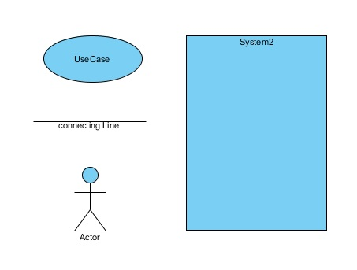

* **USE CASE DIAGRAM:-CUSTOMER(ACTOR WISE)**

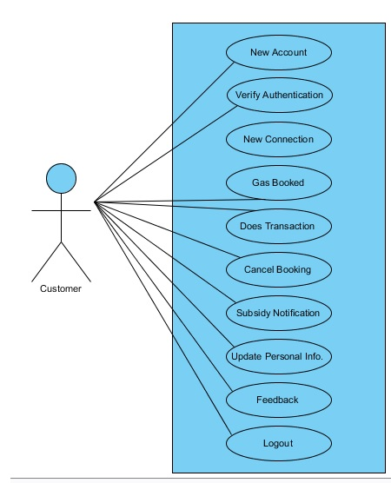

* **USE CASE DIAGRAM :-ADMIN(ACTOR WISE)**

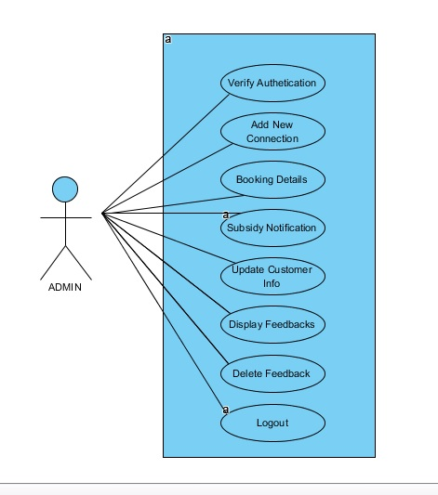

* **USE CASE SCENARIO:-**

1. **Use case name:** New account

**Scenario:** Customer wants to create a new account

**Actors:** Customer

**Triggering event:** New account

**Flow of activities:**

1. Customer wants to create a new account.
2. Customer enters details.

**Pre-Condition:** Customer do not have an account

**Post-Condition:** Customer successfully created new account.

1. **Use case name:** Verify authentication.

**Scenario:** Customer wants to login.

**Actors:** Customer

**Triggering event:** Request to login

**Flow of activities:**

1. Customer enters login Details.
2. Customer logs in to system.

**Pre-Condition:** Customer is not logged in.

**Post-Condition:** Customer successfully logged in.

1. **Use case name:** New Connection.

**Scenario:** Customer wants a new gas connection.

**Actors:** Customer

**Triggering event:** Request to new connection.

**Flow of activities:**

1. Customer enters new connection Details.

2. Customer gets new connection.

**Pre-Condition:** Customer do not have new connection.

**Post-Condition:** Customer successfully get new connection details.

1. **Use case name:** Gas Booking .

**Scenario:** Customer wants to book a gas .

**Actors:** Customer

**Triggering event:** Request to gas booking.

**Flow of activities:**

1. Customer enters Gas booking Details.

2. Customer Book gas.

**Pre-Condition:** Customer is not book gas .

**Post-Condition:** Customer successfully booked gas.

1. **Use case name:** Transaction Details.

**Scenario:** Customer wants to make payment.

**Actors:** Customer

**Triggering event:** Request for transaction

**Flow of activities:**

1. Customer enters Transaction Details.

2.Customer make payment.

**Pre-Condition:** Customer does not make payment.

**Post-Condition:** Customer successfully make payment.

1. **Use case name:** Subsidy Notification.

**Scenario:** Customer gets subsidy notification.

**Actors:** Customer

**Triggering event:** get subsidy notification.

**Flow of activities:**

1**.** Customer view subsidy notification details.

**Pre-Condition:** Customer book gas.

**Post-Condition:** Customer gets subsidy notification and view subsidy details.

1. **Use case name:** Cancel Booking.

**Scenario:** Customer wants to cancel booking.

**Actors:** Customer

**Triggering event:** Request for cancel booking.

**Flow of activities:**

1. Customer enters cancel booking Details.
2. Customer gets confirmation about cancel booking.

**Pre-Condition:** Customer Book gas.

**Post-Condition:** Customer successfully canceled a booking.

1. **Use case name:** Feedback form.

**Scenario:** Customer wants to give feedback.

**Actors:** Customer

**Triggering event:** Request for feedback.

**Flow of activities:**

1. Customer submits feedback form.

**Pre-Condition:** Customer logged in account.

**Post-Condition:** Customer successfully give feedback.

1. **Use case name:** update account information .

**Scenario:** Customer wants to change in personal details.

**Actors:** Customer

**Triggering event:** Request for updating information.

**Flow of activities:**

1. Customer update personal info.

**Pre-Condition:** Customer logged in system.

**Post-Condition:** Customer successfully updated account.

**10) Use case name:** customer logout.

**Scenario:** Customer wants to logout.

**Actors:** Customer

**Triggering event:** Request to logout.

**Flow of activities:**

1. Customer logs out from system.

**Pre-Condition:** Customer logged in system.

**Post-Condition:** Customer successfully log out from system.

**11)Use case name:** Verify Authentication.

**Scenario:** Admin wants to login.

**Actors:** Admin

**Triggering event:** Request for login.

**Flow of activities:**

1. Admin enters login details.

2. Admin logs into system.

**Pre-Condition:** Admin is not logged in.

**Post-Condition:** Admin successfully logged in.

**12) Use case name:** View new connection Details.

**Scenario:** Admin wants to view new connection details.

**Actors:** Admin

**Triggering event:** View new connection details.

**Flow of activities:**

1. Admin verify the customer details.

**Pre-Condition:** Admin logged in system.

**Post-Condition:** Admin successfully view new connection details.

**13) Use case name:** Gas Booking Details.

**Scenario:** Admin wants to view gas booking details.

**Actors:** Admin

**Triggering event:** Request to check details.

**Flow of activities:**

1. Admin view the customer gas booking details.

**Pre-Condition:** Admin logged in system.

**Post-Condition:** Admin successfully view the customer booking details.

**14)Use case name:** Subsidy Details.

**Scenario:** Admin view subsidy details of customer.

**Actors:** Admin

**Triggering event:** Request to check subsidy details.

**Flow of activities:**

1. Admin checks subsidy details.

**Pre-Condition:** Admin logged in system.

**Post-Condition:** Admin successfully view subsidy details .

**15) Use case name:** Customer Account details .

**Scenario:** Admin wants to view customer details .

**Actors:** Admin

**Triggering event:** Request to the customer account details.

**Flow of activities:**

1. Admin checks customer details.

**Pre-Condition:** Admin logged in system.

**Post-Condition:** Admin successfully view customer details.

**16) Use case name:** Display Feedbacks

**Scenario:** Admin wants to check outs feedback.

**Actors:** Admin

**Triggering event:** Request to display feedback details.

**Flow of activities:**

1. Admin view feedbacks .

**Pre-Condition:** Admin logged in system.

**Post-Condition:** Admin successfully view feedbacks.

**17) Use case name:** Delete feedback .

**Scenario:** Admin wants to delete feedback.

**Actors:** Admin

**Triggering event:** Request to delete feedback.

**Flow of activities:**

1. Admin selects feedback.

2. Admin deletes feedback.

**Pre-Condition:** Admin views feedback.

**Post-Condition:** Admin successfully deletes selected feedbacks.

**18) Use case name:** Admin logout .

**Scenario:** Admin wants to logout from system.

**Actors:** Admin

**Triggering event:** Request to logout .

**Flow of activities:**

1. Admin logs out from system .

**Pre-Condition:** Admin logged in system.

**Post-Condition:** Admin successfully logout from system .

* **ACTIVITY DIGRAM (Event wise):-**

1. **Customer create an account :-** 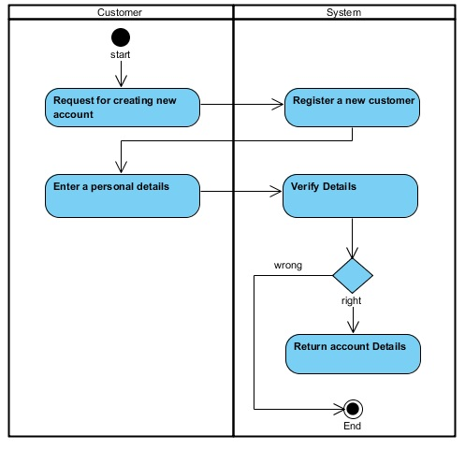
2. **Customer wants to login:-** 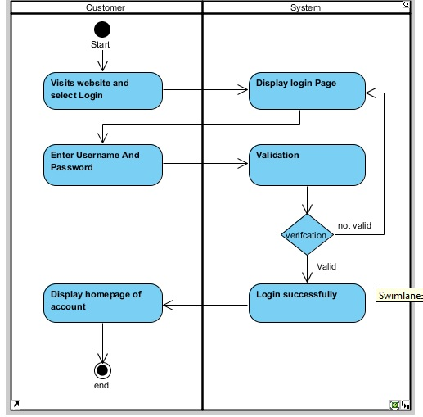
3. **Apply for new connection:-** 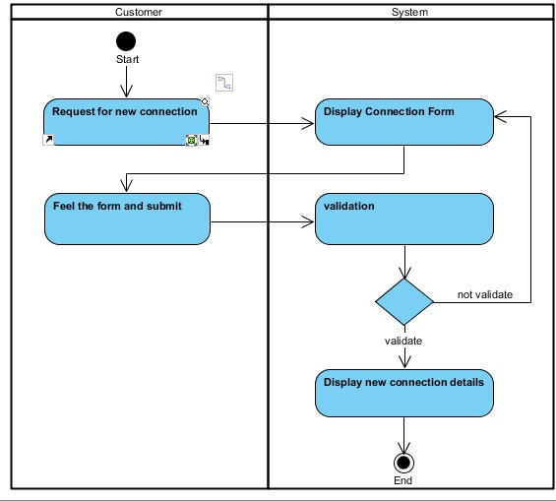
4. **Gas Booking:-**

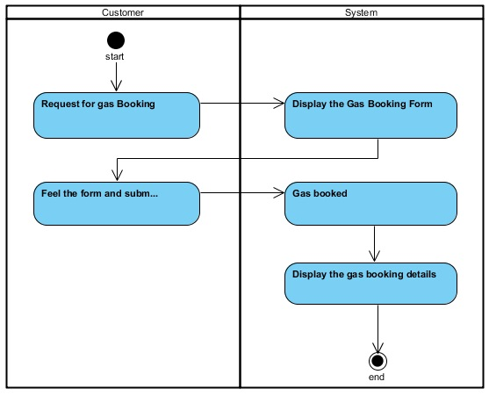

1. **Transaction Details:-** 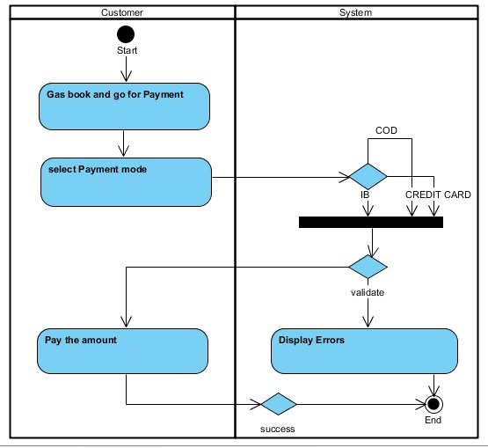
2. **Get subsidy notification:-**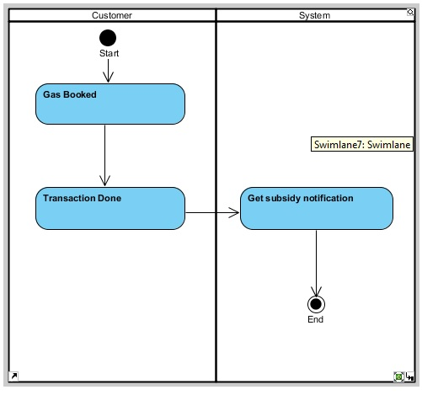
3. **Cancel Booking:-** 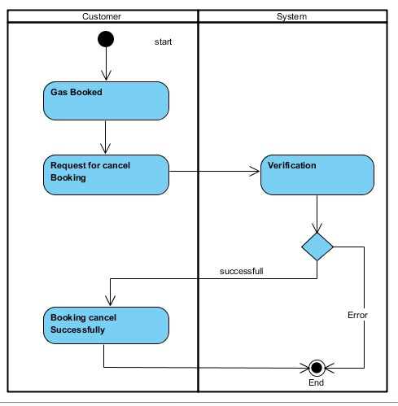
4. **Feedback Form:-** 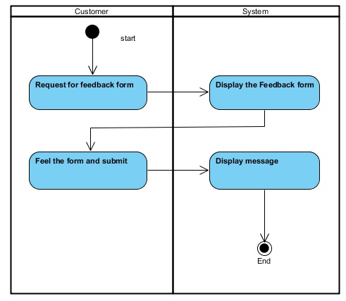
5. **Change in personal details:-** 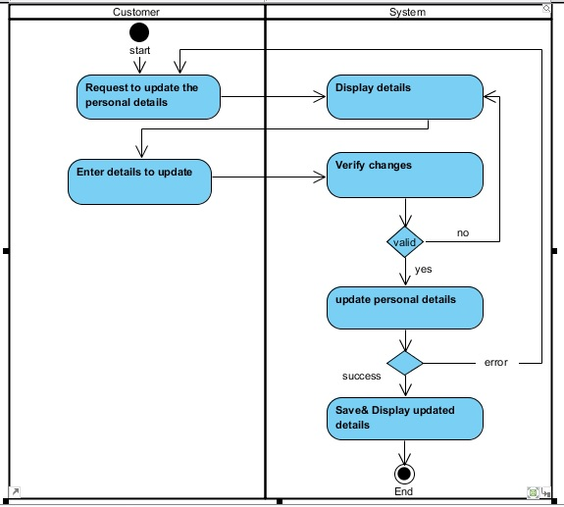

**10.Customer Logout:-** 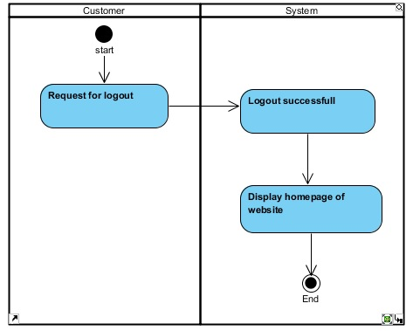

**11.Admin Login:- 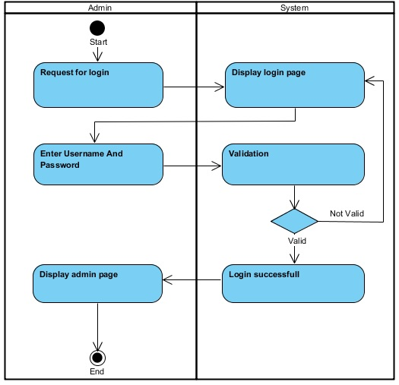12.View the New Connection Details:-**

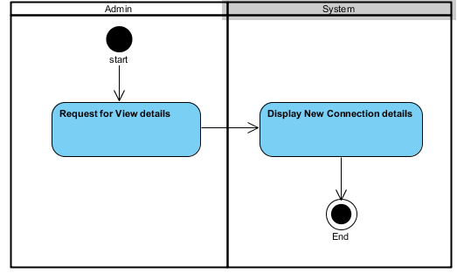

**13.View the Gas Booking Details:-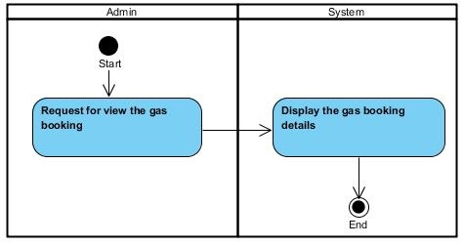14.Checks Customer Subsidy:-**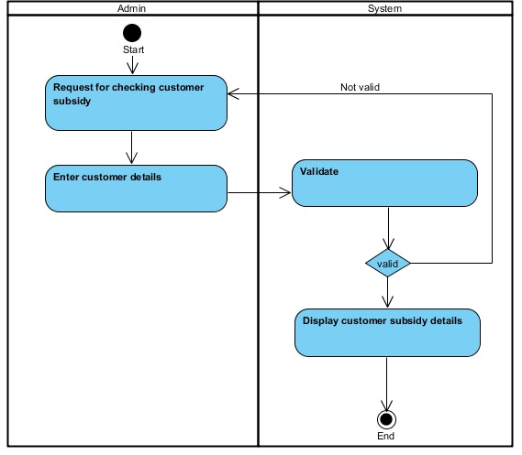

**15.View Cancel Booking Details:-**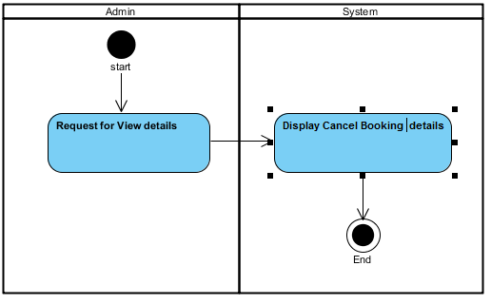

**16.Admin Views Customer Details:-**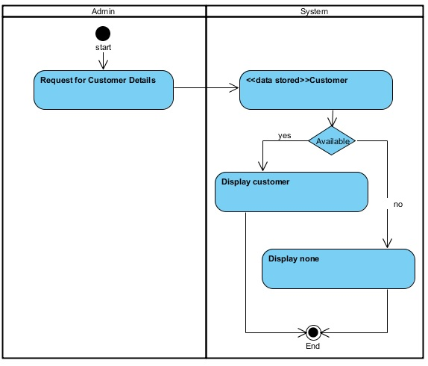

**17.Admin Views Feedbacks:-** 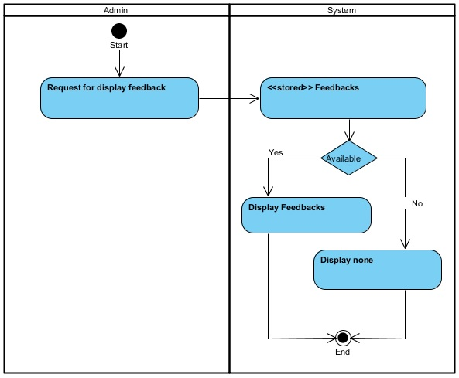

**18.Admin wants to delete feedbacks:-**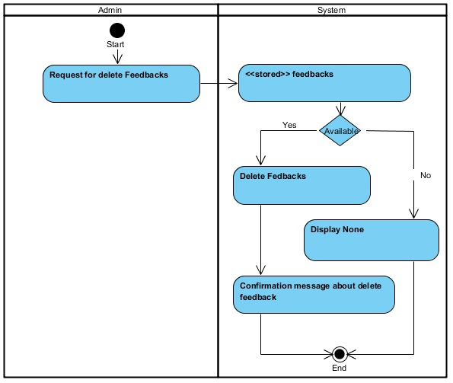

**19.Admin Logout:-**

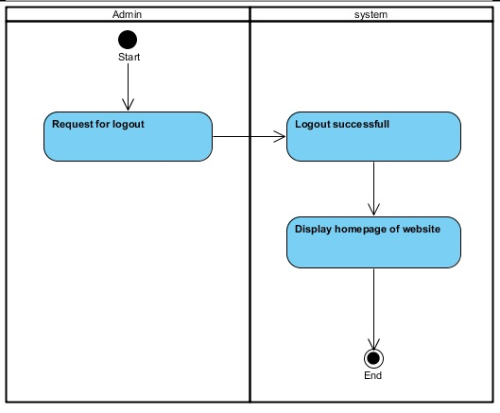

* **CLASS DIAGRAM:-**

The class diagram are used to identify and classify the objects which constitute a system. It also includes the important attributes of the objects which must be capture.

* **CLASS:-**

It is a collection of objects of same type.

* **RELATIONSHIP:-**

A naturally occurring association among specific things.

* **DESCRIPTION:-**

It is model which is used to show the classes constituting a system and their interrelationship .It is based on UML . Only the important attributes and methods are shown in class Diagrams. In the initial period of analysis , the important attributes of the classes, which must be captured and functionalities provided by the class may not be very clear . As the analysis progresses, the attributes and methods may be added. If more focus is on interrelationship of classes, then the attributes and methods may not be shown in the class diagram.

* **CLASS DIAGRAM:-**

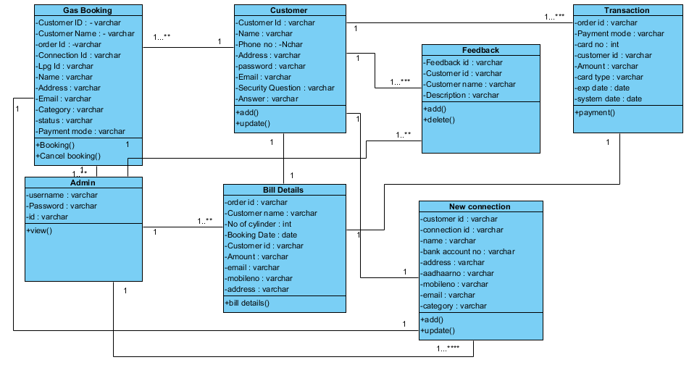

* **SEQUENCE DIAGRAM:-**

Sequence diagrams describe interactions among classes in terms of an exchange of messages over time.  A sequence diagram is a good way to visualize and validate various runtime scenarios. These can help to predict how a system will behave and to discover responsibilities a class may need to have in the process of modeling a new system.

* **Class Roles or Participants**

Class roles describe the way an object will behave in context. Use the UML object symbol to illustrate class roles, but don't list object attributes.

* **Activation or Execution Occurrence**

Activation boxes represent the time an object needs to complete a task. When an object is busy executing a process or waiting for a reply message, use a thin gray rectangle placed vertically on its lifeline.

* **Messages**

Messages are arrows that represent communication between objects. Use half-arrowed lines to represent asynchronous messages. Asynchronous messages are sent from an object that will not wait for a response from the receiver before continuing its tasks.

* **Lifelines**

Lifelines are vertical dashed lines that indicate the object's presence over time.

* **Destroying Objects**

Objects can be terminated early using an arrow labeled "<< destroy >>" that points to an X. This object is removed from memory. When that object's lifeline ends, you can place an X at the end of its lifeline to denote a destruction occurrence.

* **SEQUENCE DIAGRAM(Actor wise):-**

1. Customer creating new account:-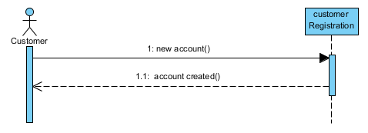
2. Verify Authentication(customer login):-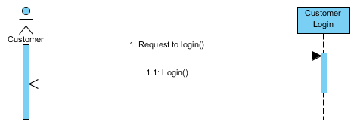
3. Customer Apply for new connection:-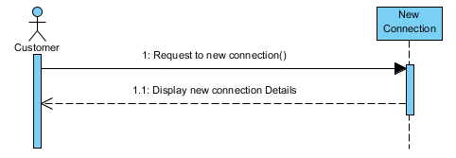
4. Gas Booking:-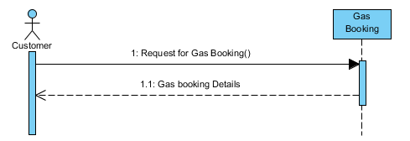
5. Transaction details:-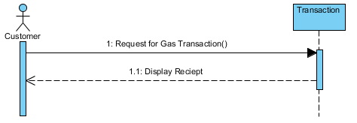
6. Get subsidy Notification:-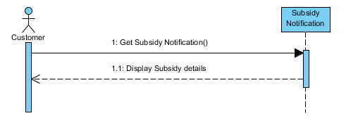
7. Cancel Booking:-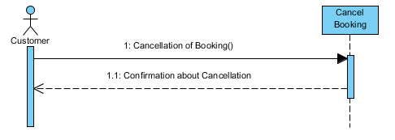
8. Feedback Form:-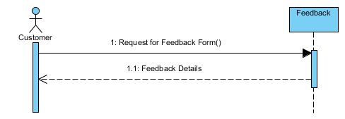
9. Change in Personal Details:-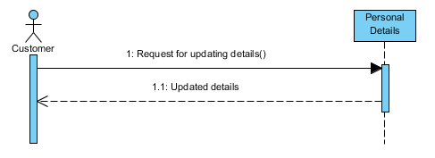
10. Logout:-

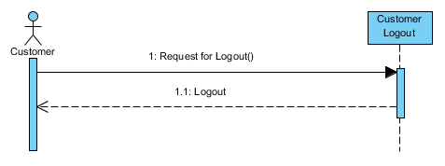11. Verify Authentication (Admin Login):-

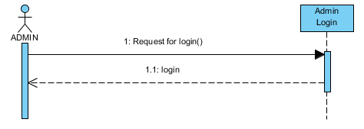

12.New Connection Details:-

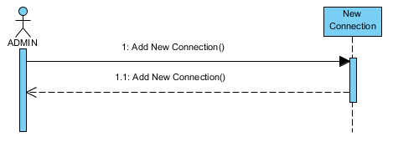

13.View Gas Booking Details:-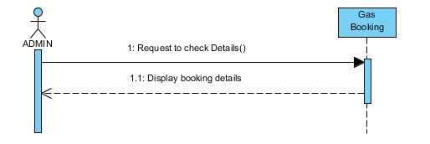

14. Checks Customer subsidy:-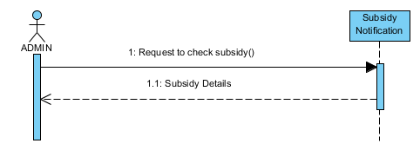

15. View Cancel Booking Details:-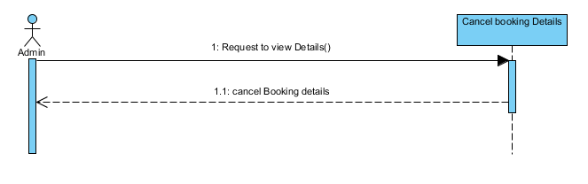

16. View Customer Details:-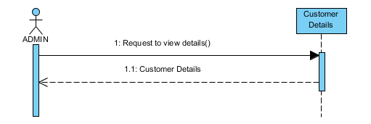

17. Feedback Form:-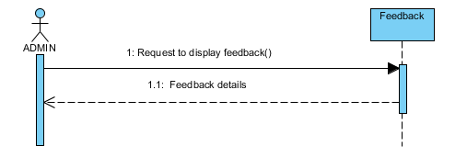

18. Delete Feedback:-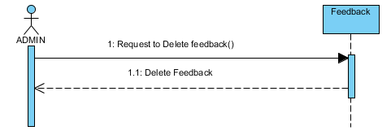

19. Admin Logout:-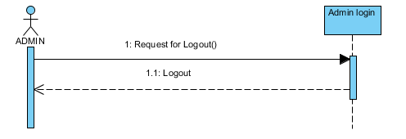

* **STATE DIAGRAM:-**

A state diagram shows the behavior of classes in response to external stimuli. Specifically a state diagram describes the behavior of a single object in response to a series of events in a system

State diagram describes the flow of control from one state to another state. States are defined as a condition in which an object exists and it changes when some event is triggered. The most important purpose of State diagram is to model lifetime of an object from creation to termination.

* **States**

States represent situations during the life of an object. You can easily illustrate a state in smart draw by using a rectangle with rounded corners.

* **Transition**

A solid arrow represents the path between different states of an object. Label the transition with the event that triggered it and the action that results from it. A state can have a transition that points back to itself.

* **Initial State**

A filled circle followed by an arrow represents the object's initial state.

* **Final State**

An arrow pointing to a filled circle nested inside another circle represents the object's final state.

* **Synchronization and Splitting of Control**

A short heavy bar with two transitions entering it represents a synchronization of control.

* **STATE DIGRAM FOR ADMIN:-**

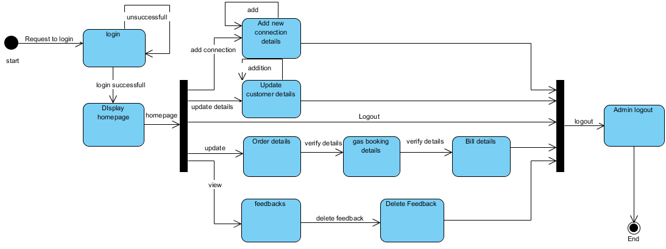

* **STATE DIAGRAM FOR CUSTOMER:-**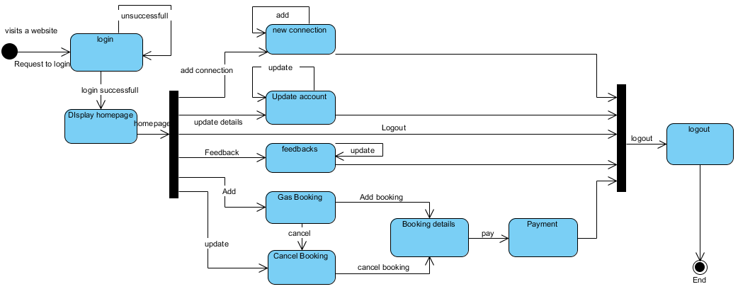
* **STATE DIGRAM FOR PAYMENT:-**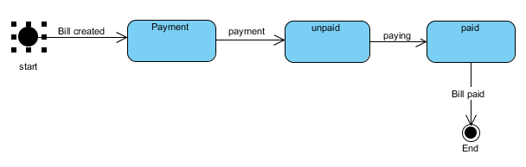
* **STATE DIGRAM FOR FEEDBACK:-**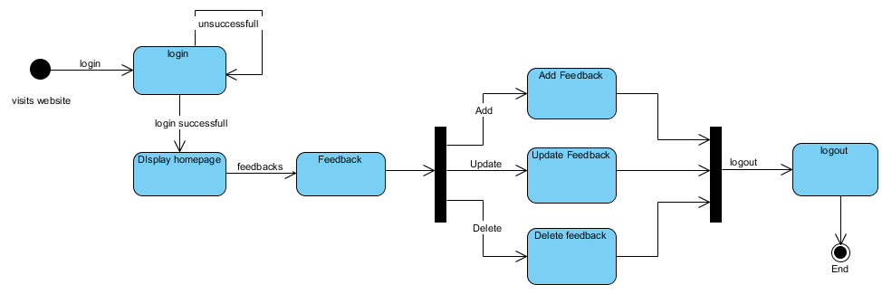
* **STATE DIAGRAM FOR ORDER DETAILS:-**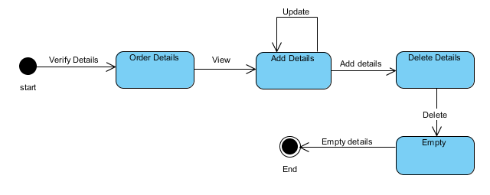
* **STATE DIAGRAM FOR GAS BOOKNG:-**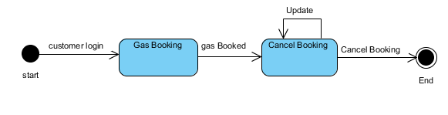
* **STATE DIGRAM FOR BILL DETAILS:-**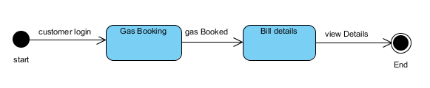

**SYSTEM DESIGN**

* **TOPICS AHEAD:-**
* Design Class Diagram
* Component Diagram
* Package Diagram
* Deployment Diagram
* **Design Class Diagram:-**

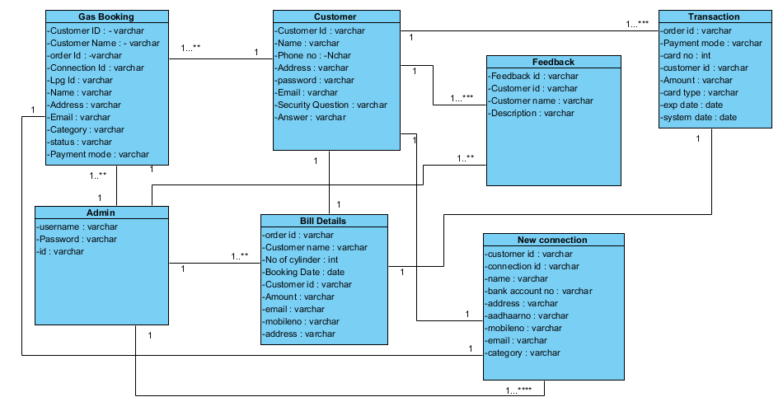

* **Component Daigram:-**

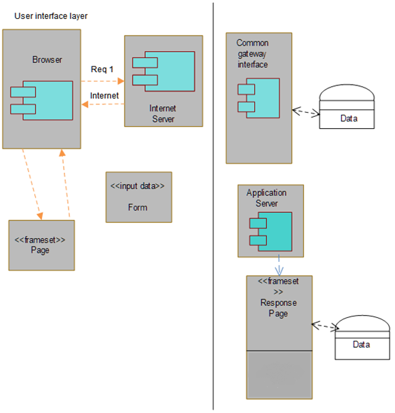

* **PACKAGE DIAGRAM:-**

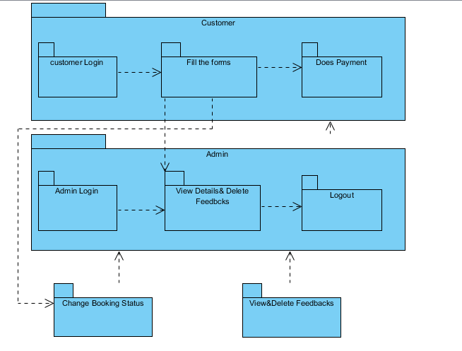

* **Deployment Daigram:-**



**SYSTEM CODING**

* **TOPICS AHEAD:-**
* Menu Tree/Sitemap
* List of Tables with Attributes & Constrains
* Design Pattern
* Program Description
* Screen Layout
* Report Layout
* **MENU TREE/SITEMAP:-**
* **SITEMAP FOR UNREGISTERED USERS:-**
* HOME
* REGISTER
* SIGN UP
* ABOUT US
* SERVICES
* SAFTY TIPS
* CONTACT
* LOGIN
* **SITEMAP FOR REGISTERED USERS:**
* HOME
* ABOUT US
* SERVICES
* GAS BOOKING
* CANCEL BOOKING
* NEW CONNECTION
* SUBSIDY DETAILS
* UPDATE PERSONAL INFO
* SAFTY TIPS
* CONTACT US
* FEEDBACK
* LOGOUT
* FORGOT PASSWORD
* **SITEMAP FOR ADMIN:**
* HOME
* ABOUT US
* DETAILS
* GAS BOOKING
* CANCEL BOOKING
* NEW CONNECTION
* SUBSIDY DETAILS
* CUSTOMER DETAILS
* SAFTY TIPS
* FEEDBACK
* CONTACT US
* FEEDBACK
* LOGIN
* LOGOUT
* **LIST OF TABLES WITH ATTRIBUTES & CONSTRAINS:-**

|  |  |  |  |  |
| --- | --- | --- | --- | --- |
| **TABLE NAME** | **FIELD NAME** | **DATATYPE** | **SIZE** | **DESCRIPTION** |
| **REGISTER** | CUSTID | Varchar | 20 | Not null |
| FNAME | Varchar | 20 | Not null |
| LNAME | Varchar | 20 | Not null |
| USERNAME | Varchar | 20 | Not null |
| PASSWORD | Varchar | 20 | Not null |
| CPASSWORD | Varchar | 20 | Not null |
| MOBILE NO | NChar | 11 | Not null |
| EMAIL | Varchar | max | Not null |
| SECURITY QUESTION | Varchar | max | Not null |
| ANS | Varchar | max | Not null |
| **New Connection** | CUSTID | varchar | 20 | Not null |
| CONNECTIONID | Varchar | 20 | Not null |
| FNAME | Varchar | 20 | Not null |
| LNAME | Varchar | 20 | Not null |
| BANK ACCOUNT NO. | varchar | 18 | Not null |
| ADDRESS | varchar | MAX | Not null |
| CADDRESS | varchar | MAX | Not null |
| AADHAAR NO. | varchar | 20 | Not null |
| MOBILE NO. | varchar | 12 | Not null |
| EMAIL | varchar | MAX | Not null |
| CATEGORY | varchar | MAX | Not null |
|  |  |  |  |
| **GAS BOOKING** | ORDERID | Varchar | 25 | Not null |
| CUSTOMERID | Varchar | 20 | Not null |
| CONNECTIONID | Varchar | 20 | Not null |
| LPGID | Varchar | 25 | Not null |
| FNAME | Varchar | 20 | Not null |
| LNAME | Varchar | 20 | Not null |
| ADDRESS | Varchar | MAX | Not null |
| CADDRESS | Varchar | MAX | Not null |
| MOBILENO. | NCHAR | 12 | Not null |
| EMAIL | Varchar | MAX | Not null |
| CATEGORY | Varchar | MAX | Not null |
| DATETIME | DATE | - | Not null |
| STATUS | Varchar | 10 | Not null |
| PAYMENT MODE | Varchar | 20 | Not null |
| SUBSIDY | Varchar | 20 | Allow null |
| **TRANSACTION** | CUSTOMERID | Varchar | 20 | Not null |
| AMOUNT | Varchar | MAX | Not null |
| CARDTYPE | Datetime | - | Not null |
| NAME | Varchar | MAX | Not null |
| CARDNO. | Varchar | MAX | Not null |
| CVV | Varchar | MAX | Not null |
| EXP DATE | Varchar | MAX | Not null |
| SYSTEM DATE | Datetime | -- | Not null |
| **ADMIN LOGIN** | ID | INT | - | Not null |
| USERNAME | Varchar | 20 | Not null |
| PASSWORD | Varchar | 20 | Not null |
| **BILL DETAILS** | ORDERID | Varchar | 10 | Not null |
| DATE | Varchar | MAX | Not null |
| CUSTOMERID | Varchar | 20 | Not null |
| CONNECTIONID | Varchar | 20 | Not null |
| LPGID | Varchar | 25 | Not null |
| FNAME | Varchar | MAX | Not null |
| ADDRESS | Varchar | MAX | Not null |
| MOBILENO. | Varchar | 12 | Not null |
| CATEGORY | Varchar | MAX | Not null |
| AMOUNT | Varchar | MAX | Not null |
| EMAIL | Varchar | MAX | Not null |
| **FEEDBACK** | ID | Varchar | 20 | Not null |
| CUSTOMERID | Varchar | 20 | Not null |
| NAME | Varchar | 30 | Not null |
| EMAIL | Varchar | MAX | Not null |
| FEEDBACK | Varchar | MAX | Not null |

* **DESIGN PATTERNS:-**
* **MVC PATTERN:-**

Model-View-Controller is a classic design pattern often used by applications that need the ability to maintain multiple views of the same data.

The MVC Pattern hinges on a separation of objects into one of the 3 categories:

**Models:-** For maintaining data.

**Views:-** For displaying all data or a protion of data.

**Controllers:-** For handling events that affect the model or view.

The main components of MVC in details:-

* **MODEL:-** The model represents enterprise data and the business rules that govern access to data and updates this data.Often the model serves as a software approximation to real world modeling techniques apply when defining the Model.
* **VIEW:**-The view renders the contents of a model.It accesses enterprise data through the model and specifies how that data should be presented.
* **CONTROLLER:**-The controller translates interactions with the view into actions to be perform by the model.The action performed by the models includes activating business processes or changing the state of model.
* **PROGRAM DESCRIPTION:-**

1. **Register Form for Customer:-**

The Register Form privides functionality of adding new Customer for login.It creates New Account for Customer.It provides unique username and email to customer to make it simple to find its details from database.

1. **Customer Login Form:-**

After regestering, a customer login form provides the functionality to login in the system.

1. **New Connection Form:-**

After Loging, The new connection form provides the Functionality Adding a new connection for customer.provides unique username and email to customer to make it simple to find its details from database.

1. **Gas Booking Form:-**

The Gas Booking form provides the Functionality to book gas. The Booking Difference between two bookings should be greater than 5 days.

1. **Transaction Form:-**

The Transaction form provides the Functionality to payment of booked gas.

1. **Update Personal Information form:-**

The Update personal information form provides the Functionality to update account details.

1. **Admin Login Form:-**

Admin login form provides the functionality to login in the system.

1. **Feedback Form:-**

With the help of Feedback Form Customer can give feedback.

* **INPUT/OUTPUT SCREEN LAYOUTS & REPORT LAYOUT:-**
* **Home page(without login)**

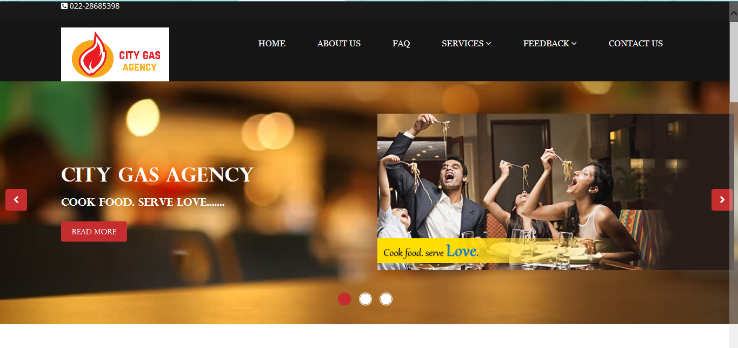

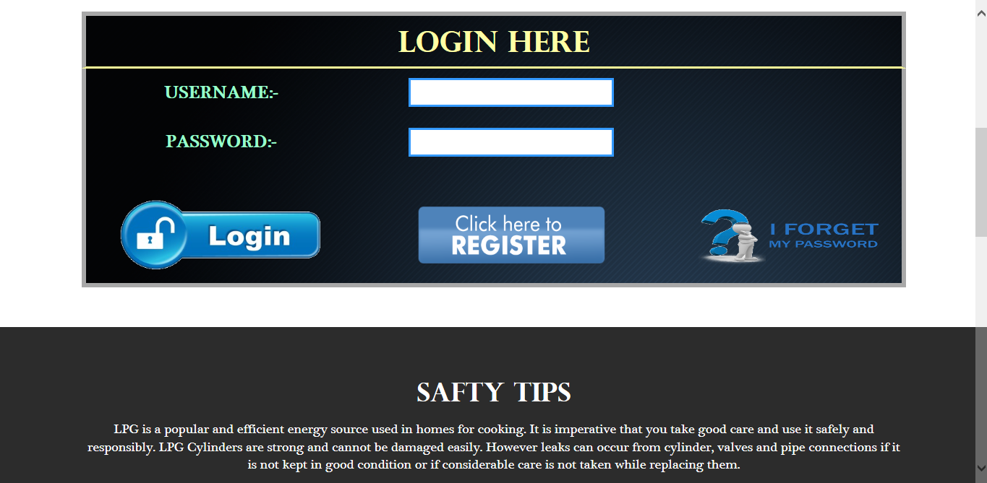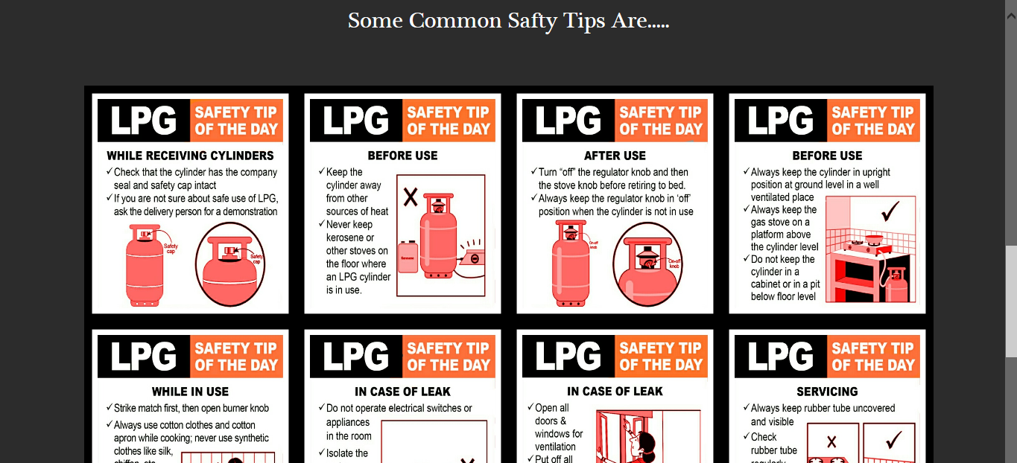

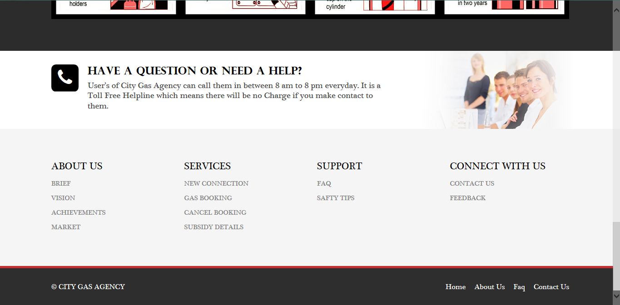

* **Aboutus**

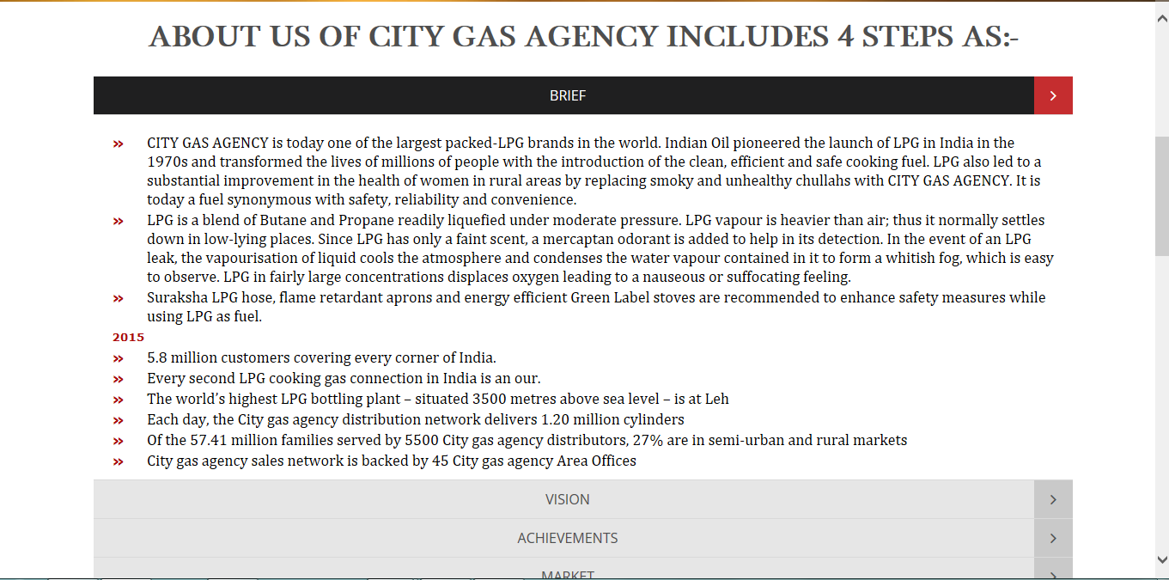

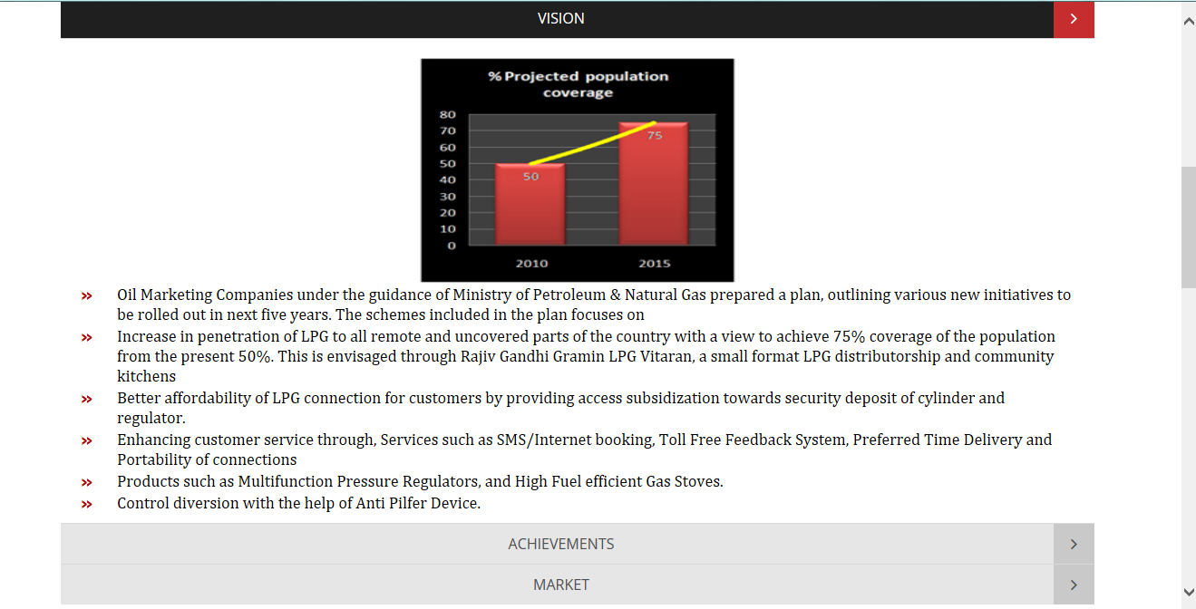

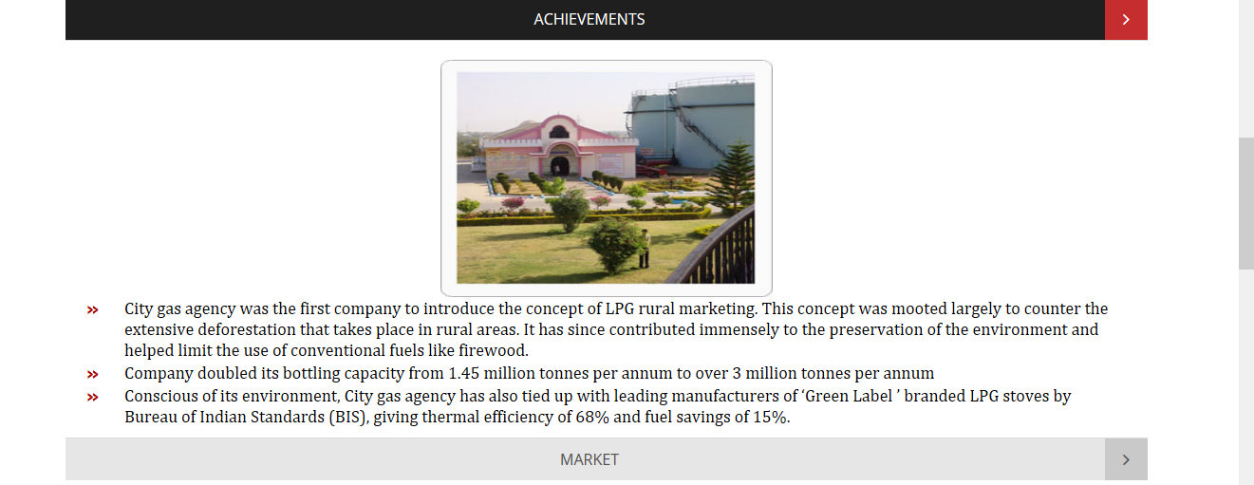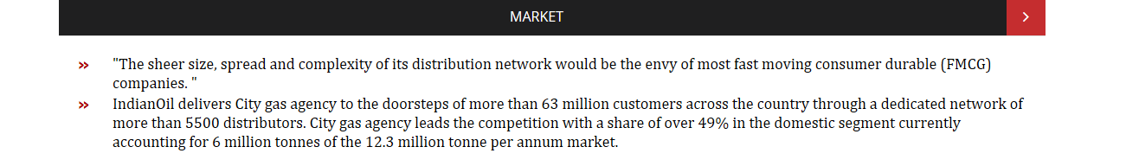

* **Faq**

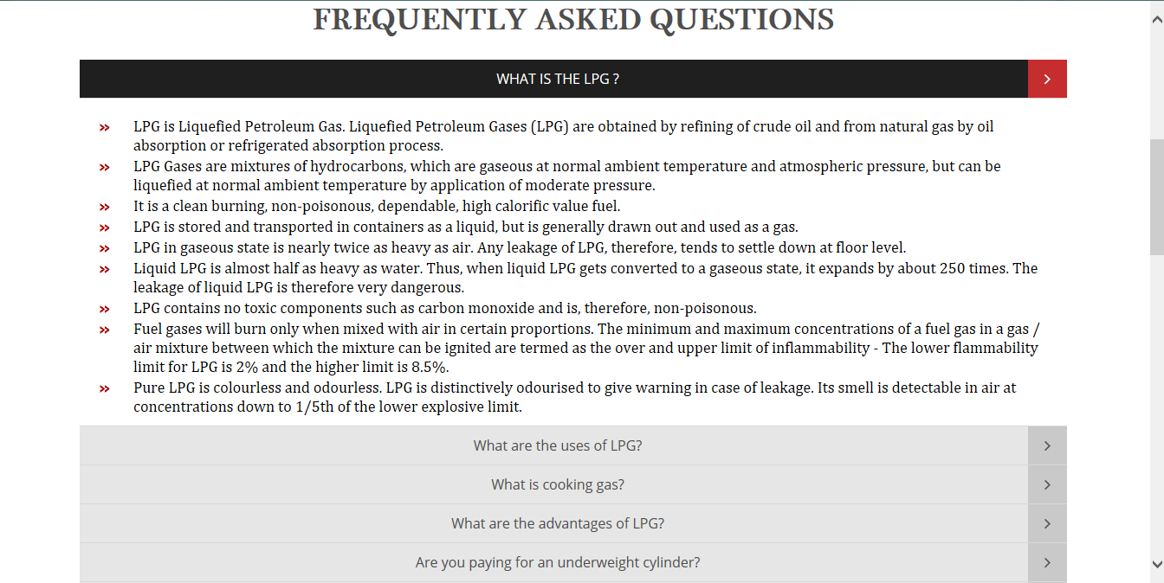

* **Gas Booking(without Login)**

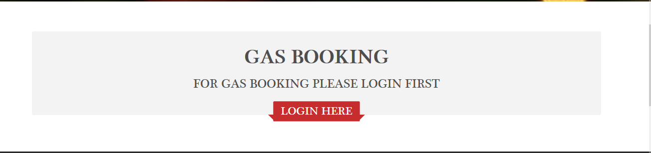

* **New Connection(Without login)**
* **Cancel Booking (without login)**
* **Subsidy Details(without login)**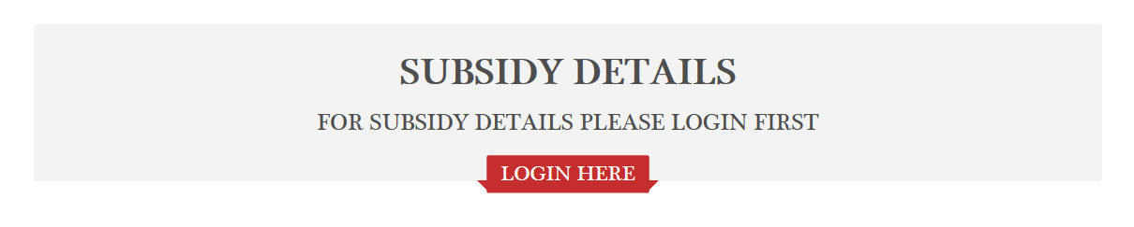
* **Personal Info(without login)**
* **Contactus**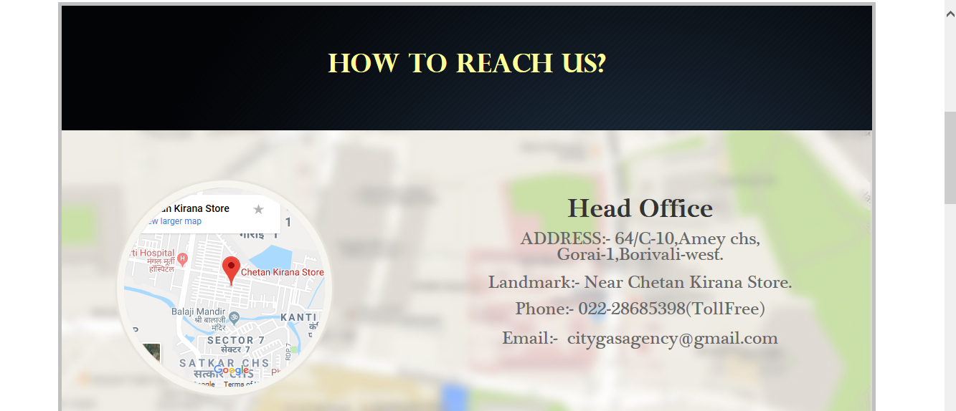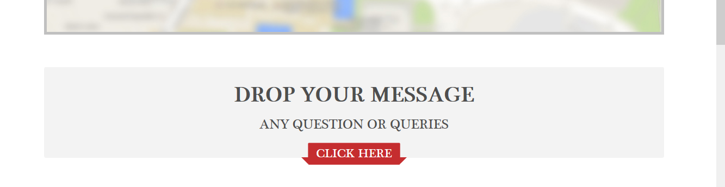
* **Fill Login Form (validation)**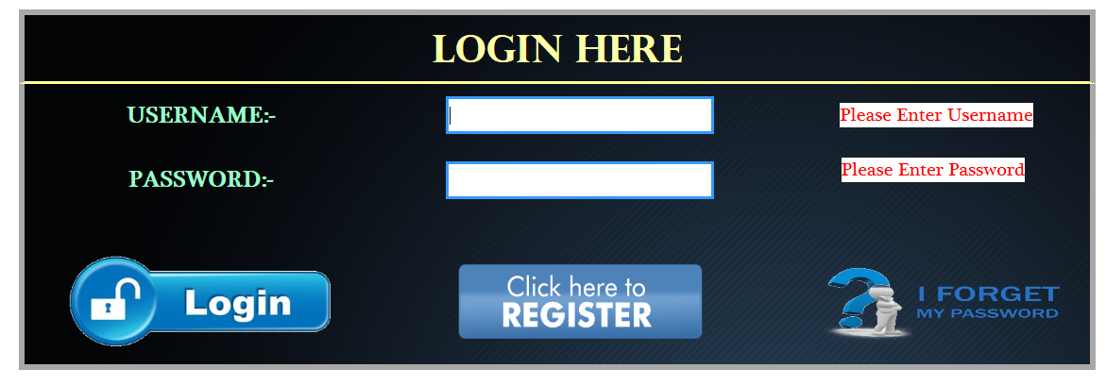
* **Forgot Password**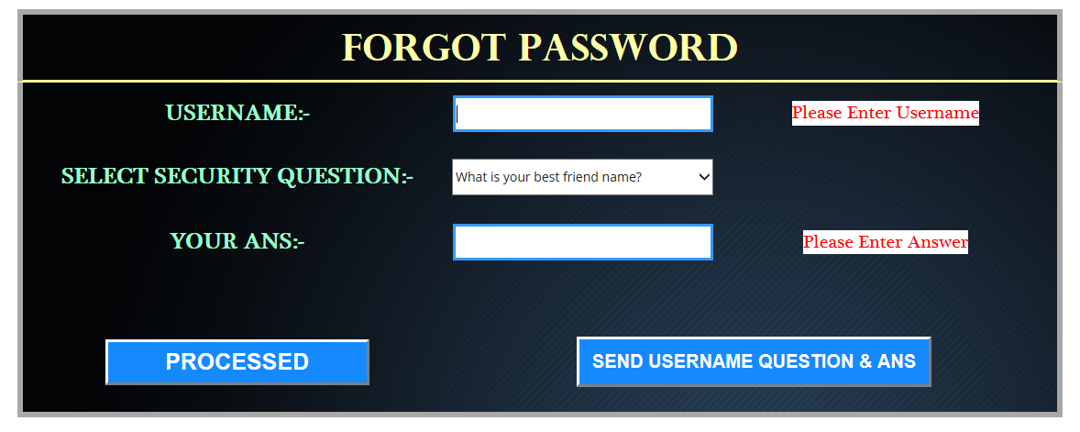
* **Password Recover through email**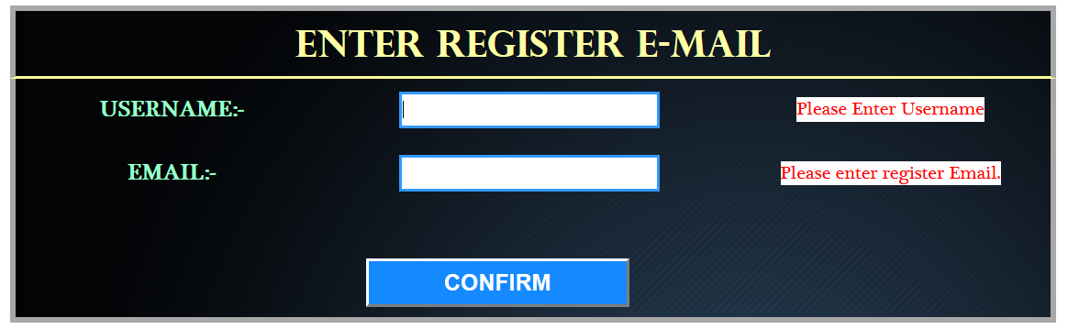
* **Set password**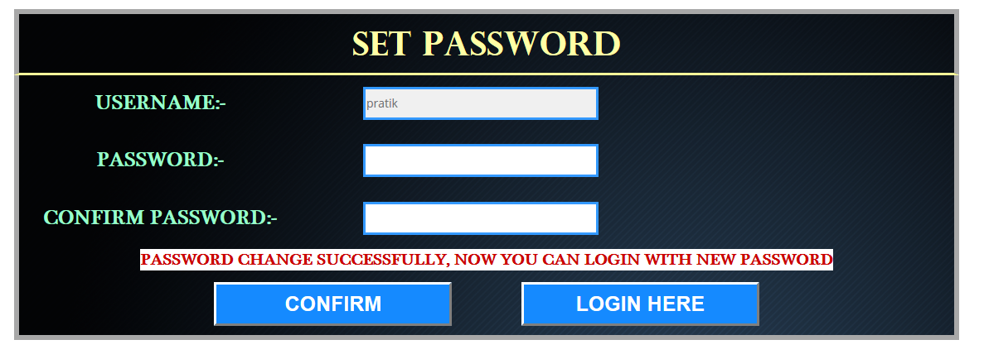
* **Homepage(after login)**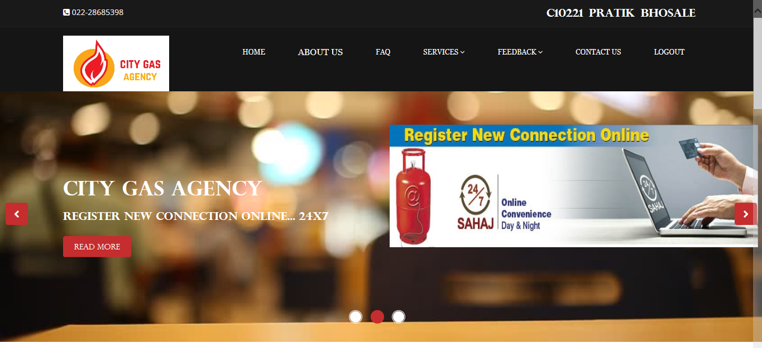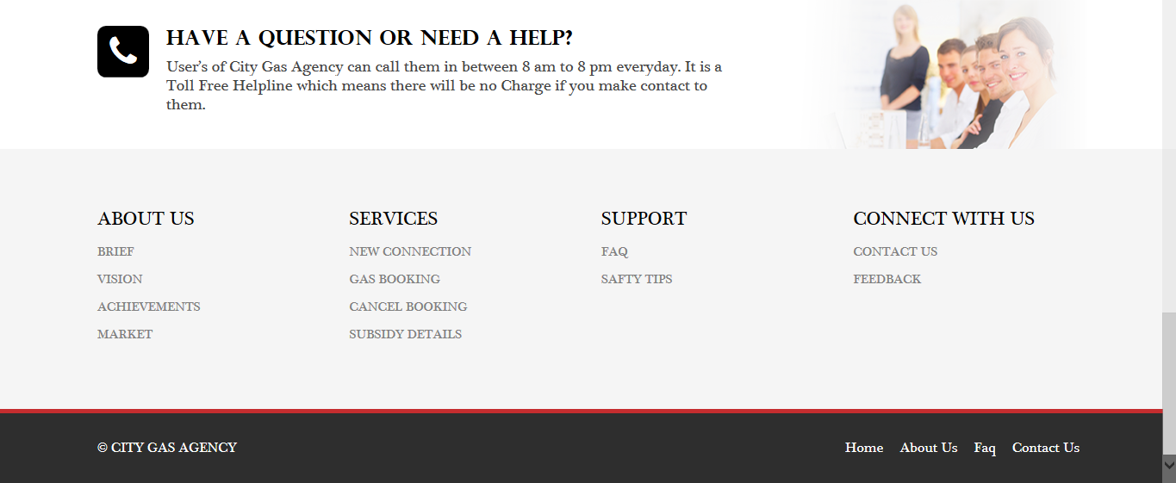
* **Newconnection**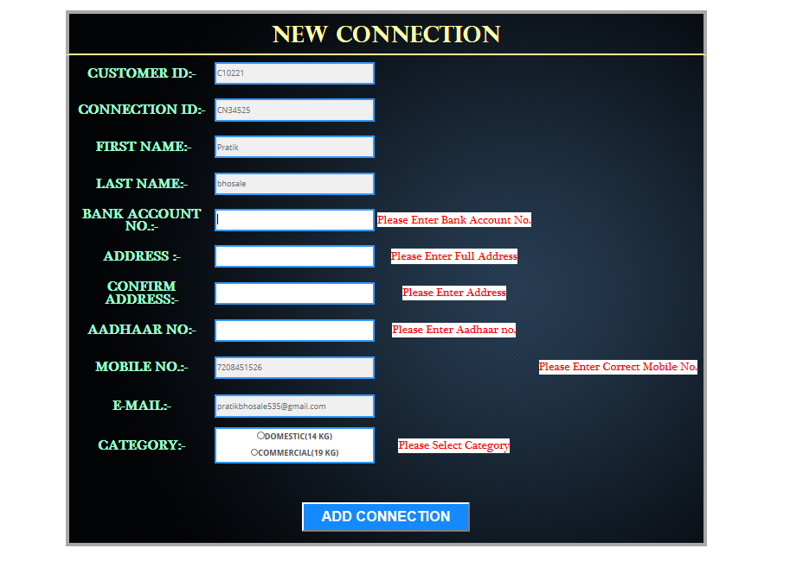
* **Cancel Booking**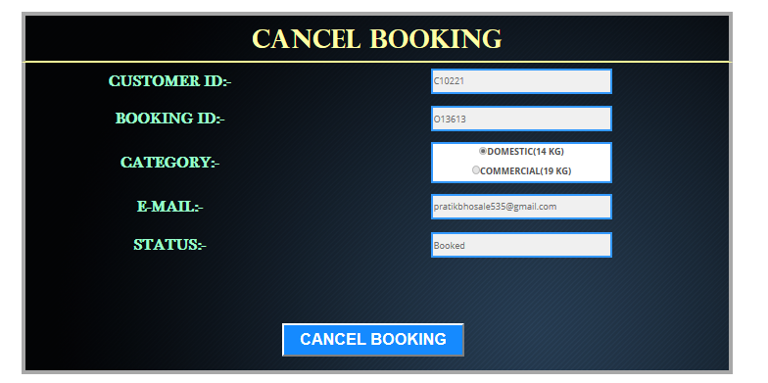
* **GasBooking**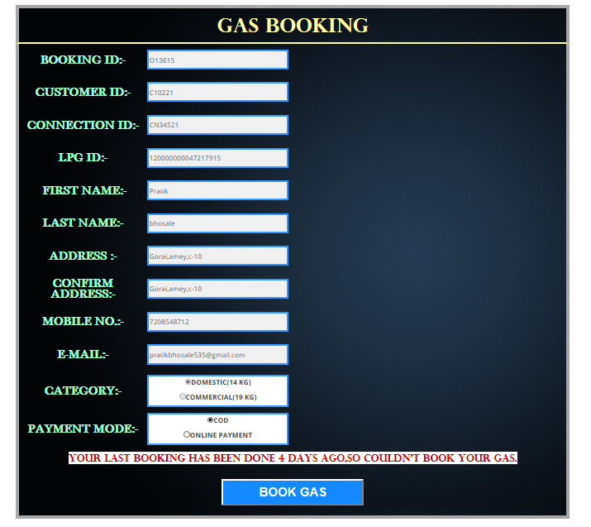
* **Subsidy Details**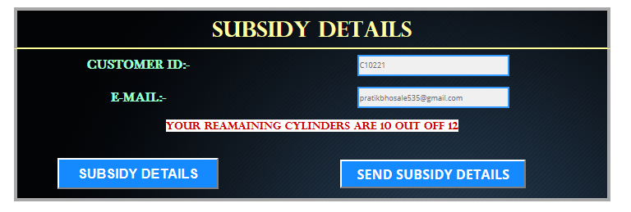
* **Update account**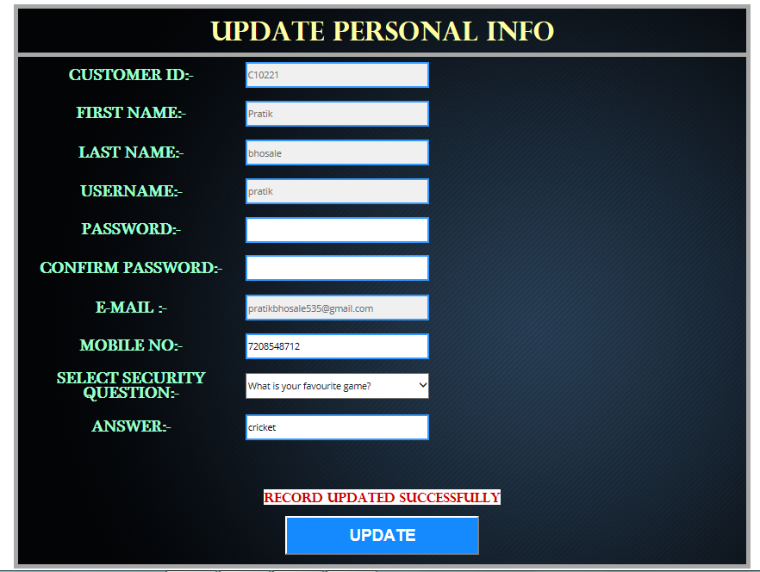
* **Feedback**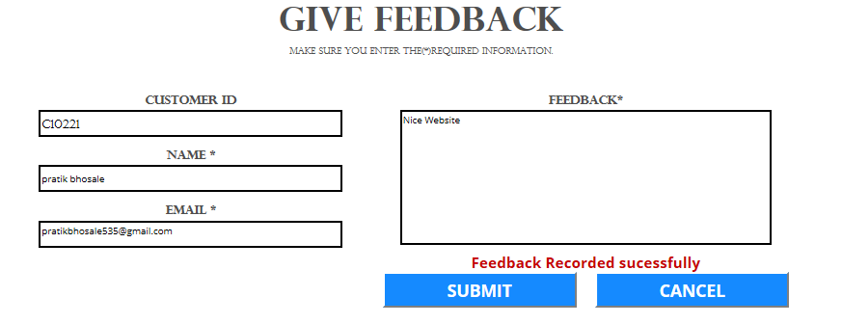
* **Transaction(after book gas)**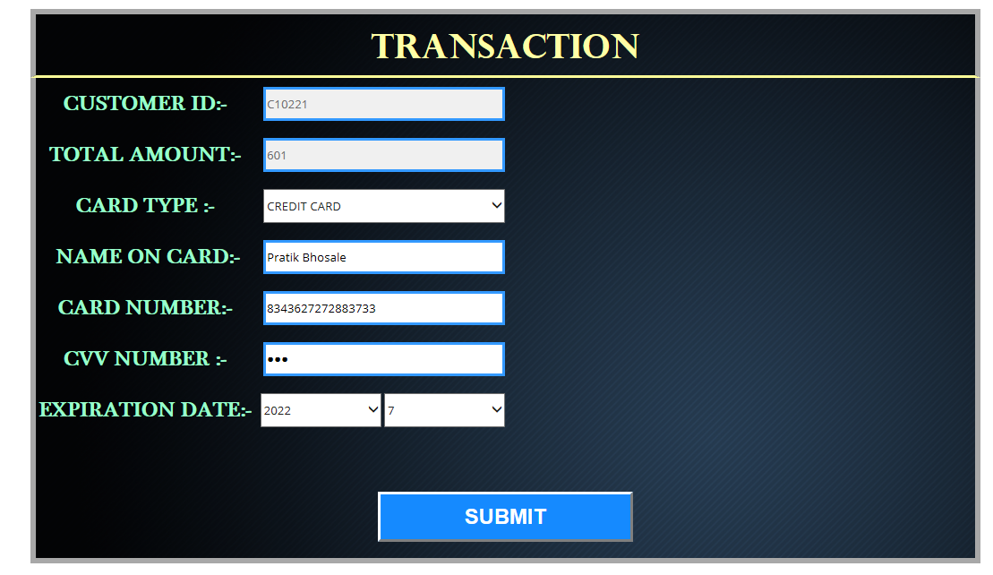
* **Bill details**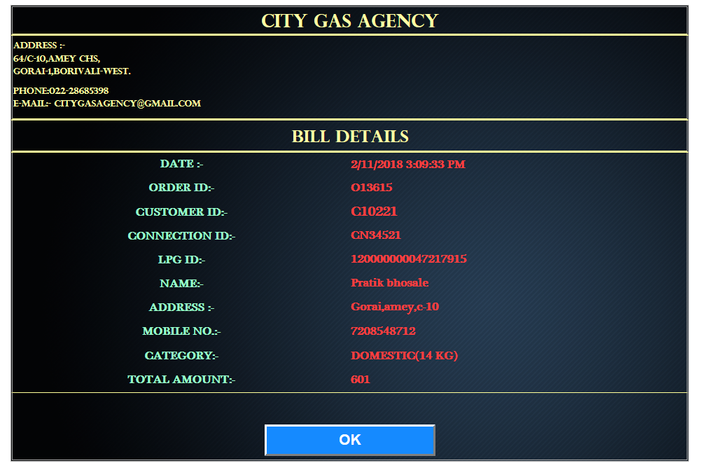
* **Bill details sent Successfully to email**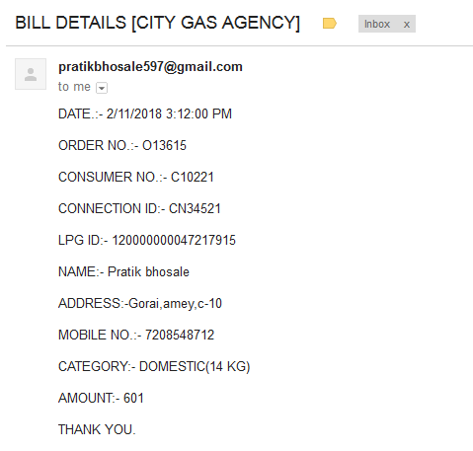
* **Safty Tips**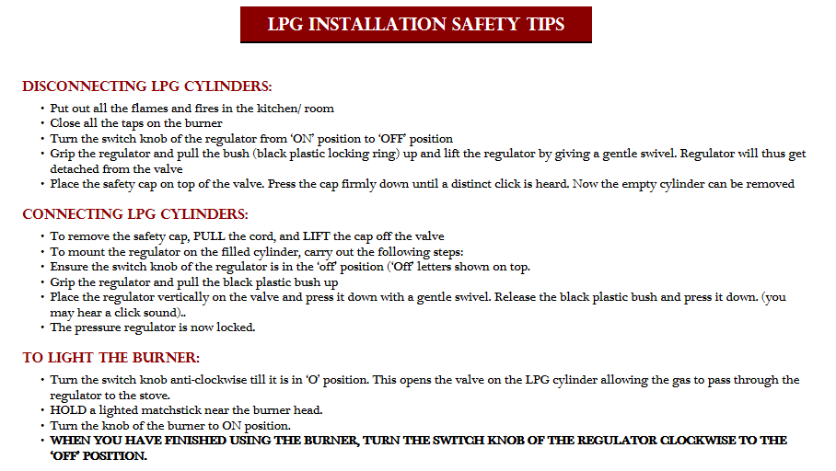

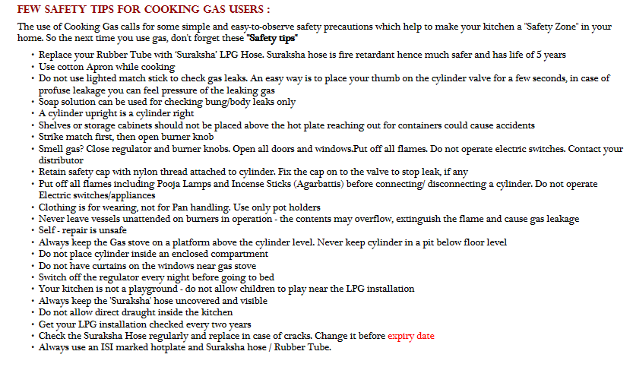

* **Admin Login**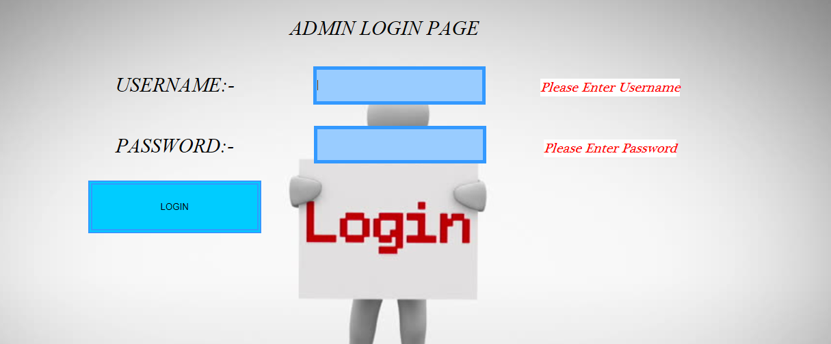
* **Admin Home page**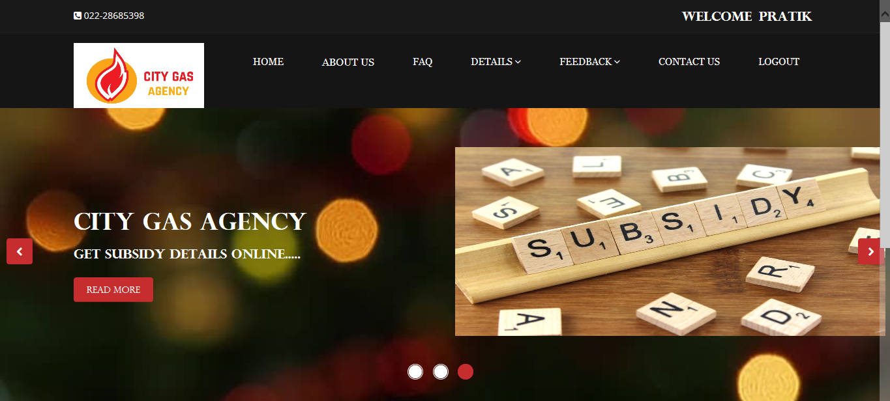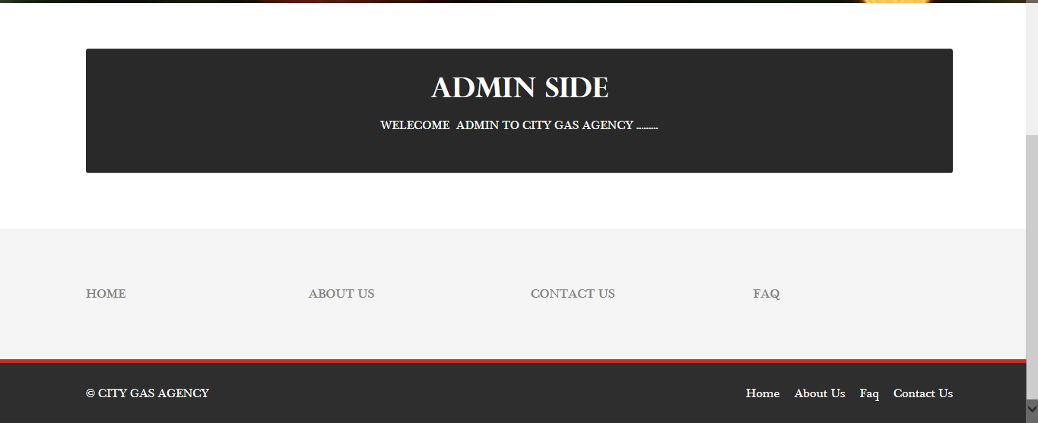
* **Gas Booking**

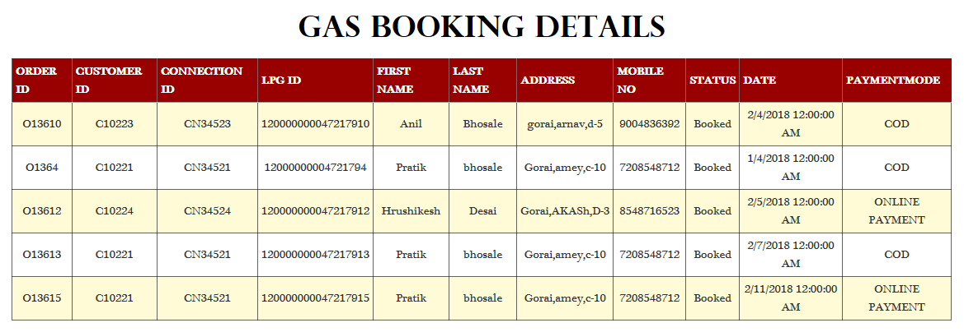

* **New Connection Details**

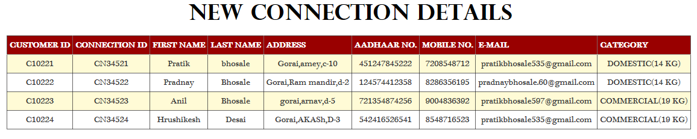

* **Cancel Booking**

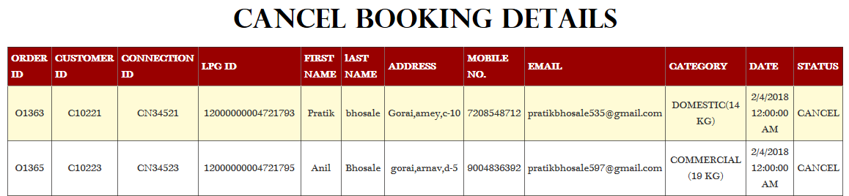

* **Customer Details**

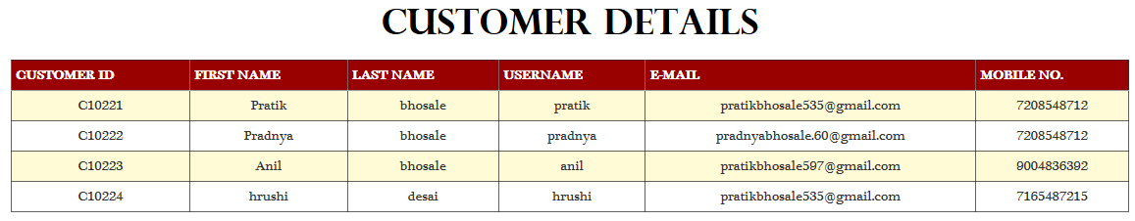

* **Subsidy Details**

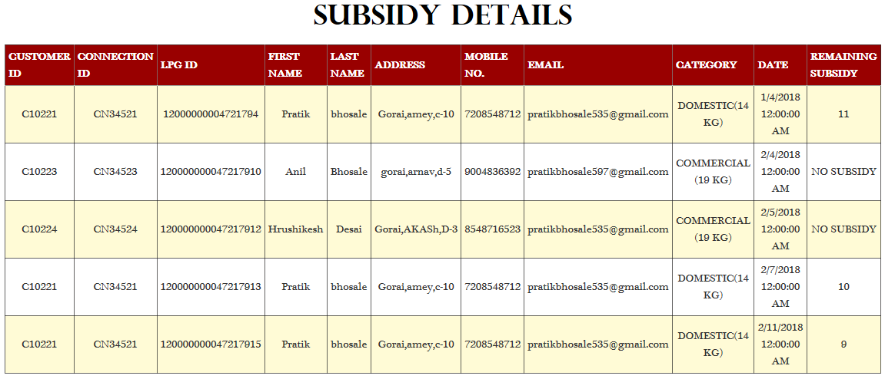

* **Feedback**

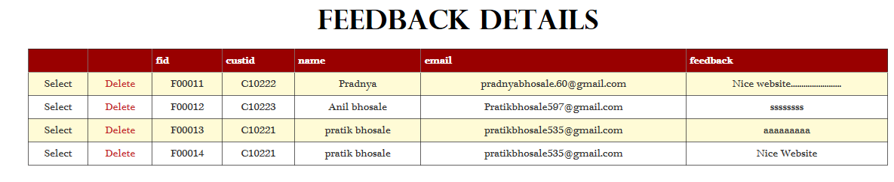

**SYSTEM IMPLEMENTATION & CODING**

* **Client Side:-**
* **Withoulg.master**

<%@ Master Language="C#" AutoEventWireup="true" CodeBehind="withoutlg.master.cs" Inherits="citygas.withoutlg" %>

<!DOCTYPE html>

<html lang="en">

<head>

<meta charset="utf-8">

<meta name="viewport" content="width=device-width, initial-scale=1.0">

<meta name="description" content="">

<meta name="author" content="">

<title>Home | Corlate</title>

<!-- core CSS -->

<link href="css/bootstrap.min.css" rel="stylesheet">

<link href="css/font-awesome.min.css" rel="stylesheet">

<link href="css/animate.min.css" rel="stylesheet">

<link href="css/prettyPhoto.css" rel="stylesheet">

<link href="css/main.css" rel="stylesheet">

<link href="css/responsive.css" rel="stylesheet">

<!--[if lt IE 9]>

<script src="js/html5shiv.js"></script>

<script src="js/respond.min.js"></script>

<![endif]-->

<link rel="shortcut icon" href="images/ico/favicon.ico">

<link rel="apple-touch-icon-precomposed" sizes="144x144" href="images/ico/apple-touch-icon-144-precomposed.png">

<link rel="apple-touch-icon-precomposed" sizes="114x114" href="images/ico/apple-touch-icon-114-precomposed.png">

<link rel="apple-touch-icon-precomposed" sizes="72x72" href="images/ico/apple-touch-icon-72-precomposed.png">

<link rel="apple-touch-icon-precomposed" href="images/ico/apple-touch-icon-57-precomposed.png">

</head><!--/head-->

<body class="homepage">

<header id="header">

<div class="top-bar">

<div class="container">

<div class="row">

<div class="col-sm-6 col-xs-4">

<div class="top-number"><p><i class="fa fa-phone-square"></i> 022-28685398</p></div>

</div>

</div>

</div><!--/.container-->

</div><!--/.top-bar-->

<nav class="navbar navbar-inverse" role="banner">

<div class="container">

<div class="navbar-header">

<button type="button" class="navbar-toggle" data-toggle="collapse" data-target=".navbar-collapse">

<span class="sr-only">Toggle navigation</span>

<span class="icon-bar"></span>

<span class="icon-bar"></span>

<span class="icon-bar"></span>

</button>

<a class="navbar-brand" href="Home.aspx">

<img src="images/rr.jpg" height="100" width="200" > </a>

</div>

<div class="collapse navbar-collapse navbar-right">

<ul class="nav navbar-nav">

<li ><a href="Home.aspx" style="font-family: Georgia, 'Times New Roman', Times, serif; font-size: 16px;">HOME</a></li>

<li> <a href="aboutus.aspx" style="font-family: Georgia, 'Times New Roman', Times, serif; font-size: 16px;">ABOUT US</a></li>

<li ><a href="faq.aspx" style="font-family: Georgia, 'Times New Roman', Times, serif; font-size: 16px;">FAQ</a></li>

<li class="dropdown">

<a href="#" class="dropdown-toggle" data-toggle="dropdown" style="font-family: Georgia, 'Times New Roman', Times, serif; font-size: 16px;">SERVICES <i class="fa fa-angle-down"></i></a>

<ul class="dropdown-menu">

<li ><a href="gasbooking.aspx" style="font-family: Georgia, 'Times New Roman', Times, serif; font-size: 16px;">GAS BOOKING</a></li>

<li ><a href="newconnection.aspx" style="font-family: Georgia, 'Times New Roman', Times, serif; font-size: 16px;">NEW CONNECTION</a></li>

<li ><a href="cancelbooking.aspx" style="font-family: Georgia, 'Times New Roman', Times, serif; font-size: 16px;">CANCEL BOOKING</a></li>

<li ><a href="saftytips.aspx" style="font-family: Georgia, 'Times New Roman', Times, serif; font-size: 16px;">SAFTY TIPS</a></li>

<li ><a href="subsidy.aspx" style="font-family: Georgia, 'Times New Roman', Times, serif; font-size: 16px;">SUBSIDY DETAILS</a></li>

<li ><a href="update.aspx" style="font-family: Georgia, 'Times New Roman', Times, serif; font-size: 16px;">PERSONAL INFO</a></li>

</ul>

</li>

<li class="dropdown" >

<a href="#" class="dropdown-toggle" data-toggle="dropdown" style="font-family: Georgia, 'Times New Roman', Times, serif; font-size: 16px;">FEEDBACK <i class="fa fa-angle-down"></i></a>

<ul class="dropdown-menu">

<li><a href="feedback.aspx" style="font-family: Georgia, 'Times New Roman', Times, serif; font-size: 16px;">FEEDBACK</a></li>

</ul>

<li><a href="contactus.aspx" style="font-family: Georgia, 'Times New Roman', Times, serif; font-size: 16px;">CONTACT US</a></li>

</ul>

</div>

</div><!--/.container-->

</nav><!--/nav-->

</header><!--/header-->

<section id="main-slider" class="no-margin" data-interval="6000" data-pause="false" data-ride="carousel">

<div class="carousel slide">

<ol class="carousel-indicators">

<li data-target="#main-slider" data-slide-to="0" class="active"></li>

<li data-target="#main-slider" data-slide-to="1"></li>

<li data-target="#main-slider" data-slide-to="2"></li>

</ol>

<div class="carousel-inner">

<div class="item active" style="background-image:url('/images/slider/001.jpg'); ">

<div class="container">

<div class="row slide-margin">

<div class="col-sm-6">

<div class="carousel-content">

<h1 class="animation animated-item-1" style="font-family: 'Perpetua Titling MT'">CITY GAS AGENCY</h1>

<h2 class="animation animated-item-2" style="font-family: 'Perpetua Titling MT'">COOK FOOD. SERVE LOVE.......</h2>

<a class="btn-slide animation animated-item-3" href="home.aspx" style="font-family: 'Perpetua Titling MT'">Read More</a>

</div>

</div>

<div class="col-sm-6 hidden-xs animation animated-item-4">

<div class="slider-img">

<img src="images/slider/03.jpg" height="290" width="660" >

</div>

</div>

</div>

</div>

</div><!--/.item-->

<div class="item" style="background-position: center center; background-image: url(images/slider/003.jpg)" >

<div class="container">

<div class="row slide-margin">

<div class="col-sm-6">

<div class="carousel-content">

<h1 class="animation animated-item-1" style="font-family: 'Perpetua Titling MT'">CITY GAS AGENCY</h1>

<h2 class="animation animated-item-2" style="font-family: 'Perpetua Titling MT'">REGISTER NEW CONNECTION ONLINE...

24x7

</h2>

<a class="btn-slide animation animated-item-3" href="newconnection.aspx" style="font-family: 'Perpetua Titling MT'">Read More</a>

</div>

</div>

<div class="col-sm-6 hidden-xs animation animated-item-4">

<div class="slider-img">

<img src="images/slider/01.jpg" height="220" width="660" >

</div>

</div>

</div>

</div>

</div><!--/.item-->

<div class="item" style="background-image: url(images/slider/002.jpg)">

<div class="container">

<div class="row slide-margin">

<div class="col-sm-6">

<div class="carousel-content">

<h1 class="animation animated-item-1" style="font-family: 'Perpetua Titling MT'">CITY GAS AGENCY</h1>

<h2 class="animation animated-item-2" style="font-family: 'Perpetua Titling MT'">GET SUBSIDY DETAILS ONLINE.....</h2>

<a class="btn-slide animation animated-item-3" href="subsidy.aspx" style="font-family: 'Perpetua Titling MT'">Read More</a>

</div>

</div>

<div class="col-sm-6 hidden-xs animation animated-item-4">

<div class="slider-img">

<img src="images/slider/00.jpg" height="290" width="660">

</div>

</div>

</div>

</div>

</div><!--/.item-->

</div><!--/.carousel-inner-->

</div><!--/.carousel-->

<a class="prev hidden-xs" href="#main-slider" data-slide="prev">

<i class="fa fa-chevron-left"></i>

</a>

<a class="next hidden-xs" href="#main-slider" data-slide="next">

<i class="fa fa-chevron-right"></i>

</a>

</section>

<div class="container">

<div class="center wow fadeInDown">

<asp:ContentPlaceHolder ID="ContentPlaceHolder1" runat="server"></asp:ContentPlaceHolder>

</div>

</div> <!--/#main-slider-->

<!--/#feature-->

<section id="recent-works" style="background-color: #2C2C2C; color: #FFFFFF;">

<div class="container" style="background-color: #2C2C2C; color: #FFFFFF;">

<div class="center wow fadeInDown" style="font-family: 'Plantagenet Cherokee'; font-size: 20px">

<h2 style="color: #FFFFFF; font-family: 'Perpetua Titling MT';">SAFTY TIPS</h2>

<p class="lead"><span style="color: rgb(255, 255, 255); font-family: 'Plantagenet Cherokee'; font-size: 18px; font-style: normal; font-variant-ligatures: normal; font-variant-caps: normal; font-weight: normal; letter-spacing: normal; orphans: 2; text-align: start; text-indent: 0px; text-transform: none; white-space: normal; widows: 2; word-spacing: 0px; -webkit-text-stroke-width: 0px; background-color: background-color: #2C2C2C; text-decoration-style: initial; text-decoration-color: initial; display: inline !important; float: none;">LPG is a popular and efficient energy source used in homes for cooking. It is imperative that you take good care and use it safely and responsibly. LPG Cylinders are strong and cannot be damaged easily. However leaks can occur from cylinder, valves and pipe connections if it is not kept in good condition or if considerable care is not taken while replacing them.</span></p>

<p class="lead" style="font-family: 'Plantagenet Cherokee'; font-size: 30px;">Some Common Safty Tips Are.....</p>

</div>

<div class="col-xs-12 col-sm-4 col-md-3">

<div class="recent-work-wrap">

<img class="img-responsive" src="images/safty tips/1.png" alt="">

<div class="overlay">

<div class="recent-work-inner" style="font-family: 'Plantagenet Cherokee'; font-size: 18px; color: white;">

<h3 Style="font-family: 'Plantagenet Cherokee'; font-size: 25px; color: #FFFFFF">SAFTY TIP </h3>

<p>While Recieving Cylinder</p>

<a class="preview" href="images/safty tips/1.png"><i class="fa fa-eye"></i> View</a>

</div>

</div>

</div>

</div>

<div class="col-xs-12 col-sm-4 col-md-3">

<div class="recent-work-wrap">

<img class="img-responsive" src="images/safty tips/2.png" alt="">

<div class="overlay">

<div class="recent-work-inner" style="font-family: 'Plantagenet Cherokee'; font-size: 18px; color: white;">

<h3 Style="font-family: 'Plantagenet Cherokee'; font-size: 25px; color: #FFFFFF">SAFTY TIP </h3>

<p>Before Use</p>

<a class="preview" href="images/safty tips/2.png"><i class="fa fa-eye"></i> View</a>

</div>

</div>

</div>

</div>

<div class="col-xs-12 col-sm-4 col-md-3">

<div class="recent-work-wrap">

<img class="img-responsive" src="images/safty tips/4.png" alt="">

<div class="overlay">

<div class="recent-work-inner" style="font-family: 'Plantagenet Cherokee'; font-size: 18px; color: white;">

<h3 Style="font-family: 'Plantagenet Cherokee'; font-size: 25px; color: #FFFFFF">SAFTY TIP </h3>

<p>After Use</p>

<a class="preview" href="images/safty tips/4.png"><i class="fa fa-eye"></i> View</a>

</div>

</div>

</div>

</div>

<div class="col-xs-12 col-sm-4 col-md-3">

<div class="recent-work-wrap">

<img class="img-responsive" src="images/safty tips/5.png" alt="">

<div class="overlay">

<div class="recent-work-inner" style="font-family: 'Plantagenet Cherokee'; font-size: 18px; color: white;">

<h3 Style="font-family: 'Plantagenet Cherokee'; font-size: 25px; color: #FFFFFF">SAFTY TIP </h3>

<p>Before Use</p>

<a class="preview" href="images/safty tips/5.png"><i class="fa fa-eye"></i> View</a>

</div>

</div>

</div>

</div>

<div class="col-xs-12 col-sm-4 col-md-3">

<div class="recent-work-wrap">

<img class="img-responsive" src="images/safty tips/6.png" alt="">

<div class="overlay">

<div class="recent-work-inner" style="font-family: 'Plantagenet Cherokee'; font-size: 18px; color: white;">

<h3 Style="font-family: 'Plantagenet Cherokee'; font-size: 25px; color: #FFFFFF">SAFTY TIP </h3>

<p>While In Use</p>

<a class="preview" href="images/safty tips/6.png"><i class="fa fa-eye"></i> View</a>

</div>

</div>

</div>

</div>

<div class="col-xs-12 col-sm-4 col-md-3">

<div class="recent-work-wrap">

<img class="img-responsive" src="images/safty tips/7.png" alt="">

<div class="overlay">

<div class="recent-work-inner" style="font-family: 'Plantagenet Cherokee'; font-size: 18px; color: white;">

<h3 Style="font-family: 'Plantagenet Cherokee'; font-size: 25px; color: #FFFFFF">SAFTY TIP </h3>

<p>In Case Of Leak</p>

<a class="preview" href="images/safty tips/7.png"><i class="fa fa-eye"></i> View</a>

</div>

</div>

</div>

</div>

<div class="col-xs-12 col-sm-4 col-md-3">

<div class="recent-work-wrap">

<img class="img-responsive" src="images/safty tips/8.png" alt="">

<div class="overlay">

<div class="recent-work-inner" style="font-family: 'Plantagenet Cherokee'; font-size: 18px; color: white;">

<h3 Style="font-family: 'Plantagenet Cherokee'; font-size: 25px; color: #FFFFFF">SAFTY TIP </h3>

<p>In Case Of Leak</p>

<a class="preview" href="images/safty tips/8.png"><i class="fa fa-eye"></i> View</a>

</div>

</div>

</div>

</div>

<div class="col-xs-12 col-sm-4 col-md-3">

<div class="recent-work-wrap">

<img class="img-responsive" src="images/safty tips/9.png" alt="">

<div class="overlay">

<div class="recent-work-inner" style="font-family: 'Plantagenet Cherokee'; font-size: 18px; color: white;">

<h3 Style="font-family: 'Plantagenet Cherokee'; font-size: 25px; color: #FFFFFF">SAFTY TIP </h3>

<p>Servicing</p>

<a class="preview" href="images/safty tips/9.png"><i class="fa fa-eye"></i> View</a>

</div>

</div>

</div>

</div>

</div><!--/.row-->

</div><!--/.container-->

</section><!--/.container-->

<!--/#recent-works-->

<section id="conatcat-info">

<div class="container">

<div class="row">

<div class="col-sm-8">

<div class="media contact-info wow fadeInDown" data-wow-duration="1000ms" data-wow-delay="600ms">

<div class="pull-left">

<i class="fa fa-phone"></i>

</div>

<div class="media-body">

<h2 style="font-family: 'Perpetua Titling MT'; font-size: 24px; font-weight: bold;">Have a question or need a help?</h2>

<p><span style="color: rgb(68, 68, 68); font-family: 'Plantagenet Cherokee'; font-size: 18px; font-style: normal; font-variant-ligatures: normal; font-variant-caps: normal; font-weight: 400; letter-spacing: normal; orphans: 2; text-align: start; text-indent: 0px; text-transform: none; white-space: normal; widows: 2; word-spacing: 0px; -webkit-text-stroke-width: 0px; background-color: rgb(255, 255, 255); text-decoration-style: initial; text-decoration-color: initial; display: inline !important; float: none;">User’s of City Gas Agency can call them in between 8 am to 8 pm everyday. It is a Toll Free Helpline which means there will be no Charge if you make contact to them.</span></p>

</div>

</div>

</div>

</div>

</div><!--/.container-->

</section><!--/#conatcat-info-->

<section id="bottom">

<div class="container wow fadeInDown" data-wow-duration="1000ms" data-wow-delay="600ms">

<div class="row" style="font-family: 'Plantagenet Cherokee'; font-size: 15px; color: #3F3F3F;">

<div class="col-md-3 col-sm-6">

<div class="widget">

<h3 style="color: #000000; font-family: 'Plantagenet Cherokee';">ABOUT US</h3>

<ul>

<li><a href="aboutus.aspx">BRIEF</a></li>

<li><a href="aboutus.aspx">VISION</a></li>

<li><a href="aboutus.aspx"> ACHIEVEMENTS</a></li>

<li><a href="aboutus.aspx">MARKET</a></li>

</ul>

</div>

</div><!--/.col-md-3-->

<div class="col-md-3 col-sm-6">

<div class="widget">

<h3 style="font-family: 'Plantagenet Cherokee'; color: #000000">SERVICES</h3>

<ul><li><a href="newconnection.aspx">NEW CONNECTION</a></li>

<li><a href="gasbooking.aspx">GAS BOOKING</a></li>

<li><a href="cancelbooking.aspx">CANCEL BOOKING</a></li>

<li><a href="subsidy.aspx">SUBSIDY DETAILS</a></li>

</ul>

</div>

</div><!--/.col-md-3-->

<div class="col-md-3 col-sm-6">

<div class="widget">

<h3 style="font-family: 'Plantagenet Cherokee'; color: #000000">SUPPORT</h3>

<ul>

<li><a href="faq.aspx">FAQ</a></li>

<li><a href="saftytips.aspx">SAFTY TIPS</a></li>

</ul>

</div>

</div><!--/.col-md-3-->

<div class="col-md-3 col-sm-6">

<div class="widget">

<h3 style="font-family: 'Plantagenet Cherokee'; color: #000000">CONNECT WITH US</h3><ul>

<li><a href="contactus.aspx">CONTACT US</a></li>

<li><a href="feedback.aspx">FEEDBACK</a></li>

</ul>

</div>

</div><!--/.col-md-3-->

</div>

</div>

</section><!--/#bottom-->

<footer id="footer" class="midnight-blue">

<div class="container">

<div class="row">

<div class="col-sm-6" style="font-family: 'Plantagenet Cherokee'; color: #FFFFFF; font-size: 16px;" >

© CITY GAS AGENCY</div>

<div class="col-sm-6">

<ul class="pull-right" style="font-family: 'Plantagenet Cherokee'; color: #FFFFFF; font-size: 16px">

<li><a href="Home.aspx">Home</a></li>

<li><a href="aboutus.aspx">About Us</a></li>

<li><a href="faq.aspx">Faq</a></li>

<li><a href="contactus.aspx">Contact Us</a></li>

</ul>

</div>

</div>

</div>

</footer><!--/#footer-->

<script src="js/jquery.js"></script>

<script src="js/bootstrap.min.js"></script>

<script src="js/jquery.prettyPhoto.js"></script>

<script src="js/jquery.isotope.min.js"></script>

<script src="js/main.js"></script>

<script src="js/wow.min.js"></script>

</body>

</html>

**Withnsty.master**

<%@ Master Language="C#" AutoEventWireup="true" CodeBehind="withlgnst.master.cs" Inherits="citygas.withlgnst" %>

<!DOCTYPE html>

<html lang="en">

<head>

<meta charset="utf-8">

<meta name="viewport" content="width=device-width, initial-scale=1.0">

<meta name="description" content="">

<meta name="author" content="">

<title>Home | Corlate</title>

<!-- core CSS -->

<link href="css/bootstrap.min.css" rel="stylesheet">

<link href="css/font-awesome.min.css" rel="stylesheet">

<link href="css/animate.min.css" rel="stylesheet">

<link href="css/prettyPhoto.css" rel="stylesheet">

<link href="css/main.css" rel="stylesheet">

<link href="css/responsive.css" rel="stylesheet">

<link rel="shortcut icon" href="images/ico/favicon.ico">

<link rel="apple-touch-icon-precomposed" sizes="144x144" href="images/ico/apple-touch-icon-144-precomposed.png">

<link rel="apple-touch-icon-precomposed" sizes="114x114" href="images/ico/apple-touch-icon-114-precomposed.png">

<link rel="apple-touch-icon-precomposed" sizes="72x72" href="images/ico/apple-touch-icon-72-precomposed.png">

<link rel="apple-touch-icon-precomposed" href="images/ico/apple-touch-icon-57-precomposed.png">

</head><!--/head-->

<body class="homepage">

<header id="header">

<div class="top-bar">

<div class="container">

<div class="row">

<div class="col-sm-6 col-xs-4">

<div class="top-number"><p><i class="fa fa-phone-square"></i> 022-28685398</p></div>

</div>

<div class="col-sm-6 col-xs-8">

<div class="social">

<asp:Label ID="lbl1" runat="server" Text="" ForeColor="White" Font-Bold="True" Font-Size="20px" Font-Names="Perpetua Titling MT"></asp:Label>&nbsp&nbsp

<asp:Label ID="lbl2" runat="server" Text="" ForeColor="White" Font-Bold="True" Font-Size="20px" Font-Names="Perpetua Titling MT" ></asp:Label>&nbsp&nbsp

<asp:Label ID="lbl3" runat="server" Text="" ForeColor="White" Font-Bold="True" Font-Size="20px" Font-Names="Perpetua Titling MT" ></asp:Label>&nbsp&nbsp

</div>

</div>

</div>

</div><!--/.container-->

</div><!--/.top-bar-->

<nav class="navbar navbar-inverse" role="banner">

<div class="container">

<div class="navbar-header">

<button type="button" class="navbar-toggle" data-toggle="collapse" data-target=".navbar-collapse">

<span class="sr-only">Toggle navigation</span>

<span class="icon-bar"></span>

<span class="icon-bar"></span>

<span class="icon-bar"></span>

</button>

<a class="navbar-brand" href="Home.aspx">

<img src="images/rr.jpg" height="100" width="190" > </a>

</div>

<div class="collapse navbar-collapse navbar-right">

<ul class="nav navbar-nav">

<li><a href="Home.aspx" style="font-family: Georgia, 'Times New Roman', Times, serif; font-size: 13px;">HOME</a></li>

<li> <a href="aboutus.aspx" style="font-family: Georgia, 'Times New Roman', Times, serif; font-size: 16px;">ABOUT US</a></li>

<li><a href="faq.aspx" style="font-family: Georgia, 'Times New Roman', Times, serif; font-size: 13px;">FAQ</a></li>

<li class="dropdown">

<a href="#" class="dropdown-toggle" data-toggle="dropdown" style="font-family: Georgia, 'Times New Roman', Times, serif; font-size: 13px;">SERVICES <i class="fa fa-angle-down"></i></a>

<ul class="dropdown-menu">

<li><a href="gasbooking.aspx" style="font-family: Georgia, 'Times New Roman', Times, serif; font-size: 13px;">GAS BOOKING</a></li>

<li><a href="newconnection.aspx" style="font-family: Georgia, 'Times New Roman', Times, serif; font-size: 13px;">NEW CONNECTION</a></li>

<li><a href="cancelbooking.aspx" style="font-family: Georgia, 'Times New Roman', Times, serif; font-size: 13px;" >CANCEL BOOKING</a></li>

<li><a href="saftytips.aspx" style="font-family: Georgia, 'Times New Roman', Times, serif; font-size: 13px;">SAFTY TIPS</a></li>

<li><a href="subsidy.aspx" style="font-family: Georgia, 'Times New Roman', Times, serif; font-size: 13px;">SUBSIDY DETAILS</a></li>

<li><a href="update.aspx" style="font-family: Georgia, 'Times New Roman', Times, serif; font-size: 13px;">PERSONAL INFO</a></li></ul>

</li>

<li class="dropdown">

<a href="#" class="dropdown-toggle" style="font-family: Georgia, 'Times New Roman', Times, serif; font-size: 13px;">FEEDBACK <i class="fa fa-angle-down"></i></a>

<ul class="dropdown-menu">

<li><a href="feedback.aspx" style="font-family: Georgia, 'Times New Roman', Times, serif; font-size: 13px;">FEEDBACK</a></li>

</ul>

<li><a href="contactus.aspx" style="font-family: Georgia, 'Times New Roman', Times, serif; font-size: 13px;">CONTACT US</a></li>

<li><a href="Logout.aspx" style="font-family: Georgia, 'Times New Roman', Times, serif; font-size: 13px;">LOGOUT</a></li>

</ul>

</div>

</div><!--/.container-->

</nav><!--/nav-->

</header><!--/header-->

<section id="main-slider" class="no-margin" data-interval="6000" data-pause="false" data-ride="carousel">

<div class="carousel slide">

<ol class="carousel-indicators">

<li data-target="#main-slider" data-slide-to="0" class="active"></li>

<li data-target="#main-slider" data-slide-to="1"></li>

<li data-target="#main-slider" data-slide-to="2"></li>

</ol>

<div class="carousel-inner">

<div class="item active" style="background-image:url('/images/slider/001.jpg'); ">

<div class="container">

<div class="row slide-margin">

<div class="col-sm-6">

<div class="carousel-content">

<h1 class="animation animated-item-1" style="font-family: 'Perpetua Titling MT'">CITY GAS AGENCY</h1>

<h2 class="animation animated-item-2" style="font-family: 'Perpetua Titling MT'">COOK FOOD. SERVE LOVE.......</h2>

<a class="btn-slide animation animated-item-3" href="Home.aspx" style="font-family: 'Perpetua Titling MT'">Read More</a>

</div>

</div>

<div class="col-sm-6 hidden-xs animation animated-item-4">

<div class="slider-img">

<img src="images/slider/03.jpg" height="290" width="660" >

</div>

</div>

</div>

</div>

</div><!--/.item-->

<div class="item" style="background-position: center center; background-image: url(images/slider/003.jpg)">

<div class="container">

<div class="row slide-margin">

<div class="col-sm-6">

<div class="carousel-content">

<h1 class="animation animated-item-1" style="font-family: 'Perpetua Titling MT'">CITY GAS AGENCY</h1>

<h2 class="animation animated-item-2" style="font-family: 'Perpetua Titling MT'">REGISTER NEW CONNECTION ONLINE...

24x7

</h2>

<a class="btn-slide animation animated-item-3" href="newconnection.aspx" style="font-family: 'Perpetua Titling MT'">Read More</a>

</div>

</div>

<div class="col-sm-6 hidden-xs animation animated-item-4">

<div class="slider-img">

<img src="images/slider/01.jpg" height="220" width="660" >

</div>

</div>

</div>

</div>

</div><!--/.item-->

<div class="item" style="background-image: url(images/slider/002.jpg)">

<div class="container">

<div class="row slide-margin">

<div class="col-sm-6">

<div class="carousel-content">

<h1 class="animation animated-item-1" style="font-family: 'Perpetua Titling MT'">CITY GAS AGENCY</h1>

<h2 class="animation animated-item-2" style="font-family: 'Perpetua Titling MT'">GET SUBSIDY DETAILS ONLINE.....</h2>

<a class="btn-slide animation animated-item-3" href="subsidy.aspx" style="font-family: 'Perpetua Titling MT'">Read More</a>

</div>

</div>

<div class="col-sm-6 hidden-xs animation animated-item-4">

<div class="slider-img">

<img src="images/slider/00.jpg" height="290" width="660" >

</div>

</div>

</div>

</div>

</div><!--/.item-->

</div><!--/.carousel-inner-->

</div><!--/.carousel-->

<a class="prev hidden-xs" href="#main-slider" data-slide="prev">

<i class="fa fa-chevron-left"></i>

</a>

<a class="next hidden-xs" href="#main-slider" data-slide="next">

<i class="fa fa-chevron-right"></i>

</a>

</section>

<div class="container">

<div class="center wow fadeInDown">

<asp:ContentPlaceHolder ID="ContentPlaceHolder1" runat="server"></asp:ContentPlaceHolder>

</div>

</div>

<section id="conatcat-info">

<div class="container">

<div class="row">

<div class="col-sm-8">

<div class="media contact-info wow fadeInDown" data-wow-duration="1000ms" data-wow-delay="600ms">

<div class="pull-left">

<i class="fa fa-phone"></i>

</div>

<div class="media-body">

<h2 style="font-family: 'Perpetua Titling MT'; font-size: 24px; font-weight: bold;">Have a question or need a help?</h2>

<p><span style="color: rgb(68, 68, 68); font-family: 'Plantagenet Cherokee'; font-size: 18px; font-style: normal; font-variant-ligatures: normal; font-variant-caps: normal; font-weight: 400; letter-spacing: normal; orphans: 2; text-align: start; text-indent: 0px; text-transform: none; white-space: normal; widows: 2; word-spacing: 0px; -webkit-text-stroke-width: 0px; background-color: rgb(255, 255, 255); text-decoration-style: initial; text-decoration-color: initial; display: inline !important; float: none;">User’s of City Gas Agency can call them in between 8 am to 8 pm everyday. It is a Toll Free Helpline which means there will be no Charge if you make contact to them.</span></p>

</div>

</div>

</div>

</div>

</div><!--/.container-->

</section><!--/#conatcat-info-->

<section id="bottom">

<div class="container wow fadeInDown" data-wow-duration="1000ms" data-wow-delay="600ms">

<div class="row" style="font-family: 'Plantagenet Cherokee'; font-size: 15px; color: #3F3F3F;">

<div class="col-md-3 col-sm-6">

<div class="widget">

<h3 style="color: #000000; font-family: 'Plantagenet Cherokee';">ABOUT US</h3>

<ul>

<li><a href="aboutus.aspx">BRIEF</a></li>

<li><a href="aboutus.aspx">VISION</a></li>

<li><a href="aboutus.aspx"> ACHIEVEMENTS</a></li>

<li><a href="aboutus.aspx">MARKET</a></li>

</ul>

</div>

</div><!--/.col-md-3-->

<div class="col-md-3 col-sm-6">

<div class="widget">

<h3 style="font-family: 'Plantagenet Cherokee'; color: #000000">SERVICES</h3>

<ul><li><a href="newconnection.aspx">NEW CONNECTION</a></li>

<li><a href="gasbooking.aspx">GAS BOOKING</a></li>

<li><a href="cancelbooking.aspx">CANCEL BOOKING</a></li>

<li><a href="subsidy.aspx">SUBSIDY DETAILS</a></li>

</ul>

</div>

</div><!--/.col-md-3-->

<div class="col-md-3 col-sm-6">

<div class="widget">

<h3 style="font-family: 'Plantagenet Cherokee'; color: #000000">SUPPORT</h3>

<ul>

<li><a href="faq.aspx">FAQ</a></li>

<li><a href="saftytips.aspx">SAFTY TIPS</a></li>

</ul>

</div>

</div><!--/.col-md-3-->

<div class="col-md-3 col-sm-6">

<div class="widget">

<h3 style="font-family: 'Plantagenet Cherokee'; color: #000000">CONNECT WITH US</h3>

<ul>

<li><a href="contactus.aspx">CONTACT US</a></li>

<li><a href="feedback.aspx">FEEDBACK</a></li> </ul>

</div>

</div><!--/.col-md-3-->

</div>

</div>

</section><!--/#bottom-->

<footer id="footer" class="midnight-blue">

<div class="container">

<div class="row">

<div class="col-sm-6" style="font-family: 'Plantagenet Cherokee'; color: #FFFFFF; font-size: 16px;" >

© CITY GAS AGENCY</div>

<div class="col-sm-6">

<ul class="pull-right" style="font-family: 'Plantagenet Cherokee'; color: #FFFFFF; font-size: 16px">

<li><a href="Home.aspx">Home</a></li>

<li><a href="aboutus.aspx">About Us</a></li>

<li><a href="faq.aspx">Faq</a></li>

<li><a href="contactus.aspx">Contact Us</a></li>

</ul>

</div>

</div>

</div>

</footer><!--/#footer-->

<script src="js/jquery.js"></script>

<script src="js/bootstrap.min.js"></script>

<script src="js/jquery.prettyPhoto.js"></script>

<script src="js/jquery.isotope.min.js"></script>

<script src="js/main.js"></script>

<script src="js/wow.min.js"></script>

</body>

</html>

* **Home.aspx**

<%@ Page Title="" Language="C#" MasterPageFile="~/withoutlg.Master" AutoEventWireup="true" CodeBehind="Home.aspx.cs" Inherits="citygas.withoutlogin.Home" %>

<asp:Content ID="Content1" ContentPlaceHolderID="ContentPlaceHolder1" runat="server">

<form id="form41" runat="server">

<table style="border: 6px solid #A8A8A8; margin-top:5%; margin-right: 3%; width:100%; background-image: url('images/123.png'); background-repeat: inherit; background-attachment: inherit;">

<tr> <td colspan="3" class="plan-action" style="border: medium solid #FFFF99; height: 74px; font-family: 'Perpetua Titling MT'; font-size: 40px; font-weight: bold; font-style: normal; font-variant: normal; text-transform: capitalize; color: #FFFFA6; " title="LOGIN HERE">LOGIN HERE</td> </tr>

<tr> <td class="auto-style15" style="height: 69px; width: 376px; font-family: 'Plantagenet Cherokee'; font-size: 25px; font-weight: bolder; font-style: normal; font-variant: normal; text-transform: capitalize; color: #99FFCC;">USERNAME:-</td>

<td class="auto-style16" style="height: 69px; width: 430px; ">

<asp:TextBox ID="username" runat="server" Height="40px" Width="284px" BorderWidth="3px" BorderColor="#3399FF"></asp:TextBox></td>

<td class="auto-style17" style="height: 69px">

<asp:RequiredFieldValidator ID="RequiredFieldValidator6" runat="server" ControlToValidate="username" ErrorMessage="Please Enter Username" SetFocusOnError="True" ForeColor="Red" BackColor="White" Font-Names="Plantagenet Cherokee" Font-Size="20px"></asp:RequiredFieldValidator></td></tr>

<tr><td class="auto-style19" style="width: 376px; height: 70px; font-family: 'Plantagenet Cherokee'; font-size: 25px; font-weight: bolder; font-style: normal; font-variant: normal; text-transform: capitalize; color: #99FFCC;">PASSWORD:-</td>

<td class="auto-style20" style="height: 70px; width: 430px;">

<asp:TextBox ID="password" runat="server" Height="40px" Width="284px" BorderWidth="3px" BorderColor="#3399FF" TextMode="Password"></asp:TextBox></td>

<td class="auto-style21" style="height: 70px">

<asp:RequiredFieldValidator ID="RequiredFieldValidator5" runat="server" ControlToValidate="password" ErrorMessage="Please Enter Password" ForeColor="Red" SetFocusOnError="True" BackColor="White" Font-Names="Plantagenet Cherokee" Font-Size="20px"></asp:RequiredFieldValidator>

&nbsp<br />

&nbsp;</td>

</tr>

<tr>

<td class="plan-action" style="height: 32px;" colspan="3">

<asp:Label ID="lbl" runat="server" BackColor="White" Font-Names="Plantagenet Cherokee" Font-Size="20px" ForeColor="#CC0000" Font-Bold="True"></asp:Label>

</td>

</tr> <tr >

<td class="auto-style1" width: 378px; height: 83px; font-family: Arial; font-size: 20px; font-weight: bolder; font-style: italic; font-variant: normal; text-transform: capitalize; color: #99FFCC;" style="height: 131px; width: 376px;">

<asp:ImageButton ID="btn1" runat="server" Height="102px" ImageUrl="~/images/buttons/lg1.png" Width="280px" OnClick="btn1_Click" />

</td>

<td class="plan-action" height: 84px; width: 430px;" style="height: 131px">

<asp:ImageButton ID="ImageButton2" runat="server" Height="95px" ImageUrl="~/images/buttons/rg1.png" Width="325px" CausesValidation="False" OnClick="ImageButton2_Click" /></td>

<td class="plan-action" style="height: 131px">

<asp:ImageButton ID="ImageButton3" runat="server" Height="108px" ImageUrl="~/images/buttons/pass.png" Width="302px" CausesValidation="False" OnClick="ImageButton3_Click" /></td>

</tr>

</table>

</form>

</asp:Content>

* **Home.aspx.cs**

using System;

using System.Collections.Generic;

using System.Linq;

using System.Web;

using System.Web.UI;

using System.Web.UI.WebControls;

using System.Data.SqlClient;

using System.Data.Sql;

using System.Data;

using System.Web.Configuration;

namespace citygas.withoutlogin

{

public partial class Home : System.Web.UI.Page

{

static int attempt = 3;

protected void Page_Load(object sender, EventArgs e)

{

}

protected void btn1_Click(object sender, ImageClickEventArgs e)

{

SqlConnection objConn = new SqlConnection(WebConfigurationManager.ConnectionStrings["gasConnectionString"].ConnectionString);

SqlDataReader objRead;

try

{

objConn.Open();

String strQuery = "select * from register1 where username=@username and password=@password";

SqlCommand objCmd = new SqlCommand(strQuery, objConn);

objCmd.Parameters.AddWithValue("@username", username.Text);

objCmd.Parameters.AddWithValue("@password", password.Text);

String custid = Convert.ToString(objCmd.ExecuteScalar());

objRead = objCmd.ExecuteReader();

if (objRead.Read())

{

Session["custid"] = "" + custid.ToString();

attempt = 0;

Response.Redirect("/withlogin/Home.aspx");

}

else if (attempt > 0)

{//(attempt == 3) && (attempt > 0)

lbl.Text = ("You Have Only " + Convert.ToString(attempt) + " Attempt Left To Try");

--attempt;

}

else

{

lbl.Text = "LOGIN UNSUCCESSFUL";

if (attempt == 0)

{

username.Enabled = false;

password.Enabled = false;

} }}

finally

{

}

}

protected void ImageButton2_Click(object sender, ImageClickEventArgs e)

{

Response.Redirect("register.aspx");

}

protected void ImageButton3_Click(object sender, ImageClickEventArgs e)

{

Response.Redirect("forgotp.aspx");

}

} }

* **Setpassword**
* **Fp.aspx**

<%@ Page Title="" Language="C#" MasterPageFile="~/withoutlg.Master" AutoEventWireup="true" CodeBehind="fp.aspx.cs" Inherits="citygas.withoutlogin.fp" %>

<asp:Content ID="Content1" ContentPlaceHolderID="ContentPlaceHolder1" runat="server">

<form id="form43" runat="server">

<table style="border: 6px solid #A8A8A8; margin-top:5%; margin-right: 3%; width:100%; background-image: url('images/123.png'); background-repeat: inherit; background-attachment: inherit;">

<tr><td colspan="4" class="plan-action" style="border: medium solid #FFFF99; height: 75px; font-family: 'Perpetua Titling MT'; font-size: 40px; font-weight: bold; font-style: normal; font-variant: normal; text-transform: capitalize; color: #FFFFA6; " title="SET PASSWORD">SET PASSWORD</td>

</tr>

<tr>

<td class="auto-style15" style="height: 70px; width: 343px; font-family: 'Plantagenet Cherokee'; font-size: 25px; font-weight: bolder; font-style: normal; font-variant: normal; text-transform: capitalize; color: #99FFCC;">USERNAME:-</td>

<td class="auto-style16" style="height: 70px; width: 306px;" colspan="2">

<asp:TextBox ID="username" runat="server" Height="40px" Width="284px" BorderWidth="3px" BorderColor="#3399FF" Enabled="False"></asp:TextBox></td>

<td class="auto-style17" style="height: 70px">

<asp:RequiredFieldValidator ID="RequiredFieldValidator6" runat="server" ControlToValidate="username" ErrorMessage="Please Enter Username" ForeColor="Red" SetFocusOnError="True" BackColor="White" Font-Names="Plantagenet Cherokee" Font-Size="20px"></asp:RequiredFieldValidator>

</td>

</tr>

<tr>

<td class="auto-style19" style="width: 343px; height: 70px; font-family: 'Plantagenet Cherokee'; font-size: 25px; font-weight: bolder; font-style: normal; font-variant: normal; text-transform: capitalize; color: #99FFCC;">PASSWORD:-</td>

<td class="auto-style20" style="height: 70px; width: 306px;" colspan="2">

<asp:TextBox ID="password" runat="server" Height="40px" Width="284px" BorderWidth="3px" BorderColor="#3399FF" TextMode="Password"></asp:TextBox>

</td>

<td class="auto-style21" style="height: 70px">

<asp:RequiredFieldValidator ID="RequiredFieldValidator5" runat="server" ControlToValidate="password" ErrorMessage="Please enter password" ForeColor="Red" SetFocusOnError="True" BackColor="White" Font-Names="Plantagenet Cherokee" Font-Size="20px"></asp:RequiredFieldValidator>

</td>

</tr>

<tr>

<td class="auto-style19" style="width: 343px; height: 70px; font-family: 'Plantagenet Cherokee'; font-size: 25px; font-weight: bolder; font-style: normal; font-variant: normal; text-transform: capitalize; color: #99FFCC;">CONFIRM PASSWORD:-</td>

<td class="auto-style20" style="height: 70px; width: 306px;" colspan="2">

<asp:TextBox ID="cpassword" runat="server" Height="40px" Width="284px" BorderWidth="3px" BorderColor="#3399FF" TextMode="Password"></asp:TextBox>

</td>

<td class="auto-style21" style="height: 70px">

<asp:RequiredFieldValidator ID="RequiredFieldValidator1" runat="server" ControlToValidate="password" ErrorMessage="Please enter password" ForeColor="Red" SetFocusOnError="True" BackColor="White" Font-Names="Plantagenet Cherokee" Font-Size="20px"></asp:RequiredFieldValidator>

<br />

<asp:CompareValidator ID="CompareValidator1" runat="server" ControlToCompare="cpassword" ControlToValidate="password" ErrorMessage="Please enter same password." ForeColor="Red" SetFocusOnError="True" BackColor="White" Font-Names="Plantagenet Cherokee" Font-Size="20px"></asp:CompareValidator>

</td>

</tr>

<tr>

<td class="plan-action" style="height: 31px;" colspan="4">

<asp:RegularExpressionValidator ID="RegularExpressionValidator3" runat="server" BackColor="White" ControlToValidate="password" ErrorMessage="Password length must be between 7 to 16 characters and contain at least one upper case letter, one lower case letter, and one numeric digit." ForeColor="Red" ValidationExpression="^(?=.*\d)(?=.*[a-z])(?=.*[A-Z]).{7,16}$" Font-Names="Plantagenet Cherokee" Font-Size="20px"></asp:RegularExpressionValidator>

<br />

<asp:Label ID="lbl" runat="server" BackColor="White" Font-Names="Plantagenet Cherokee" Font-Size="20px" ForeColor="#CC0000" Font-Bold="True"></asp:Label>

</td>

</tr>

<tr>

<td colspan="4" class="auto-style1" style="height: 78px; font-family: Arial; font-size: 20px; font-weight: bolder; font-style: italic; font-variant: normal; text-transform: capitalize; color: #99FFCC;" colspan="2">

<asp:Button ID="sub" runat="server" Text="CONFIRM" OnClick="sub_Click" BackColor="#158AFF" BorderColor="White" BorderWidth="3px" ForeColor="White" Height="53px" BorderStyle="Outset" Font-Bold="True" Font-Size="25px" Width="287px" />

&nbsp;&nbsp;&nbsp;&nbsp;&nbsp;&nbsp;&nbsp;&nbsp;&nbsp;&nbsp;&nbsp; &nbsp;

<asp:Button ID="sub0" runat="server" Text="LOGIN HERE" OnClick="sub0_Click" CausesValidation="False" BackColor="#158AFF" BorderColor="White" BorderWidth="3px" ForeColor="White" Height="53px" BorderStyle="Outset" Font-Bold="True" Font-Size="25px" Width="287px" />

</td>

</tr>

</table>

</form>

</asp:Content>

* **Fp.aspx.cs**

using System;

using System.Collections.Generic;

using System.Linq;

using System.Web;

using System.Web.UI;

using System.Web.UI.WebControls;

using System.Data.Sql;

using System.Data;

using System.Web.Configuration;

using System.Data.SqlClient;

namespace citygas.withoutlogin

{

public partial class fp : System.Web.UI.Page

{

protected void Page_Load(object sender, EventArgs e)

{

username.Text = Session["username"] + "";

}

protected void sub_Click(object sender, EventArgs e)

{

SqlConnection objConn = new SqlConnection(WebConfigurationManager.ConnectionStrings["gasConnectionString"].ConnectionString);

try

{

objConn.Open();

String strQuery = "update register1 set password=@password, cpassword=@cpassword where username= @username";

SqlCommand objCmd = new SqlCommand(strQuery, objConn);

objCmd.Parameters.AddWithValue("@username", username.Text);

objCmd.Parameters.AddWithValue("@password", password.Text);

objCmd.Parameters.AddWithValue("@cpassword", cpassword.Text);

objCmd.ExecuteNonQuery();

// objRead = objCmd.ExecuteReader();

lbl.Text = "PASSWORD CHANGE SUCCESSFULLY, NOW YOU CAN LOGIN WITH NEW PASSWORD";

}

catch

{

lbl.Text = "ERROR";

}

finally

{

objConn.Close();

}

}

protected void sub0_Click(object sender, EventArgs e)

{

Response.Redirect("home.aspx");

}

}

}

* **Newconnection.aspx**

<%@ Page Title="" Language="C#" MasterPageFile="~/withlgnst.Master" AutoEventWireup="true" CodeBehind="newconnection.aspx.cs" Inherits="citygas.withlogin.newconnection" %>

<asp:Content ID="Content1" ContentPlaceHolderID="ContentPlaceHolder1" runat="server">

<form id="form73" runat="server">

<table style="border: 6px solid #A8A8A8;; margin-top:5%; margin-right: 3%; width:100%; background-image: url('images/123.png'); background-repeat: inherit; background-attachment: inherit;"><tr>

<td colspan="4" class="plan-action" style="border: medium solid #FFFF99; height: 76px; font-family: 'Perpetua Titling MT'; font-size: 40px; font-weight: bold; font-style: normal; font-variant: normal; text-transform: capitalize; color: #FFFFA6; " title="NEW CONNECTION">NEW CONNECTION</td></tr>

<tr><td class="auto-style15" style="height: 66px; width: 261px; font-family: 'Plantagenet Cherokee'; font-size: 25px; font-weight: bolder; font-style: normal; font-variant: normal; text-transform: capitalize; color: #99FFCC;">CUSTOMER ID:-</td>

<td class="auto-style16" style="height: 66px">

<asp:TextBox ID="custid" runat="server" Height="40px" Width="284px" BorderWidth="3px" BorderColor="#3399FF" Enabled="False"></asp:TextBox></td>

<td class="auto-style17" style="height: 66px"></td>

<td class="auto-style18" style="height: 66px"></td></tr>

<tr><td class="auto-style19" style="width: 261px; height: 66px; font-family: 'Plantagenet Cherokee'; font-size: 25px; font-weight: bolder; font-style: normal; font-variant: normal; text-transform: capitalize; color: #99FFCC;">CONNECTION ID:-</td>

<td class="auto-style20" style="height: 66px">

<asp:TextBox ID="connectionid" runat="server" Height="42px" Width="284px" BorderWidth="3px" BorderColor="#3399FF" Enabled="False"></asp:TextBox></td>

<td class="auto-style21" style="height: 66px"></td>

<td class="auto-style22" style="height: 66px"></td></tr>

<tr><td class="auto-style19" style="width: 261px; height: 66px; font-family: 'Plantagenet Cherokee'; font-size: 25px; font-weight: bolder; font-style: normal; font-variant: normal; text-transform: capitalize; color: #99FFCC;">&nbsp;FIRST nAME:-</td>

<td class="auto-style20" style="height: 66px">

<asp:TextBox ID="fname" runat="server" Height="40px" Width="284px" BorderWidth="3px" BorderColor="#3399FF" Enabled="False"></asp:TextBox></td>

<td class="auto-style21" style="height: 66px">

<asp:RequiredFieldValidator ID="RequiredFieldValidator7" runat="server" ControlToValidate="fname" ErrorMessage="Please Enter First Name" ForeColor="Red" SetFocusOnError="True" BackColor="White" Font-Names="Plantagenet Cherokee" Font-Size="20px"></asp:RequiredFieldValidator></td>

<td class="auto-style22" style="height: 66px"></td></tr>

<tr><td class="auto-style15" style="height: 65px; width: 261px; font-family: 'Plantagenet Cherokee'; font-size: 25px; font-weight: bolder; font-style: normal; font-variant: normal; text-transform: capitalize; color: #99FFCC;">LAST NAME:-</td>

<td class="auto-style16" style="height: 65px">

<asp:TextBox ID="lname" runat="server" Height="40px" Width="284px" BorderWidth="3px" BorderColor="#3399FF" Enabled="False"></asp:TextBox></td>

<td class="auto-style17" style="height: 65px">

<asp:RequiredFieldValidator ID="RequiredFieldValidator1" runat="server" ControlToValidate="lname" ErrorMessage="Please Enter Last Name" ForeColor="Red" SetFocusOnError="True" BackColor="White" Font-Names="Plantagenet Cherokee" Font-Size="20px"></asp:RequiredFieldValidator></td>

<td class="auto-style18" style="height: 65px"></td></tr>

<tr><td class="auto-style15" style="height: 65px; width: 261px; font-family: 'Plantagenet Cherokee'; font-size: 25px; font-weight: bolder; font-style: normal; font-variant: normal; text-transform: capitalize; color: #99FFCC;">BANK ACCOUNT NO.:-</td>

<td class="auto-style16" style="height: 65px">

<asp:TextBox ID="account" runat="server" Height="40px" Width="284px" BorderWidth="3px" BorderColor="#3399FF" MaxLength="18"></asp:TextBox></td>

<td class="auto-style17" style="height: 65px">

<asp:RequiredFieldValidator ID="RequiredFieldValidator11" runat="server" ControlToValidate="account" ErrorMessage="Please Enter Bank Account No." ForeColor="Red" SetFocusOnError="True" BackColor="White" Font-Names="Plantagenet Cherokee" Font-Size="20px"></asp:RequiredFieldValidator></td>

<td class="auto-style18" style="height: 65px">&nbsp;</td></tr>

<tr><td class="auto-style19" style="width: 261px; height: 65px; font-family: 'Plantagenet Cherokee'; font-size: 25px; font-weight: bolder; font-style: normal; font-variant: normal; text-transform: capitalize; color: #99FFCC;">ADDRESS :-</td>

<td class="auto-style20" style="height: 65px">

<asp:TextBox ID="address" runat="server" Height="40px" Width="284px" BorderWidth="3px" BorderColor="#3399FF"></asp:TextBox></td>

<td class="auto-style21" style="height: 65px">

<asp:RequiredFieldValidator ID="RequiredFieldValidator2" runat="server" ControlToValidate="address" ErrorMessage="Please Enter Full Address" ForeColor="Red" SetFocusOnError="True" BackColor="White" Font-Names="Plantagenet Cherokee" Font-Size="20px"></asp:RequiredFieldValidator></td>

<td class="auto-style22" style="height: 65px"></td></tr>

<tr><td class="auto-style19" style="width: 261px; height: 66px; font-family: 'Plantagenet Cherokee'; font-size: 25px; font-weight: bolder; font-style: normal; font-variant: normal; text-transform: capitalize; color: #99FFCC;">CONFIRM ADDRESS:-</td>

<td class="auto-style20" style="height: 66px; width: 110px;">

<asp:TextBox ID="caddress" runat="server" Height="40px" Width="284px" BorderWidth="3px" BorderColor="#3399FF"></asp:TextBox></td>

<td class="auto-style21" style="height: 66px">

<asp:RequiredFieldValidator ID="RequiredFieldValidator3" runat="server" ControlToValidate="caddress" ErrorMessage="Please Enter Address" ForeColor="Red" SetFocusOnError="True" BackColor="White" Font-Names="Plantagenet Cherokee" Font-Size="20px"></asp:RequiredFieldValidator></td>

<td class="auto-style22" style="height: 66px">

<asp:CompareValidator ID="CompareValidator1" runat="server" BackColor="White" ControlToCompare="caddress" ControlToValidate="address" ErrorMessage="Please Enter Same Address" ForeColor="Red" Font-Names="Plantagenet Cherokee" Font-Size="20px"></asp:CompareValidator></td></tr>

<tr><td class="auto-style19" style="width: 261px; height: 66px; font-family: 'Plantagenet Cherokee'; font-size: 25px; font-weight: bolder; font-style: normal; font-variant: normal; text-transform: capitalize; color: #99FFCC;">AADHAAR NO:-</td>

<td class="auto-style20" style="height: 66px"><asp:TextBox ID="aadhaar" runat="server" Height="40px" Width="284px" BorderWidth="3px" BorderColor="#3399FF" MaxLength="12" ValidationGroup="/d{12}"></asp:TextBox></td>

<td class="auto-style21" style="height: 66px">

<asp:RequiredFieldValidator ID="RequiredFieldValidator10" runat="server" ControlToValidate="aadhaar" ErrorMessage="Please Enter Aadhaar no." ForeColor="Red" SetFocusOnError="True" BackColor="White" Font-Names="Plantagenet Cherokee" Font-Size="20px"></asp:RequiredFieldValidator></td>

<td class="auto-style22" style="height: 66px">

<asp:RegularExpressionValidator ID="RegularExpressionValidator3" runat="server" BackColor="White" ControlToValidate="aadhaar" ErrorMessage="Please Enter Correct Aadhaar No." ForeColor="Red" ValidationExpression="\d{12}" Font-Names="Plantagenet Cherokee" Font-Size="20px"></asp:RegularExpressionValidator></td></tr>

<tr><td class="auto-style15" style="height: 66px; width: 261px; font-family: 'Plantagenet Cherokee'; font-size: 25px; font-weight: bolder; font-style: normal; font-variant: normal; text-transform: capitalize; color: #99FFCC;">MOBILE NO.:-</td>

<td class="auto-style16" style="height: 66px">

<asp:TextBox ID="mno" runat="server" Height="40px" Width="284px" BorderWidth="3px" BorderColor="#3399FF" MaxLength="10" ValidationGroup="/d{10}" Enabled="False"></asp:TextBox></td>

<td class="auto-style17" style="height: 66px">

<asp:RequiredFieldValidator ID="RequiredFieldValidator4" runat="server" ControlToValidate="mno" ErrorMessage="Please Enter Mobile No." ForeColor="Red" SetFocusOnError="True" BackColor="White" Font-Names="Plantagenet Cherokee" Font-Size="20px"></asp:RequiredFieldValidator></td>

<td class="auto-style18" style="height: 66px">

<asp:RegularExpressionValidator ID="RegularExpressionValidator1" runat="server" BackColor="White" ControlToValidate="mno" ErrorMessage="Please Enter Correct Mobile No." ForeColor="Red" ValidationExpression="\d{10}" Font-Names="Plantagenet Cherokee" Font-Size="20px"></asp:RegularExpressionValidator></td></tr>

<tr> <td class="auto-style19" style="width: 261px; height: 72px; font-family: 'Plantagenet Cherokee'; font-size: 25px; font-weight: bolder; font-style: normal; font-variant: normal; text-transform: capitalize; color: #99FFCC;">E-MAIL:-</td>

<td class="auto-style20" style="height: 72px">

<asp:TextBox ID="email" runat="server" Height="41px" Width="284px" BorderWidth="3px" BorderColor="#3399FF" Enabled="False"></asp:TextBox></td>

<td class="auto-style21" style="height: 72px">

<asp:RequiredFieldValidator ID="RequiredFieldValidator8" runat="server" ControlToValidate="email" ErrorMessage="Please Enter First Name" ForeColor="Red" SetFocusOnError="True" BackColor="White" Font-Names="Plantagenet Cherokee" Font-Size="20px"></asp:RequiredFieldValidator></td>

<td class="auto-style22" style="height: 72px">

<asp:RegularExpressionValidator ID="RegularExpressionValidator2" runat="server" BackColor="White" ControlToValidate="email" ErrorMessage="Please Enter Correct E-Mail." ForeColor="Red" ValidationExpression="\w+([-+.']\w+)*@\w+([-.]\w+)*\.\w+([-.]\w+)*" Font-Names="Plantagenet Cherokee" Font-Size="20px"></asp:RegularExpressionValidator></td></tr>

<tr><td class="auto-style19" style="width: 261px; height: 69px; font-family: 'Plantagenet Cherokee'; font-size: 25px; font-weight: bolder; font-style: normal; font-variant: normal; text-transform: capitalize; color: #99FFCC;">CATEGORY:-</td>

<td class="auto-style20" style="height: 69px">

<asp:RadioButtonList ID="rb" Align="center" runat="server" BackColor="White" BorderColor="#3399FF" BorderStyle="Solid" BorderWidth="3px" Width="285px" CausesValidation="True" Height="40px" >

<asp:ListItem>DOMESTIC(14 KG)</asp:ListItem>

<asp:ListItem>COMMERCIAL(19 KG)</asp:ListItem>

</asp:RadioButtonList></td>

<td class="auto-style21" style="height: 69px">

<asp:RequiredFieldValidator ID="RequiredFieldValidator9" runat="server" ControlToValidate="rb" ErrorMessage="Please Select Category" ForeColor="Red" SetFocusOnError="True" BackColor="White" Font-Names="Plantagenet Cherokee" Font-Size="20px"></asp:RequiredFieldValidator></td>

<td class="auto-style22" style="height: 69px"></td></tr>

<tr> <td class="auto-style19" style="height: 44px; font-family: Arial; font-size: 20px; font-weight: bolder; font-style: italic; font-variant: normal; text-transform: capitalize; color: #99FFCC;" colspan="4">

<asp:Label ID="lbl" runat="server" BackColor="White" ForeColor="#CC0000" Font-Bold="True" Font-Size="20px" Font-Names="Perpetua Titling MT" Font-Italic="False"></asp:Label>

<br />

<br /></td></tr>

<tr><td class="auto-style19" style="height: 95px; font-family: Arial; font-size: 20px; font-weight: bolder; font-style: italic; font-variant: normal; text-transform: capitalize; color: #99FFCC;" colspan="4">

<asp:Button ID="btn1" runat="server" BackColor="#158AFF" BorderColor="White" BorderWidth="3px" ForeColor="White" Height="53px" BorderStyle="Outset" Font-Bold="True" Font-Size="25px" Width="298px" Text="ADD CONNECTION" OnClick="btn1_Click" /></td></tr>

</table>

</form>

</asp:Content>

* **Newconnection.aspx.cs**

using System;

using System.Collections.Generic;

using System.Linq;

using System.Web;

using System.Web.UI;

using System.Web.UI.WebControls;

using System.Data;

using System.Web.Configuration;

using System.Data.SqlClient;

namespace citygas.withlogin

{

public partial class newconnection : System.Web.UI.Page

{ string strConnString = WebConfigurationManager.ConnectionStrings["gasConnectionString"].ConnectionString;

string str;

SqlCommand com;

int count;

protected void Page_Load(object sender, EventArgs e)

{

{

string strConn = WebConfigurationManager.ConnectionStrings["gasConnectionString"].ConnectionString;

SqlConnection objConn = new SqlConnection(strConn);

try

{

objConn.Open();

custid.Text = Session["custid"] + "";

String strQuery = "select fname,lname,email,mn from register1 where custid='" + custid.Text + "'";

SqlCommand objCmd = new SqlCommand(strQuery, objConn);

SqlDataReader reader = objCmd.ExecuteReader();

while (reader.Read())

{

fname.Text = reader["fname"] + "";

lname.Text = reader["lname"] + "";

email.Text = reader["email"] + "";

mno.Text = reader["mn"] + "";

}

}

catch

{

}

objConn.Close();

}

SqlConnection con = new SqlConnection(strConnString);

str = "select count(*) from nconnection1";

com = new SqlCommand(str, con);

con.Open();

count = Convert.ToInt16(com.ExecuteScalar()) + 1;

connectionid.Text = "CN3452" + count;

con.Close();

}

protected void btn1_Click(object sender, EventArgs e)

{

bool inputIsValid = true;

try

{

var con = new SqlConnection(WebConfigurationManager.ConnectionStrings["gasConnectionString"].ConnectionString);

var custidcmd = new SqlCommand("SELECT 1 FROM nconnection1 WHERE custid = @custid ", con);

var emailCmd = new SqlCommand("SELECT 1 FROM nconnection1 WHERE email = @email", con);

con.Open();

custidcmd.Parameters.AddWithValue("@custid", custid.Text);

emailCmd.Parameters.AddWithValue("@email", email.Text);

using (var custidReader = custidcmd.ExecuteReader())

{

if (custidReader.HasRows)

{

inputIsValid = false;

lbl.Text = "Customer Id already exists, You have already a Connection";

}

}

using (var emailReader = emailCmd.ExecuteReader())

{

if (emailReader.HasRows)

{

inputIsValid = false;

lbl.Text = "Email address already exists Please enter other Email";

}

}

if (inputIsValid)

{

str = "insert into nconnection1 values(@custid,@connectionid,@fname,@lname,@account,@address,@caddress,@aadhaar,@mno,@email,@category)";

com = new SqlCommand(str, con);

com.Parameters.AddWithValue("@custid", custid.Text);

com.Parameters.AddWithValue("@connectionid", connectionid.Text);

com.Parameters.AddWithValue("@fname", fname.Text);

com.Parameters.AddWithValue("@lname", lname.Text);

com.Parameters.AddWithValue("@account", account.Text);

com.Parameters.AddWithValue("@address", address.Text);

com.Parameters.AddWithValue("@caddress", caddress.Text);

com.Parameters.AddWithValue("@aadhaar", aadhaar.Text);

com.Parameters.AddWithValue("@mno", mno.Text);

com.Parameters.AddWithValue("@email", email.Text);

com.Parameters.AddWithValue("@category", rb.SelectedValue);

com.ExecuteNonQuery();

lbl.Text = "CONNECTION ADDED SUCCESSFULLY, NOW YOU CAN BOOK GAS";

} con.Close();

}

catch

{ lbl.Text = "error"; }

}

}

}

* **Gasbooking.aspx**

<%@ Page Title="" Language="C#" MasterPageFile="~/withlgnst.Master" AutoEventWireup="true" CodeBehind="gasbooking.aspx.cs" Inherits="citygas.withlogin.gasbooking" %>

<asp:Content ID="Content1" ContentPlaceHolderID="ContentPlaceHolder1" runat="server">

<form id="form72" runat="server">

<table style="border: 6px solid #A8A8A8;; margin-top:5%; margin-right: 3%; width:98%; background-image: url('images/123.png'); background-repeat: inherit; background-attachment: inherit;">

<tr><td colspan="4" class="plan-action" style="border: medium solid #FFFF99; height: 74px; font-family: 'Perpetua Titling MT'; font-size: 40px; font-weight: bold; font-style: normal; font-variant: normal; text-transform: capitalize; color: #FFFFA6; " title="GAS BOOKING">GAS BOOKING</td> </tr>

<tr><td class="auto-style15" style="height: 66px; width: 261px; font-family: 'Plantagenet Cherokee'; font-size: 25px; font-weight: bolder; font-style: normal; font-variant: normal; text-transform: capitalize; color: #99FFCC;">BOOKING ID:-</td>

<td class="auto-style16" style="height: 66px; width: 110px;">

<asp:TextBox ID="order" runat="server" Height="40px" Width="284px" BorderWidth="3px" BorderColor="#3399FF" Enabled="False"></asp:TextBox></td>

<td class="auto-style17" style="height: 66px"></td>

<td class="auto-style18" style="height: 66px"></td></tr>

<tr><td class="auto-style15" style="height: 66px; width: 261px; font-family: 'Plantagenet Cherokee'; font-size: 25px; font-weight: bolder; font-style: normal; font-variant: normal; text-transform: capitalize; color: #99FFCC;">CUSTOMER ID:-</td>

<td class="auto-style16" style="height: 66px; width: 110px;">

<asp:TextBox ID="custid" runat="server" Height="40px" Width="284px" BorderWidth="3px" BorderColor="#3399FF" Enabled="False"></asp:TextBox></td>

<td class="auto-style17" style="height: 66px"></td>

<td class="auto-style18" style="height: 66px"></td></tr>

<tr><td class="auto-style19" style="width: 261px; height: 66px; font-family: 'Plantagenet Cherokee'; font-size: 25px; font-weight: bolder; font-style: normal; font-variant: normal; text-transform: capitalize; color: #99FFCC;">CONNECTION ID:-</td>

<td class="auto-style20" style="height: 66px; width: 110px;">

<asp:TextBox ID="connectionid" runat="server" Height="40px" Width="284px" BorderWidth="3px" BorderColor="#3399FF" Enabled="False"></asp:TextBox></td>

<td class="auto-style21" style="height: 66px"></td>

<td class="auto-style22" style="height: 66px"></td></tr>

<tr> <td class="auto-style19" style="width: 261px; height: 66px; font-family: 'Plantagenet Cherokee'; font-size: 25px; font-weight: bolder; font-style: normal; font-variant: normal; text-transform: capitalize; color: #99FFCC;">LPG ID:-</td>

<td class="auto-style20" style="height: 66px; width: 110px;">

<asp:TextBox ID="lid" runat="server" Height="40px" Width="284px" BorderWidth="3px" BorderColor="#3399FF" Enabled="False"></asp:TextBox></td>

<td class="auto-style21" style="height: 66px"></td>

<td class="auto-style22" style="height: 66px"></td></tr>

<tr><td class="auto-style19" style="width: 261px; height: 66px; font-family: 'Plantagenet Cherokee'; font-size: 25px; font-weight: bolder; font-style: normal; font-variant: normal; text-transform: capitalize; color: #99FFCC;">&nbsp;FIRST nAME:-</td>

<td class="auto-style20" style="height: 66px; width: 110px;">

<asp:TextBox ID="fname" runat="server" Height="40px" Width="284px" BorderWidth="3px" BorderColor="#3399FF" Enabled="False"></asp:TextBox></td>

<td class="auto-style21" style="height: 66px">

<asp:RequiredFieldValidator ID="RequiredFieldValidator7" runat="server" ControlToValidate="fname" ErrorMessage="Please Enter First Name" ForeColor="Red" SetFocusOnError="True" BackColor="White" Font-Names="Plantagenet Cherokee" Font-Size="20px"></asp:RequiredFieldValidator></td>

<td class="auto-style22" style="height: 66px"></td></tr>

<tr> <td class="auto-style15" style="height: 66px; width: 261px; font-family: 'Plantagenet Cherokee'; font-size: 25px; font-weight: bolder; font-style: normal; font-variant: normal; text-transform: capitalize; color: #99FFCC;" >LAST NAME:-</td>

<td class="auto-style16" style="height: 66px; width: 110px;">

<asp:TextBox ID="lname" runat="server" Height="40px" Width="284px" BorderWidth="3px" BorderColor="#3399FF" Enabled="False"></asp:TextBox></td>

<td class="auto-style17" style="height: 66px">

<asp:RequiredFieldValidator ID="RequiredFieldValidator1" runat="server" ControlToValidate="lname" ErrorMessage="Please Enter Last Name" ForeColor="Red" SetFocusOnError="True" BackColor="White" Font-Names="Plantagenet Cherokee" Font-Size="20px"></asp:RequiredFieldValidator></td>

<td class="auto-style18" style="height: 66px"></td></tr>

<tr> <td class="auto-style19" style="width: 261px; height: 66px; font-family: 'Plantagenet Cherokee'; font-size: 25px; font-weight: bolder; font-style: normal; font-variant: normal; text-transform: capitalize; color: #99FFCC;">ADDRESS :-</td>

<td class="auto-style20" style="height: 66px; width: 110px;">

<asp:TextBox ID="address" runat="server" Height="40px" Width="284px" BorderWidth="3px" BorderColor="#3399FF" Enabled="False"></asp:TextBox></td>

<td class="auto-style21" style="height: 66px">

<asp:RequiredFieldValidator ID="RequiredFieldValidator2" runat="server" ControlToValidate="address" ErrorMessage="Please Enter Address" ForeColor="Red" SetFocusOnError="True" BackColor="White" Font-Names="Plantagenet Cherokee" Font-Size="20px"></asp:RequiredFieldValidator></td>

<td class="auto-style22" style="height: 66px"></td></tr>

<tr> <td class="auto-style19" style="width: 261px; height: 66px; font-family: 'Plantagenet Cherokee'; font-size: 25px; font-weight: bolder; font-style: normal; font-variant: normal; text-transform: capitalize; color: #99FFCC;">CONFIRM ADDRESS:-</td>

<td class="auto-style20" style="height: 66px; width: 110px;">

<asp:TextBox ID="caddress" runat="server" Height="40px" Width="284px" BorderWidth="3px" BorderColor="#3399FF" Enabled="False"></asp:TextBox></td>

<td class="auto-style21" style="height: 66px">

<asp:RequiredFieldValidator ID="RequiredFieldValidator3" runat="server" ControlToValidate="caddress" ErrorMessage="Please Enter Address" ForeColor="Red" SetFocusOnError="True" BackColor="White" Font-Names="Plantagenet Cherokee" Font-Size="20px"></asp:RequiredFieldValidator></td>

<td class="auto-style22" style="height: 66px">

<asp:CompareValidator ID="CompareValidator1" runat="server" BackColor="White" ControlToCompare="caddress" ControlToValidate="address" ErrorMessage="Please Enter Same Address" ForeColor="Red" Font-Names="Plantagenet Cherokee" Font-Size="20px"></asp:CompareValidator></td></tr>

<tr><td class="auto-style15" style="height: 66px; width: 261px; font-family: 'Plantagenet Cherokee'; font-size: 25px; font-weight: bolder; font-style: normal; font-variant: normal; text-transform: capitalize; color: #99FFCC;">MOBILE NO.:-</td>

<td class="auto-style16" style="height: 66px; width: 110px;">

<asp:TextBox ID="mno" runat="server" Height="40px" Width="284px" BorderWidth="3px" BorderColor="#3399FF" MaxLength="10" ValidationGroup="/d{10}" Enabled="False"></asp:TextBox></td>

<td class="auto-style17" style="height: 66px">

<asp:RequiredFieldValidator ID="RequiredFieldValidator4" runat="server" ControlToValidate="mno" ErrorMessage="Please Enter Mobile No." ForeColor="Red" SetFocusOnError="True" BackColor="White" Font-Names="Plantagenet Cherokee" Font-Size="20px"></asp:RequiredFieldValidator></td>

<td class="auto-style18" style="height: 66px">&nbsp;</td></tr>

<tr> <td class="auto-style19" style="width: 261px; height: 66px; font-family: 'Plantagenet Cherokee'; font-size: 25px; font-weight: bolder; font-style: normal; font-variant: normal; text-transform: capitalize; color: #99FFCC;">E-MAIL:-</td>

<td class="auto-style20" style="height: 66px; width: 110px;">

<asp:TextBox ID="email" runat="server" Height="42px" Width="284px" BorderWidth="3px" BorderColor="#3399FF" Enabled="False"></asp:TextBox></td>

<td class="auto-style21" style="height: 66px">

<asp:RequiredFieldValidator ID="RequiredFieldValidator8" runat="server" ControlToValidate="email" ErrorMessage="Please Enter First Name" ForeColor="Red" SetFocusOnError="True" BackColor="White" Font-Names="Plantagenet Cherokee" Font-Size="20px"></asp:RequiredFieldValidator></td>

<td class="auto-style22" style="height: 66px">

<asp:RegularExpressionValidator ID="RegularExpressionValidator2" runat="server" BackColor="White" ControlToValidate="email" ErrorMessage="Please Enter Correct E-Mail." ForeColor="Red" ValidationExpression="\w+([-+.']\w+)*@\w+([-.]\w+)*\.\w+([-.]\w+)*" Font-Names="Plantagenet Cherokee" Font-Size="20px"></asp:RegularExpressionValidator></td></tr>

<tr><td class="auto-style19" style="width: 261px; height: 81px; font-family: 'Plantagenet Cherokee'; font-size: 25px; font-weight: bolder; font-style: normal; font-variant: normal; text-transform: capitalize; color: #99FFCC;">CATEGORY:-</td>

<td class="auto-style20" style="height: 81px; width: 110px;">

<asp:RadioButtonList ID="rbl" Align="center" runat="server" BackColor="White" BorderColor="#3399FF" BorderStyle="Solid" BorderWidth="3px" Width="285px" CausesValidation="True" Height="45px" Enabled="False" >

<asp:ListItem>DOMESTIC(14 KG)</asp:ListItem>

<asp:ListItem>COMMERCIAL(19 KG)</asp:ListItem>

</asp:RadioButtonList></td>

<td class="auto-style21" style="height: 81px">

<asp:RequiredFieldValidator ID="RequiredFieldValidator9" runat="server" ControlToValidate="rbl" ErrorMessage="Please Select Category" ForeColor="Red" SetFocusOnError="True" BackColor="White" Font-Names="Plantagenet Cherokee" Font-Size="20px"></asp:RequiredFieldValidator></td>

<td class="auto-style22" style="height: 81px"></td></tr>

<tr><td class="auto-style19" style="width: 261px; height: 72px; font-family: 'Plantagenet Cherokee'; font-size: 25px; font-weight: bolder; font-style: normal; font-variant: normal; text-transform: capitalize; color: #99FFCC;">PAYMENT MODE:-</td>

<td class="auto-style20" style="height: 72px; width: 110px;">

<asp:RadioButtonList ID="rbl2" Align="center" runat="server" BackColor="White" BorderColor="#3399FF" BorderStyle="Solid" BorderWidth="3px" Width="285px" CausesValidation="True" Height="45px" >

<asp:ListItem>COD</asp:ListItem>

<asp:ListItem>ONLINE PAYMENT</asp:ListItem>

</asp:RadioButtonList></td>

<td class="auto-style21" style="height: 72px">

<asp:RequiredFieldValidator ID="RequiredFieldValidator5" runat="server" ControlToValidate="rbl2" ErrorMessage="Please Select Payment Mode" ForeColor="Red" SetFocusOnError="True" BackColor="White" Font-Names="Plantagenet Cherokee" Font-Size="20px"></asp:RequiredFieldValidator></td>

<td class="auto-style22" style="height: 72px"></td></tr>

<tr><td class="auto-style19" style="height: 46px; font-family: Arial; font-size: 20px; font-weight: bolder; font-style: italic; font-variant: normal; text-transform: capitalize; color: #99FFCC;" colspan="4">

<asp:Label ID="lbl" runat="server" BackColor="White" ForeColor="#CC0000" Font-Bold="True" Font-Size="20px" Font-Names="Perpetua Titling MT" Font-Italic="False"></asp:Label></td></tr>

<tr><td class="auto-style19" style="height: 96px; font-family: Arial; font-size: 20px; font-weight: bolder; font-style: italic; font-variant: normal; text-transform: capitalize; color: #99FFCC;" colspan="4">

<asp:Button ID="btn1" runat="server" BackColor="#158AFF" BorderColor="White" BorderWidth="3px" ForeColor="White" Height="53px" BorderStyle="Outset" Font-Bold="True" Font-Size="25px" Width="287px" Text="BOOK GAS" OnClick="Button1_Click" /></td></tr>

</table>

</form>

</asp:Content>

* **Gasbooking.aspx.cs**

using System;

using System.Collections.Generic;

using System.Linq;

using System.Web;

using System.Web.UI;

using System.Web.UI.WebControls;

using System.Data.SqlClient;

using System.Data.Sql;

using System.Web.Configuration;

using System.Data;

namespace citygas.withlogin

{

public partial class gasbooking : System.Web.UI.Page

{

string strConnString = WebConfigurationManager.ConnectionStrings["gasConnectionString"].ConnectionString;

string str;

SqlCommand com;

int count;

int sub;

static Random random = new Random();

protected void Page_Load(object sender, EventArgs e)

{

string strConn = WebConfigurationManager.ConnectionStrings["gasConnectionString"].ConnectionString;

SqlConnection objConn = new SqlConnection(strConn);

try

{

objConn.Open();

custid.Text = Session["custid"] + "";

String strQuery = "select connectionid,fname,lname,address,caddress,category,email,mno from nconnection1 where custid='" + custid.Text + "'";

SqlCommand objCmd = new SqlCommand(strQuery, objConn);

SqlDataReader reader = objCmd.ExecuteReader();

while (reader.Read())

{

connectionid.Text = reader["connectionid"] + "";

fname.Text = reader["fname"] + "";

lname.Text = reader["lname"] + "";

address.Text = reader["address"] + "";

caddress.Text = reader["caddress"] + "";

rbl.SelectedValue = reader["category"] + "";

email.Text = reader["email"] + "";

mno.Text = reader["mno"] + "";

}

}

catch

{

}

objConn.Close();

{//CODE FOR AUTOGENERATE OF LPG ID

SqlConnection con = new SqlConnection(strConnString);

str = "select count(*) from gasbook1";

com = new SqlCommand(str, con);

con.Open();

count = Convert.ToInt16(com.ExecuteScalar()) + 3;

lid.Text = "1200000000472179" + count;

con.Close();

}

{//CODE OF AUTOGENERATE FOR SUBSIDY ID

SqlConnection con1 = new SqlConnection(strConnString);

str = "select count(*) from gasbook1 where custid='" + custid.Text + "' and status='Booked'";

com = new SqlCommand(str, con1);

con1.Open();

count= Convert.ToInt16(com.ExecuteScalar()) + 1;

sub = 12 - count;

con1.Close();

}

{ //CODE OF AUTOGENERATE FOR ORDER ID

SqlConnection con = new SqlConnection(strConnString);

str = "select count(*) from gasbook1";

com = new SqlCommand(str, con);

con.Open();

count = Convert.ToInt16(com.ExecuteScalar()) + 3;

order.Text = "O136" + count;

}

}

protected void btn_Click(object sender, EventArgs e)

{

Response.Redirect("Home.aspx");

}

protected void Button1_Click(object sender, EventArgs e)

{

{ //for checking booking dates should not be equal

SqlConnection conn = new SqlConnection(WebConfigurationManager.ConnectionStrings["gasConnectionString"].ConnectionString);

SqlCommand com = new SqlCommand("SELECT max(DateTime) from gasbook1 where custid='" + custid.Text + "'", conn);

SqlDataAdapter da = new SqlDataAdapter(com);

DataSet ds = new DataSet();

da.Fill(ds, "gasbook1");

DateTime dt1 = DateTime.Parse(ds.Tables["gasbook1"].Rows[0][0].ToString());

DateTime dt2 = DateTime.Parse(DateTime.Now.ToString());

int diff = (dt2 - dt1).Days;

if (diff >= 6)

{

string strConn = WebConfigurationManager.ConnectionStrings["gasConnectionString"].ConnectionString; ;

SqlConnection objConn = new SqlConnection(strConn);

try

{

objConn.Open();

DateTime dateTimeVariable = DateTime.Now;

String strQuery = "insert into gasbook1 values(@orderid,@custid,@connectionid,@lpgid,@fname,@lname,@address,@caddress,@mno,@email,@category,@DateTime,@status,@paymentmode,@subsidy)";

SqlCommand objCmd = new SqlCommand(strQuery, objConn); objCmd.Parameters.AddWithValue("@orderid", order.Text);

objCmd.Parameters.AddWithValue("@custid", custid.Text);

objCmd.Parameters.AddWithValue("@connectionid", connectionid.Text);

objCmd.Parameters.AddWithValue("@lpgid", lid.Text);

objCmd.Parameters.AddWithValue("@fname", fname.Text);

objCmd.Parameters.AddWithValue("@lname", lname.Text);

objCmd.Parameters.AddWithValue("@address", address.Text);

objCmd.Parameters.AddWithValue("@caddress", caddress.Text);

objCmd.Parameters.AddWithValue("@mno", mno.Text);

objCmd.Parameters.AddWithValue("@email", email.Text);

objCmd.Parameters.AddWithValue("@category", rbl.SelectedValue);

objCmd.Parameters.AddWithValue("@DateTime", dateTimeVariable);

objCmd.Parameters.AddWithValue("@status", "Booked");

objCmd.Parameters.AddWithValue("@paymentmode", rbl2.SelectedValue);

if (rbl.SelectedValue == "DOMESTIC(14 KG)")

{

objCmd.Parameters.AddWithValue("@subsidy", sub);

Session["amt"] = (Convert.ToString(random.Next(580, 750)));

}

else

{

objCmd.Parameters.AddWithValue("@subsidy", "NO SUBSIDY");

Session["amt"] = (Convert.ToString(random.Next(1100, 1300))); }

Session["orderid"] = order.Text;

Session["connectionid"] = connectionid.Text;

Session["lpgid"] = lid.Text;

Session["fname"] = fname.Text + " " + lname.Text;

Session["address"] = address.Text;

Session["mno"] = mno.Text;

Session["category"] = rbl.SelectedValue;

Session["email"] = email.Text;

objCmd.ExecuteNonQuery();

lbl.Text = "BOOKING SUCCESSFULLY DONE";

if (rbl2.SelectedValue == "COD")

{

Response.Redirect("bill.aspx");

}

else if (rbl2.SelectedValue == "ONLINE PAYMENT")

{

Response.Redirect("transaction.aspx");

}

}

catch

{

lbl.Text = "ERROR ";

}

objConn.Close();

}

else

{

lbl.Text = "Your last booking has been done " + diff + " days ago,so couldn't book your gas.";

} } }

}

}

* **Cancelbooking.aspx**

<%@ Page Title="" Language="C#" MasterPageFile="~/withlgnst.Master" AutoEventWireup="true" CodeBehind="cancelbooking.aspx.cs" Inherits="citygas.withlogin.cancelbooking" %>

<asp:Content ID="Content1" ContentPlaceHolderID="ContentPlaceHolder1" runat="server">

<form id="form75" runat="server">

<table style="border: 6px solid #A8A8A8; margin-top:5%; margin-right: 3%; width:98%; background-image: url('images/123.png'); background-repeat: inherit; background-attachment: inherit;">

<tr><td colspan="2" class="plan-action" style="border: medium solid #FFFF99; height: 76px; font-family: 'Perpetua Titling MT'; font-size: 40px; font-weight: bold; font-style: normal; font-variant: normal; text-transform: capitalize; color: #FFFFA6; " title="GAS BOOKING">Cancel booking</td></tr>

<tr><td class="auto-style15" style="height: 60px; width: 457px; font-family: 'Plantagenet Cherokee'; font-size: 25px; font-weight: bolder; font-style: normal; font-variant: normal; text-transform: capitalize; color: #99FFCC;">CUSTOMER ID:-</td>

<td class="auto-style16" style="height: 60px">

<asp:TextBox ID="custid" runat="server" Height="40px" Width="284px" BorderWidth="3px" BorderColor="#3399FF" Enabled="False"></asp:TextBox></td></tr>

<tr><td class="auto-style15" style="height: 60px; width: 457px; font-family: 'Plantagenet Cherokee'; font-size: 25px; font-weight: bolder; font-style: normal; font-variant: normal; text-transform: capitalize; color: #99FFCC;">BOOKING ID:-</td>

<td class="auto-style16" style="height: 60px">

<asp:TextBox ID="order" runat="server" Height="40px" Width="284px" BorderWidth="3px" BorderColor="#3399FF" Enabled="False"></asp:TextBox></td></tr>

<tr> <td class="auto-style15" style="height: 77px; width: 457px; font-family: 'Plantagenet Cherokee'; font-size: 25px; font-weight: bolder; font-style: normal; font-variant: normal; text-transform: capitalize; color: #99FFCC;">CATEGORY:-</td>

<td class="auto-style16" style="height: 77px">

<asp:RadioButtonList ID="rbl" Align="center" runat="server" BackColor="White" BorderColor="#3399FF" BorderStyle="Solid" BorderWidth="3px" Width="285px" CausesValidation="True" Height="45px" Enabled="False" >

<asp:ListItem>DOMESTIC(14 KG)</asp:ListItem>

<asp:ListItem>COMMERCIAL(19 KG)</asp:ListItem>

</asp:RadioButtonList></td></tr>

<tr><td class="auto-style15" style="height: 61px; width: 457px; font-family: 'Plantagenet Cherokee'; font-size: 25px; font-weight: bolder; font-style: normal; font-variant: normal; text-transform: capitalize; color: #99FFCC;">E-MAIL:-</td>

<td class="auto-style16" style="height: 61px">

<asp:TextBox ID="email" runat="server" Height="40px" Width="284px" BorderWidth="3px" BorderColor="#3399FF" Enabled="False"></asp:TextBox></td></tr>

<tr><td class="auto-style15" style="height: 61px; width: 457px; font-family: 'Plantagenet Cherokee'; font-size: 25px; font-weight: bolder; font-style: normal; font-variant: normal; text-transform: capitalize; color: #99FFCC;">STATUS:-</td>

<td class="auto-style16" style="height: 61px">

<asp:TextBox ID="status" runat="server" Height="40px" Width="284px" BorderWidth="3px" BorderColor="#3399FF" Enabled="False"></asp:TextBox></td></tr>

<tr><td class="auto-style15" style="height: 61px; font-family: Arial; font-size: 20px; font-weight: bolder; font-style: italic; font-variant: normal; text-transform: capitalize; color: #99FFCC;" colspan="2">

<asp:Label ID="lbl" runat="server" BackColor="White" ForeColor="#CC0000" Font-Bold="True" Font-Size="20px" Font-Names="Perpetua Titling MT" Font-Italic="False"></asp:Label><br />

<asp:RequiredFieldValidator ID="R7" runat="server" ControlToValidate="status" ErrorMessage="Please First Book you gas." ForeColor="Red" SetFocusOnError="True" BackColor="White" Font-Names="Plantagenet Cherokee" Font-Size="20px" Font-Bold="False" Font-Italic="False"></asp:RequiredFieldValidator><br />

<asp:Label ID="lbl2" runat="server" BackColor="White" ForeColor="#CC0000" Font-Bold="True" Font-Size="20px" Font-Names="Perpetua Titling MT" Font-Italic="False"></asp:Label><br /></td></tr>

<tr><td class="auto-style15" style="height: 98px; font-family: Arial; font-size: 20px; font-weight: bolder; font-style: italic; font-variant: normal; text-transform: capitalize; color: #99FFCC;" colspan="2">

<asp:Button ID="btnn" runat="server" OnClick="btnn_Click" BackColor="#158AFF" BorderColor="White" BorderWidth="3px" ForeColor="White" Height="53px" BorderStyle="Outset" Font-Bold="True" Font-Size="25px" Width="287px" Text="CANCEL BOOKING" /> &nbsp;</td></tr>

</table>

</form>

</asp:Content>

* **Cancelbooking.aspx.cs**

using System;

using System.Collections.Generic;

using System.Linq;

using System.Web;

using System.Web.UI;

using System.Web.UI.WebControls;

using System.Data.SqlClient;

using System.Data;

using System.Web.Configuration;

using System.Net.Mail;

using System.Net;

namespace citygas.withlogin

{

public partial class cancelbooking : System.Web.UI.Page

{

SqlCommand com;

int count;

protected void Page_Load(object sender, EventArgs e)

{

string strConn = WebConfigurationManager.ConnectionStrings["gasConnectionString"].ConnectionString;

SqlConnection objConn = new SqlConnection(strConn);

try

{

objConn.Open();

custid.Text = Session["custid"] + "";

String strQuery = "select orderid,category,email,status from gasbook1 where custid='" + custid.Text + "' and status='Booked'";

SqlCommand objCmd = new SqlCommand(strQuery, objConn);

SqlDataReader reader = objCmd.ExecuteReader();

while (reader.Read())

{

order.Text = reader["orderid"] + "";

rbl.SelectedValue = reader["category"] + "";

email.Text = reader["email"] + "";

status.Text = reader["status"] + ""

}

}

catch

{

} objConn.Close();

}

protected void btnn_Click(object sender, EventArgs e)

{

if (rbl.SelectedValue == "DOMESTIC(14 KG)")

{

SqlConnection conn = new SqlConnection(WebConfigurationManager.ConnectionStrings["gasConnectionString"].ConnectionString);

SqlCommand com = new SqlCommand("SELECT DateTime from gasbook1 where orderid='" + order.Text + "'", conn);

SqlDataAdapter da = new SqlDataAdapter(com);

DataSet ds = new DataSet();

da.Fill(ds, "gasbook1")

DateTime dt1 =DateTime.Parse(ds.Tables["gasbook1"].Rows[0]["DateTime"].ToString());

DateTime dateTimeVariable = DateTime.Now;

DateTime dt2 = DateTime.Parse(DateTime.Now.ToString());

int diff = (dt2 - dt1).Days; ;

if (diff <= 2)

{

string strConnString = WebConfigurationManager.ConnectionStrings["gasConnectionString"].ConnectionString;

SqlConnection con1 = new SqlConnection(strConnString);

string str = "select subsidy from gasbook1 where orderid='" + order.Text + "'";

com = new SqlCommand(str, con1);

con1.Open();

count = Convert.ToInt16(com.ExecuteScalar()) + 1;

con1.Close();

String strQuery = "update gasbook1 set status='CANCEL',subsidy='" + count + "' where orderid=@orderid ";

SqlCommand objCmd = new SqlCommand(strQuery, conn);

objCmd.Parameters.AddWithValue("@orderid", order.Text);

conn.Open();

objCmd.ExecuteNonQuery();

lbl.Text = "YOUR BOOKING SUCCESSFULLY CANCELLED";

///////////////EMAIL NOTIFICATION

string strConn = WebConfigurationManager.ConnectionStrings["gasConnectionString"].ConnectionString;

SqlConnection objConn = new SqlConnection(strConn);

MailMessage msg = new MailMessage();

msg.From = new MailAddress("pratikbhosale597@gmail.com");

msg.To.Add(email.Text);

msg.Subject = "CANCEL BOOKING DETAILS [CITY GAS AGENCY]";

msg.Body = ("DATE.:- " + dt2 + "<br/><br/>" + "ORDER NO.:- " + order.Text + "<br/><br/>" + "CONSUMER NO.:- " + custid.Text + "<br/><br/> " + " Your Booking Successfully cancelled" + "<br/><br/> " + "THANK YOU"

);

msg.IsBodyHtml = true;

SmtpClient smt = new SmtpClient();

smt.Host = "smtp.gmail.com";

System.Net.NetworkCredential ntwd = new NetworkCredential();

ntwd.UserName = "pratikbhosale597@gmail.com"; //Your Email ID

ntwd.Password = "Pratikb123#"; // Your Password

smt.UseDefaultCredentials = true;

smt.Credentials = ntwd;

smt.Port = 587;

smt.EnableSsl = true;

smt.Send(msg);

lbl2.Text = "CANCEL BOOKING DETAILS SEND SUCCESSFULLY";

lbl2.ForeColor = System.Drawing.Color.ForestGreen;

}

else

{

lbl.Text = "YOUR BOOKING COULD NOT BEEN CANCELLED";

} conn.Close();

}

else if (rbl.SelectedValue == "COMMERCIAL(19 KG)")

{

SqlConnection conn = new SqlConnection(WebConfigurationManager.ConnectionStrings["gasConnectionString"].ConnectionString);

SqlCommand com = new SqlCommand("SELECT DateTime from gasbook1 where orderid='" + order.Text + "'", conn);

SqlDataAdapter da = new SqlDataAdapter(com);

DataSet ds = new DataSet();

da.Fill(ds, "gasbook1");

DateTime dt1 = DateTime.Parse(ds.Tables["gasbook1"].Rows[0]["DateTime"].ToString());

DateTime dateTimeVariable = DateTime.Now;

DateTime dt2 = DateTime.Parse(DateTime.Now.ToString());

int diff = (dt2 - dt1).Days; ;

if (diff <= 2)

{

string strConnString = WebConfigurationManager.ConnectionStrings["gasConnectionString"].ConnectionString;

SqlConnection con1 = new SqlConnection(strConnString);

String strQuery = "update gasbook1 set status='CANCEL',subsidy='NO SUBSIDY' where orderid=@orderid ";

SqlCommand objCmd = new SqlCommand(strQuery, conn);

objCmd.Parameters.AddWithValue("@orderid", order.Text);

conn.Open();

objCmd.ExecuteNonQuery();

lbl.Text = "YOUR BOOKING SUCCESSFULLY CANCELLED";

///////////////EMAIL NOTIFICATION

string strConn = WebConfigurationManager.ConnectionStrings["gasConnectionString"].ConnectionString;

SqlConnection objConn = new SqlConnection(strConn);

MailMessage msg = new MailMessage();

msg.From = new MailAddress("pratikbhosale597@gmail.com");

msg.To.Add(email.Text);

msg.Subject = "CANCEL BOOKING DETAILS [CITY GAS AGENCY]";

msg.Body = ("DATE.:- " + dt2 + "<br/><br/>" + "ORDER NO.:- " + order.Text + "<br/><br/>" + "CONSUMER NO.:- " + custid.Text + "<br/><br/> " + " Your Booking Successfully cancelled" + "<br/><br/> " + "THANK YOU"

);

msg.IsBodyHtml = true;

SmtpClient smt = new SmtpClient();

smt.Host = "smtp.gmail.com";

System.Net.NetworkCredential ntwd = new NetworkCredential();

ntwd.UserName = "pratikbhosale597@gmail.com"; //Your Email ID

ntwd.Password = "Pratikb123#"; // Your Password

smt.UseDefaultCredentials = true;

smt.Credentials = ntwd;

smt.Port = 587;

smt.EnableSsl = true;

smt.Send(msg);

lbl2.Text = "CANCEL BOOKING DETAILS SEND SUCCESSFULLY";

lbl2.ForeColor = System.Drawing.Color.ForestGreen;

}

else

{

lbl.Text = "YOUR BOOKING COULD NOT BEEN CANCELLED";

} conn.Close();

}

} }

}

* **Bill.aspx**

<%@ Page Title="" Language="C#" MasterPageFile="~/withlgnst.Master" AutoEventWireup="true" CodeBehind="bill.aspx.cs" Inherits="citygas.withlogin.bill" %>

<asp:Content ID="Content1" ContentPlaceHolderID="ContentPlaceHolder1" runat="server">

<form id="form64" runat="server">

<table style="border: medium double #A8A8A8; margin-top:5%; margin-right: 3%; width:100%; background-image: url('images/123.png'); background-repeat: inherit; background-attachment: inherit; text-align: left;" spellcheck="False">

<tr><td colspan="2" class="plan-action" style="border: medium solid #FFFF99; height: 48px; font-family: 'Perpetua Titling MT'; font-size: 30px; font-weight: bold; font-style: normal; font-variant: normal; text-transform: capitalize; color: #FFFFA6; text-align: center;" title="GAS BOOKING">CITY GAS AGENCY</td></tr>

<tr><td colspan="2" class="plan-action" style="border: medium solid #FFFF99; height: 143px; font-family: 'Perpetua Titling MT'; font-size: 15px; font-weight: bold; font-style: normal; font-variant: normal; text-transform: capitalize; color: #FFFFA6; text-align: left;" title="GAS BOOKING">Address :-

<p>64/C-10,Amey chs,<br />Gorai-1,Borivali-west.</p>

<p>Phone:022-28685398<br>

E-mail:- citygasagency@gmail.com</p></td></tr>

<tr><td colspan="2" class="plan-action" style="border: medium solid #FFFF99; height: 54px; font-family: 'Perpetua Titling MT'; font-size: 28px; font-weight: bold; font-style: normal; font-variant: normal; text-transform: capitalize; color: #FFFFA6; text-align: center;" title="GAS BOOKING">Bill DETAILS</td></tr>

<tr> <td class="auto-style15" style="border-left: medium double #CCFFFF; border-right: medium double #CCFFFF; border-top: medium none #CCFFFF; border-bottom: medium double #CCFFFF; height: 40px; width: 481px; font-family: 'Plantagenet Cherokee'; font-size: 20px; font-weight: bolder; font-style: normal; font-variant: normal; text-transform: capitalize; color: #99FFCC; text-align: center; width:50%; border-style: none; border-color: #FFFF99;">DATE :-</td>

<td style="border-left: medium double #CCFFFF; border-right: medium double #CCFFFF; border-top: medium none #CCFFFF; border-bottom: medium double #CCFFFF; font-size: 20px; border: thin none #FFFF99;" class="plan-action">

<asp:Label ID="date" runat="server" ForeColor="#FF3E3E" Font-Names="Plantagenet Cherokee" Font-Size="20px" Font-Bold="True"></asp:Label>&nbsp;</td></tr>

<tr><td class="auto-style15" style="height: 41px; width: 481px; font-family: 'Plantagenet Cherokee'; font-size: 20px; font-weight: bolder; font-style: normal; font-variant: normal; text-transform: capitalize; color: #99FFCC; text-align: center;">ORDER ID:-</td>

<td class="auto-style16" style="height: 41px">

<asp:Label ID="order" runat="server" ForeColor="#FF3E3E" Font-Names="Plantagenet Cherokee" Font-Size="20px" Font-Bold="True"></asp:Label></td></tr>

<tr><td class="auto-style15" style="height: 40px; width: 481px; font-family: 'Plantagenet Cherokee'; font-size: 20px; font-weight: bolder; font-style: normal; font-variant: normal; text-transform: capitalize; color: #99FFCC; text-align: center;">CUSTOMER ID:-</td>

<td class="plan-action">

<asp:Label ID="custid" runat="server" ForeColor="#FF3E3E" Font-Names="Plantagenet Cherokee" Font-Size="23px" Font-Bold="True" ></asp:Label></td></tr>

<tr><td class="auto-style19" style="width: 481px; height: 40px; font-family: 'Plantagenet Cherokee'; font-size: 20px; font-weight: bolder; font-style: normal; font-variant: normal; text-transform: capitalize; color: #99FFCC; text-align: center;">CONNECTION ID:-</td>

<td class="plan-action"><asp:Label ID="connectionid" runat="server" ForeColor="#FF3E3E" Font-Names="Plantagenet Cherokee" Font-Size="20px" Font-Bold="True" ></asp:Label> </td></tr>

<tr><td class="auto-style19" style="width: 481px; height: 40px; font-family: 'Plantagenet Cherokee'; font-size: 20px; font-weight: bolder; font-style: normal; font-variant: normal; text-transform: capitalize; color: #99FFCC; text-align: center;">LPG ID:-</td>

<td class="plan-action"><asp:Label ID="lpgid" runat="server" ForeColor="#FF3E3E" Font-Names="Plantagenet Cherokee" Font-Size="20px" Font-Bold="True"></asp:Label></td></tr>

<tr><td class="auto-style19" style="width: 481px; height: 40px; font-family: 'Plantagenet Cherokee'; font-size: 20px; font-weight: bolder; font-style: normal; font-variant: normal; text-transform: capitalize; color: #99FFCC; text-align: center;">nAME:-</td><td class="plan-action">

<asp:Label ID="fname" runat="server" ForeColor="#FF3E3E" Font-Names="Plantagenet Cherokee" Font-Size="20px" Font-Bold="True"></asp:Label></td></tr>

<tr><td class="auto-style19" style="width: 481px; height: 40px; font-family: 'Plantagenet Cherokee'; font-size: 20px; font-weight: bolder; font-style: normal; font-variant: normal; text-transform: capitalize; color: #99FFCC; text-align: center;">ADDRESS :-</td><td class="plan-action">

<asp:Label ID="address" runat="server" ForeColor="#FF3E3E" Font-Names="Plantagenet Cherokee" Font-Size="20px" Font-Bold="True" ></asp:Label></td></tr>

<tr>

<td class="auto-style15" style="height: 42px; width: 481px; font-family: 'Plantagenet Cherokee'; font-size: 20px; font-weight: bolder; font-style: normal; font-variant: normal; text-transform: capitalize; color: #99FFCC; text-align: center;">MOBILE NO.:-</td>

<td class="plan-action" style="height: 42px">

<asp:Label ID="mno" runat="server" ForeColor="#FF3E3E" Font-Names="Plantagenet Cherokee" Font-Size="20px" Font-Bold="True" ></asp:Label></td></tr>

<tr><td class="auto-style19" style="width: 481px; height: 39px; font-family: 'Plantagenet Cherokee'; font-size: 20px; font-weight: bolder; font-style: normal; font-variant: normal; text-transform: capitalize; color: #99FFCC; text-align: center;">CATEGORY:-</td>

<td class="plan-action" style="height: 39px">

<asp:Label ID="category" runat="server" ForeColor="#FF3E3E" Font-Names="Plantagenet Cherokee" Font-Size="20px" Font-Bold="True" ></asp:Label></td></tr>

<tr><td class="auto-style19" style="border-width: thin; border-color: #FFFF99; width: 481px; height: 43px; font-family: 'Plantagenet Cherokee'; font-size: 20px; font-weight: bolder; font-style: normal; font-variant: normal; text-transform: capitalize; color: #99FFCC; text-align: center; border-bottom-style: solid;">TOTAL aMOUNT:-</td>

<td class="plan-action" style="border-width: thin; border-color: #FFFF99; height: 43px; border-bottom-style: solid;">

<asp:Label ID="amt" runat="server" ForeColor="#FF3E3E" Font-Names="Plantagenet Cherokee" Font-Size="20px" Font-Bold="True" ></asp:Label></td></tr>

<tr><td class="auto-style19" style="height: 114px; font-family: Arial; font-size: 20px; font-weight: bolder; font-style: italic; font-variant: normal; text-transform: capitalize; color: #99FFCC; text-align: center;" colspan="2">

<asp:Label ID="lbl" runat="server" BackColor="White" ForeColor="#CC0000" Font-Bold="True" Font-Size="20px" Font-Names="Perpetua Titling MT" Font-Italic="False"></asp:Label>

<br /> <br />

<asp:Button ID="Button1" runat="server" BackColor="#158AFF" BorderColor="White" BorderWidth="3px" ForeColor="White" Height="53px" BorderStyle="Outset" Font-Bold="True" Font-Size="25px" Width="287px" Text="OK" OnClick="Button1_Click" /></td></tr>

</table>

</form>

</asp:Content>

* **Transaction.aspx**

<%@ Page Title="" Language="C#" MasterPageFile="~/withlgnst.Master" AutoEventWireup="true" CodeBehind="transaction.aspx.cs" Inherits="citygas.withlogin.transaction" %>

<asp:Content ID="Content1" ContentPlaceHolderID="ContentPlaceHolder1" runat="server">

<form id="form78" runat="server">

<table style="border: 6px solid #A8A8A8;; margin-top:5%; margin-right: 3%; width:98%; background-image: url('images/123.png'); background-repeat: inherit; background-attachment: inherit;">

<tr>

<td colspan="4" class="plan-action" style="border: medium solid #FFFF99; height: 76px; font-family: 'Perpetua Titling MT'; font-size: 40px; font-weight: bold; font-style: normal; font-variant: normal; text-transform: capitalize; color: #FFFFA6; " title="GAS BOOKING">TRANSACTION</td>

</tr>

<tr>

<td class="auto-style15" style="height: 62px; width: 261px; font-family: 'Plantagenet Cherokee'; font-size: 25px; font-weight: bolder; font-style: normal; font-variant: normal; text-transform: capitalize; color: #99FFCC;">CUSTOMER ID:-</td>

<td class="auto-style16" style="height: 62px; width: 305px;">

<asp:TextBox ID="custid" runat="server" Height="40px" Width="284px" BorderWidth="3px" BorderColor="#3399FF" Enabled="False"></asp:TextBox>

</td>

<td class="auto-style17" style="height: 62px">

</td>

<td class="auto-style18" style="height: 62px">

</td>

</tr>

<tr>

<td class="auto-style19" style="width: 261px; height: 60px; font-family: 'Plantagenet Cherokee'; font-size: 25px; font-weight: bolder; font-style: normal; font-variant: normal; text-transform: capitalize; color: #99FFCC;">TOTAL AMOUNT:-</td>

<td class="auto-style20" style="height: 60px; width: 305px;">

<asp:TextBox ID="amt" runat="server" Height="40px" Width="284px" BorderWidth="3px" BorderColor="#3399FF" Enabled="False"></asp:TextBox>

</td>

<td class="auto-style21" style="height: 60px">

</td>

<td class="auto-style22" style="height: 60px">

</td>

</tr>

<tr>

<td class="auto-style19" style="width: 261px; height: 60px; font-family: 'Plantagenet Cherokee'; font-size: 25px; font-weight: bolder; font-style: normal; font-variant: normal; text-transform: capitalize; color: #99FFCC;">CARD TYPE :-</td>

<td class="auto-style20" style="height: 60px; width: 305px;">

<asp:DropDownList ID="ddl" runat="server" Height="40px" Width="284px">

<asp:ListItem>DEBIT CARD</asp:ListItem>

<asp:ListItem>CREDIT CARD</asp:ListItem>

</asp:DropDownList>

</td>

<td class="auto-style21" style="height: 60px">

</td>

<td class="auto-style22" style="height: 60px">

</td>

</tr>

<tr>

<td class="auto-style19" style="width: 261px; height: 60px; font-family: 'Plantagenet Cherokee'; font-size: 25px; font-weight: bolder; font-style: normal; font-variant: normal; text-transform: capitalize; color: #99FFCC;">&nbsp;NAME ON CARD:-</td>

<td class="auto-style20" style="height: 60px; width: 305px;">

<asp:TextBox ID="name" runat="server" Height="40px" Width="284px" BorderWidth="3px" BorderColor="#3399FF"></asp:TextBox>

</td>

<td class="auto-style21" style="height: 60px">

<asp:RequiredFieldValidator ID="RequiredFieldValidator7" runat="server" ControlToValidate="name" ErrorMessage="Please Enter Name On Card" ForeColor="Red" SetFocusOnError="True" BackColor="White" Font-Names="Plantagenet Cherokee" Font-Size="20px"></asp:RequiredFieldValidator>

</td>

<td class="auto-style22" style="height: 60px">

</td>

</tr>

<tr>

<td class="auto-style15" style="height: 60px; width: 261px; font-family: 'Plantagenet Cherokee'; font-size: 25px; font-weight: bolder; font-style: normal; font-variant: normal; text-transform: capitalize; color: #99FFCC;">CARD NUMBER:-</td>

<td class="auto-style16" style="height: 60px; width: 305px;">

<asp:TextBox ID="cardno" runat="server" Height="40px" Width="284px" BorderWidth="3px" BorderColor="#3399FF" MaxLength="16" ValidationGroup="/d{10}"></asp:TextBox>

</td>

<td class="auto-style17" style="height: 60px">

<asp:RequiredFieldValidator ID="RequiredFieldValidator10" runat="server" ControlToValidate="cardno" ErrorMessage="Please Enter Card No." ForeColor="Red" SetFocusOnError="True" BackColor="White" Font-Names="Plantagenet Cherokee" Font-Size="20px"></asp:RequiredFieldValidator>

</td>

<td class="auto-style18" style="height: 60px">

<asp:RegularExpressionValidator ID="RegularExpressionValidator3" runat="server" BackColor="White" ControlToValidate="cardno" ErrorMessage="Please Enter Correct Card No." ForeColor="Red" ValidationExpression="\d{16}" Font-Names="Plantagenet Cherokee" Font-Size="20px"></asp:RegularExpressionValidator>

</td>

</tr>

<tr>

<td class="auto-style19" style="width: 261px; height: 60px; font-family: 'Plantagenet Cherokee'; font-size: 25px; font-weight: bolder; font-style: normal; font-variant: normal; text-transform: capitalize; color: #99FFCC;">CVV NUMBER :-</td>

<td class="auto-style20" style="height: 60px; width: 305px;">

<asp:TextBox ID="cvv" runat="server" Height="40px" Width="284px" BorderWidth="3px" BorderColor="#3399FF" MaxLength="3" ValidationGroup="/d{10}" TextMode="Password"></asp:TextBox>

</td>

<td class="auto-style21" style="height: 60px">

<asp:RequiredFieldValidator ID="RequiredFieldValidator11" runat="server" ControlToValidate="cvv" ErrorMessage="Please Enter CVV No." ForeColor="Red" SetFocusOnError="True" BackColor="White" Font-Names="Plantagenet Cherokee" Font-Size="20px"></asp:RequiredFieldValidator>

</td>

<td class="auto-style22" style="height: 60px">

<asp:RegularExpressionValidator ID="RegularExpressionValidator4" runat="server" BackColor="White" ControlToValidate="cvv" ErrorMessage="Please Enter Correct CVV No." ForeColor="Red" ValidationExpression="\d{3}" Font-Names="Plantagenet Cherokee" Font-Size="20px"></asp:RegularExpressionValidator>

</td>

</tr>

<tr>

<td class="auto-style19" style="width: 261px; height: 60px; font-family: 'Plantagenet Cherokee'; font-size: 25px; font-weight: bolder; font-style: normal; font-variant: normal; text-transform: capitalize; color: #99FFCC;">EXPIRATION DATE:-</td>

<td class="auto-style20" style="height: 60px; width: 305px;">

<asp:DropDownList ID="ddl3" runat="server" Width="142px" Height="40px">

<asp:ListItem>2018</asp:ListItem>

<asp:ListItem>2019</asp:ListItem>

<asp:ListItem>2020</asp:ListItem>

<asp:ListItem>2021</asp:ListItem>

<asp:ListItem>2022</asp:ListItem>

<asp:ListItem>2023</asp:ListItem>

<asp:ListItem>2024</asp:ListItem>

<asp:ListItem>2025</asp:ListItem>

<asp:ListItem>2026</asp:ListItem>

<asp:ListItem>2027</asp:ListItem>

<asp:ListItem>2028</asp:ListItem>

</asp:DropDownList> <asp:DropDownList ID="ddl2" runat="server" Width="142px" Height="40px">

<asp:ListItem>1</asp:ListItem>

<asp:ListItem>2</asp:ListItem>

<asp:ListItem>3</asp:ListItem>

<asp:ListItem>4</asp:ListItem>

<asp:ListItem>6</asp:ListItem>

<asp:ListItem>7</asp:ListItem>

<asp:ListItem>8</asp:ListItem>

<asp:ListItem>9</asp:ListItem>

<asp:ListItem>10</asp:ListItem>

<asp:ListItem>11</asp:ListItem>

<asp:ListItem>12</asp:ListItem>

</asp:DropDownList>&nbsp;</td>

<td class="auto-style21" style="height: 60px">

</td>

<td class="auto-style22" style="height: 60px">

</td>

</tr>

<tr>

<td class="auto-style19" style="height: 46px; font-family: Arial; font-size: 20px; font-weight: bolder; font-style: italic; font-variant: normal; text-transform: capitalize; color: #99FFCC;" colspan="4">

<asp:Label ID="lbl" runat="server" BackColor="White" ForeColor="#CC0000" Font-Bold="True" Font-Size="20px" Font-Names="Perpetua Titling MT" Font-Italic="False"></asp:Label>

</td></tr>

<tr>

<td class="auto-style19" style="height: 101px; font-family: Arial; font-size: 20px; font-weight: bolder; font-style: italic; font-variant: normal; text-transform: capitalize; color: #99FFCC;" colspan="4">

<asp:Button ID="btn" runat="server" BackColor="#158AFF" BorderColor="White" BorderWidth="3px" ForeColor="White" Height="59px" BorderStyle="Outset" Font-Bold="True" Font-Size="25px" Width="300px" Text="SUBMIT" OnClick="btn_Click"/>

<br />

</td>

</tr>

</table>

</form>

</asp:Content>

* **Transaction.aspx.cs**

using System;

using System.Collections.Generic;

using System.Linq;

using System.Web;

using System.Web.UI;

using System.Web.UI.WebControls;

using System.Data.Sql;

using System.Data.SqlClient;

using System.Data;

using System.Web.Configuration;

namespace citygas.withlogin

{

public partial class transaction : System.Web.UI.Page

{

SqlCommand com;

static Random random = new Random();

protected void Page_Load(object sender, EventArgs e)

{

if (Session["custid"] != null)

{

custid.Text = Session["custid"] + "";

}

amt.Text = Session["amt"] + "";

}

protected void btn_Click(object sender, EventArgs e)

{

// string strConn = "Data Source=ABC-PC\\SQL;Initial Catalog=gas;Integrated Security=True";

string strConn = WebConfigurationManager.ConnectionStrings["gasConnectionString"].ConnectionString;

SqlConnection objConn = new SqlConnection(strConn);

try

{

objConn.Open();

DateTime dateTimeVariable = DateTime.Now;

String strQuery = "insert into my values(@custid,@amt,@cardtype,@name,@cardno,@cvv,@expdate,@syssdate)";

SqlCommand objCmd = new SqlCommand(strQuery, objConn);

string expdate = (ddl3.SelectedItem.Value + "-" + ddl2.SelectedItem.Value);

objCmd.Parameters.AddWithValue("@custid", custid.Text);

objCmd.Parameters.AddWithValue("@amt", amt.Text);

objCmd.Parameters.AddWithValue("@cardtype", ddl.SelectedItem.Value);

objCmd.Parameters.AddWithValue("@name", name.Text);

objCmd.Parameters.AddWithValue("@cardno", cardno.Text);

objCmd.Parameters.AddWithValue("@cvv", cvv.Text);

objCmd.Parameters.AddWithValue("@expdate", expdate);

objCmd.Parameters.AddWithValue("@syssdate", dateTimeVariable);

objCmd.ExecuteNonQuery();

lbl.Text = " sucessfully";

Response.Redirect("bill.aspx");

}

catch

{

lbl.Text = " failed";

}

objConn.Close();

}

}

}

* **Bill.aspx.cs**

using System;

using System.Collections.Generic;

using System.Linq;

using System.Web;

using System.Web.UI;

using System.Web.UI.WebControls;

using System.Data.Sql;

using System.Data;

using System.Data.SqlClient;

using System.Net.Mail;

using System.Net;

using System.Web.Configuration;

namespace citygas.withlogin

{

public partial class bill : System.Web.UI.Page

{

string strConnString = WebConfigurationManager.ConnectionStrings["gasConnectionString"].ConnectionString;

string email;

static Random random = new Random();

protected void Page_Load(object sender, EventArgs e)

{

DateTime dateTimeVariable = DateTime.Now;

date.Text = dateTimeVariable + "";

order.Text = Session["orderid"] + "";

amt.Text = Session["amt"] + ""; // to specify range for random number

custid.Text = Session["custid"] + "";

connectionid.Text = Session["connectionid"] + "";

lpgid.Text = Session["lpgid"] + "";

fname.Text = Session["fname"] + "";

address.Text = Session["address"] + "";

mno.Text = Session["mno"] + "";

category.Text = Session["category"] + "";

email = Session["email"] + "";

}

protected void Button1_Click(object sender, EventArgs e)

{

string strConn = WebConfigurationManager.ConnectionStrings["gasConnectionString"].ConnectionString;

SqlConnection objConn = new SqlConnection(strConn);

try

{

{

MailMessage msg = new MailMessage();

msg.From = new MailAddress("pratikbhosale597@gmail.com");

msg.To.Add(email);

msg.Subject = "BILL DETAILS [CITY GAS AGENCY]";

msg.Body = ("DATE.:- " + date.Text + "<br/><br/>" + "ORDER NO.:- " + order.Text + "<br/><br/>" + "CONSUMER NO.:- " + custid.Text + "<br/><br/>" + "CONNECTION ID:- " + connectionid.Text + "<br/><br/>"

+ "LPG ID:- " + lpgid.Text + "<br/><br/>" + "NAME:- " + fname.Text + "<br/><br/>" + "ADDRESS:-" + address.Text +

"<br/><br/>" + "MOBILE NO.:- " + mno.Text + "<br/><br/>" + "CATEGORY:- " + category.Text + "<br/><br/>" + "AMOUNT:- " + amt.Text + "<br/><br/>" + "THANK YOU."

);

msg.IsBodyHtml = true;

SmtpClient smt = new SmtpClient();

smt.Host = "smtp.gmail.com";

System.Net.NetworkCredential ntwd = new NetworkCredential();

ntwd.UserName = "pratikbhosale597@gmail.com"; //Your Email ID

ntwd.Password = "Pratikb123#"; // Your Password

smt.UseDefaultCredentials = true;

smt.Credentials = ntwd;

smt.Port = 587;

smt.EnableSsl = true;

smt.Send(msg);

// lbl.Text = "BILL DETAILS SEND SUCCESSFULLY";

lbl.ForeColor = System.Drawing.Color.ForestGreen;

}

objConn.Open();

String strQuery = "insert into bills values(@orderid,@date,@custid,@connectionid,@lpgid,@fname,@address,@mno,@category,@amt,@email)";

SqlCommand objCmd = new SqlCommand(strQuery, objConn);

objCmd.Parameters.AddWithValue("@orderid", order.Text);

objCmd.Parameters.AddWithValue("@date", date.Text);

objCmd.Parameters.AddWithValue("@custid", custid.Text);

objCmd.Parameters.AddWithValue("@connectionid", connectionid.Text);

objCmd.Parameters.AddWithValue("@lpgid", lpgid.Text);

objCmd.Parameters.AddWithValue("@fname", fname.Text);

objCmd.Parameters.AddWithValue("@address", address.Text);

objCmd.Parameters.AddWithValue("@mno", mno.Text);

objCmd.Parameters.AddWithValue("@category", category.Text);

objCmd.Parameters.AddWithValue("@amt", amt.Text);

objCmd.Parameters.AddWithValue("@email", email);

objCmd.ExecuteNonQuery();

lbl.Text = " BILL DETAILS SEND SUCCESSFULLY";

}

catch

{

lbl.Text = " failed, Please try again";

}

objConn.Close();

}

}

}

* **Update.aspx**

<%@ Page Title="" Language="C#" MasterPageFile="~/withlgnst.Master" AutoEventWireup="true" CodeBehind="update.aspx.cs" Inherits="citygas.withlogin.update" %>

<asp:Content ID="Content1" ContentPlaceHolderID="ContentPlaceHolder1" runat="server">

<form id="form77" runat="server">&nbsp;<table style="border: thick solid #66CCFF; margin-top:5%; margin-right: 3%; width:100%; background-image: url('images/123.png'); background-repeat: inherit; background-attachment: inherit;">

<tr><td colspan="4" class="plan-action" style="border: 6px solid #A8A8A8;; height: 75px; font-family: 'Perpetua Titling MT'; font-size: 40px; font-weight: bold; font-style: normal; font-variant: normal; text-transform: capitalize; color: #FFFFA6; " title="UPDATE PERSONAL INFO">UPDATE PERSONAL INFO</td></tr>

<tr><td class="auto-style15" style="height: 59px; width: 352px; font-family: 'Plantagenet Cherokee'; font-size: 25px; font-weight: bolder; font-style: normal; font-variant: normal; text-transform: capitalize; color: #99FFCC;">CUSTOMER ID:-</td>

<td class="plan-action" style="height: 59px; width: 290px;">

<asp:TextBox ID="custid" runat="server" Height="40px" Width="285px" BorderWidth="3px" BorderColor="#3399FF" Enabled="False"></asp:TextBox></td>

<td class="plan-action" style="height: 59px"></td> </tr>

<tr><td class="auto-style15" style="height: 63px; width: 352px; font-family: 'Plantagenet Cherokee'; font-size: 25px; font-weight: bolder; font-style: normal; font-variant: normal; text-transform: capitalize; color: #99FFCC;">fIRST nAME:-</td>

<td class="plan-action" style="height: 63px; width: 290px;">

<asp:TextBox ID="fname" runat="server" Height="40px" Width="284px" BorderWidth="3px" BorderColor="#3399FF" Enabled="False"></asp:TextBox></td>

<td class="plan-action" style="width: 181px; height: 63px;">

<asp:RequiredFieldValidator ID="RequiredFieldValidator7" runat="server" ControlToValidate="fname" ErrorMessage="Please Enter First Name" ForeColor="Red" SetFocusOnError="True" BackColor="White" Font-Names="Plantagenet Cherokee" Font-Size="20px"></asp:RequiredFieldValidator></td>

<td class="plan-action" style="height: 63px"></td></tr>

<tr><td class="auto-style15" style="height: 59px; width: 352px; font-family: 'Plantagenet Cherokee'; font-size: 25px; font-weight: bolder; font-style: normal; font-variant: normal; text-transform: capitalize; color: #99FFCC;">LAST NAME:-</td>

<td class="plan-action" style="height: 59px; width: 290px;">

<asp:TextBox ID="lname" runat="server" Height="40px" Width="284px" BorderWidth="3px" BorderColor="#3399FF" Enabled="False"></asp:TextBox></td>

<td class="plan-action" style="height: 59px; width: 181px;">

<asp:RequiredFieldValidator ID="RequiredFieldValidator8" runat="server" ControlToValidate="fname" ErrorMessage="Please Enter Last Name" ForeColor="Red" SetFocusOnError="True" BackColor="White" Font-Names="Plantagenet Cherokee" Font-Size="20px"></asp:RequiredFieldValidator></td>

<td class="plan-action" style="height: 59px"></td></tr>

<tr> <td class="auto-style15" style="height: 60px; width: 352px; font-family: 'Plantagenet Cherokee'; font-size: 25px; font-weight: bolder; font-style: normal; font-variant: normal; text-transform: capitalize; color: #99FFCC;">USERNAME:-</td>

<td class="plan-action" style="height: 60px; width: 290px;">

<asp:TextBox ID="username" runat="server" Height="40px" Width="284px" BorderWidth="3px" BorderColor="#3399FF" Enabled="False"></asp:TextBox></td>

<td class="plan-action" style="width: 181px; height: 60px;">

<asp:RequiredFieldValidator ID="RequiredFieldValidator6" runat="server" ControlToValidate="username" ErrorMessage="Please enter username" ForeColor="Red" SetFocusOnError="True" BackColor="White" Font-Names="Plantagenet Cherokee" Font-Size="20px"></asp:RequiredFieldValidator></td>

<td class="plan-action" style="height: 60px"> </td></tr>

<tr><td class="auto-style19" style="width: 352px; height: 59px; font-family: 'Plantagenet Cherokee'; font-size: 25px; font-weight: bolder; font-style: normal; font-variant: normal; text-transform: capitalize; color: #99FFCC;">PASSWORD:-</td>

<td class="auto-style20" style="height: 59px; width: 290px;">

<asp:TextBox ID="password" runat="server" Height="40px" Width="284px" BorderWidth="3px" BorderColor="#3399FF" TextMode="Password"></asp:TextBox>

</td> <td class="plan-action" style="width: 181px; height: 59px;">

<asp:RequiredFieldValidator ID="RequiredFieldValidator5" runat="server" ControlToValidate="password" ErrorMessage="Please enter password" ForeColor="Red" SetFocusOnError="True" BackColor="White" Font-Names="Plantagenet Cherokee" Font-Size="20px"></asp:RequiredFieldValidator></td>

<td class="plan-action" style="height: 59px"></td></tr>

<tr><td class="auto-style19" style="width: 352px; height: 59px; font-family: 'Plantagenet Cherokee'; font-size: 25px; font-weight: bolder; font-style: normal; font-variant: normal; text-transform: capitalize; color: #99FFCC;">CONFIRM PASSWORD:-</td>

<td class="auto-style20" style="height: 59px; width: 290px;">

<asp:TextBox ID="cpassword" runat="server" Height="40px" Width="284px" BorderWidth="3px" BorderColor="#3399FF" TextMode="Password"></asp:TextBox>

</td><td class="plan-action" style="width: 181px; height: 59px;">

<asp:RequiredFieldValidator ID="RequiredFieldValidator9" runat="server" ControlToValidate="fname" ErrorMessage="Please Enter Password" ForeColor="Red" SetFocusOnError="True" BackColor="White" Font-Names="Plantagenet Cherokee" Font-Size="20px"></asp:RequiredFieldValidator></td>

<td class="plan-action" style="height: 59px">

<asp:CompareValidator ID="CompareValidator1" runat="server" BackColor="White" ControlToCompare="password" ControlToValidate="cpassword" ErrorMessage="Please Enter Same Password" ForeColor="Red" Font-Names="Plantagenet Cherokee" Font-Size="20px"></asp:CompareValidator></td></tr>

<tr><td class="auto-style19" style="width: 352px; height: 65px; font-family: 'Plantagenet Cherokee'; font-size: 25px; font-weight: bolder; font-style: normal; font-variant: normal; text-transform: capitalize; color: #99FFCC;">E-MAIL :-</td>

<td class="auto-style20" style="height: 65px; width: 290px;">

<asp:TextBox ID="email" runat="server" Height="40px" Width="284px" BorderWidth="3px" BorderColor="#3399FF" Enabled="False" ></asp:TextBox></td>

<td class="auto-style21" style="height: 65px; width: 181px;">

<asp:RequiredFieldValidator ID="RequiredFieldValidator10" runat="server" ControlToValidate="fname" ErrorMessage="Please Enter Email." ForeColor="Red" SetFocusOnError="True" BackColor="White" Font-Names="Plantagenet Cherokee" Font-Size="20px"></asp:RequiredFieldValidator></td>

<td class="plan-action" style="height: 65px">

<asp:RegularExpressionValidator ID="RegularExpressionValidator1" runat="server" BackColor="White" ControlToValidate="email" ErrorMessage="Please Enter Correct Email." ForeColor="Red" ValidationExpression="\w+([-+.']\w+)*@\w+([-.]\w+)*\.\w+([-.]\w+)*" Font-Names="Plantagenet Cherokee" Font-Size="20px"></asp:RegularExpressionValidator></td></tr>

<tr><td class="auto-style19" style="width: 352px; height: 53px; font-family: 'Plantagenet Cherokee'; font-size: 25px; font-weight: bolder; font-style: normal; font-variant: normal; text-transform: capitalize; color: #99FFCC;">MOBILE nO:-</td>

<td class="auto-style20" style="height: 53px; width: 290px;">

<asp:TextBox ID="mn" runat="server" Height="40px" Width="284px" BorderWidth="3px" BorderColor="#3399FF" MaxLength="10"></asp:TextBox> </td>

<td class="auto-style21" style="height: 53px; width: 181px;">

<asp:RequiredFieldValidator ID="RequiredFieldValidator11" runat="server" ControlToValidate="mn" ErrorMessage="Please Enter Mobile No." ForeColor="Red" SetFocusOnError="True" BackColor="White" Font-Names="Plantagenet Cherokee" Font-Size="20px"></asp:RequiredFieldValidator>

<td class="plan-action" style="height: 53px">

<asp:RegularExpressionValidator ID="RegularExpressionValidator2" runat="server" BackColor="White" ControlToValidate="mn" ErrorMessage="Please Enter Correct Mobile No." ForeColor="Red" ValidationExpression="\d{10}" Font-Names="Plantagenet Cherokee" Font-Size="20px"></asp:RegularExpressionValidator

</tr>

<tr><td class="auto-style19" style="width: 352px; height: 70px; font-family: 'Plantagenet Cherokee'; font-size: 25px; font-weight: bolder; font-style: normal; font-variant: normal; text-transform: capitalize; color: #99FFCC;">SELECT SECURITY QUESTION:-</td>

<td class="auto-style20" style="height: 70px; width: 290px;">

<asp:DropDownList ID="ddl" runat="server" Height="40px" Width="284px">

<asp:ListItem>What is your best friend name?</asp:ListItem>

<asp:ListItem>What is favourite food?</asp:ListItem>

<asp:ListItem>What is your favourite game?</asp:ListItem>

<asp:ListItem>What is your nickname?</asp:ListItem>

<asp:ListItem>Who is your favourite actor?</asp:ListItem>

<asp:ListItem>What is your favourite holiday spot?</asp:ListItem>

</asp:DropDownList></td>

<td class="auto-style21" style="height: 70px; width: 181px;">

<asp:RequiredFieldValidator ID="RequiredFieldValidator1" runat="server" ControlToValidate="ddl" ErrorMessage="Please Select Your Question." ForeColor="Red" SetFocusOnError="True" BackColor="White" Font-Names="Plantagenet Cherokee" Font-Size="20px"></asp:RequiredFieldValidator></td>

<td class="plan-action" style="height: 70px"></td></tr>

<tr> <td class="auto-style19" style="width: 352px; height: 58px; font-family: 'Plantagenet Cherokee'; font-size: 25px; font-weight: bolder; font-style: normal; font-variant: normal; text-transform: capitalize; color: #99FFCC;">ANSWER:-</td>

<td class="auto-style20" style="height: 58px; width: 290px;">

<asp:TextBox ID="ans" runat="server" Height="40px" Width="284px" BorderWidth="3px" BorderColor="#3399FF"

></asp:TextBox> </td>

<td class="auto-style21" style="height: 58px; width: 181px;">

<asp:RequiredFieldValidator ID="RequiredFieldValidator13" runat="server" ControlToValidate="ans" ErrorMessage="Please Enter Your Answer." ForeColor="Red" SetFocusOnError="True" BackColor="White" Font-Names="Plantagenet Cherokee" Font-Size="20px"></asp:RequiredFieldValidator></td>

<td class="plan-action" style="height: 58px"></td></tr>

<tr><td class="auto-style1" style="height: 31px; font-family: Arial; font-size: 20px; font-weight: bolder; font-style: italic; font-variant: normal; text-transform: capitalize; color: #99FFCC;" colspan="4">

<asp:RegularExpressionValidator ID="RegularExpressionValidator3" runat="server" BackColor="White" ControlToValidate="password" ErrorMessage="Password length must be between 7 to 16 characters and contain at least one upper case letter, one lower case letter, and one numeric digit." ForeColor="Red" ValidationExpression="^(?=.*\d)(?=.*[a-z])(?=.*[A-Z]).{7,16}$" Font-Names="Plantagenet Cherokee" Font-Size="20px" Font-Bold="False" Font-Italic="False"></asp:RegularExpressionValidator>

<br /><br />

<asp:Label ID="lbl" runat="server" BackColor="White" ForeColor="#CC0000" Font-Bold="True" Font-Size="20px" Font-Names="Perpetua Titling MT" Font-Italic="False" ></asp:Label>

</td></tr>

<tr><td class="auto-style1" style="height: 95px; font-family: Arial; font-size: 20px; font-weight: bolder; font-style: italic; font-variant: normal; text-transform: capitalize; color: #99FFCC;" colspan="4">

<asp:Button ID="btn" runat="server" BackColor="#158AFF" BorderColor="White" BorderWidth="3px" ForeColor="White" Height="59px" BorderStyle="Outset" Font-Bold="True" Font-Size="25px" Width="300px" Text="UPDATE" OnClick="btn_Click"/></td> </tr>

</table>

</form>

</asp:Content>

* **Update.aspx.cs**

using System;

using System.Collections.Generic;

using System.Linq;

using System.Web;

using System.Web.UI;

using System.Web.UI.WebControls;

using System.Data.SqlClient;

using System.Data;

using System.Web.Configuration;

namespace citygas.withlogin

{

public partial class update : System.Web.UI.Page

{

protected void Page_Load(object sender, EventArgs e)

{

string strConn = WebConfigurationManager.ConnectionStrings["gasConnectionString"].ConnectionString;

SqlConnection objConn = new SqlConnection(strConn);

try

{

objConn.Open();

custid.Text = Session["custid"] + "";

String strQuery = "select fname,lname,username,email from register1 where custid='" + custid.Text + "'";

SqlCommand objCmd = new SqlCommand(strQuery, objConn);

SqlDataReader reader = objCmd.ExecuteReader();

while (reader.Read())

{

fname.Text = reader["fname"] + "";

lname.Text = reader["lname"] + "";

username.Text = reader["username"] + "";

email.Text = reader["email"] + "";

}

}

catch

{

}

objConn.Close();

}

protected void btn_Click(object sender, EventArgs e)

{

string strConn = WebConfigurationManager.ConnectionStrings["gasConnectionString"].ConnectionString;

SqlConnection objConn = new SqlConnection(strConn);

try

{

String strQuery = "update register1 set fname=@fname,lname=@lname,username=@username,password=@password,cpassword=@cpassword,email=@email,mn=@mn,question=@question,ans=@ans where custid=@custid";

SqlCommand objCmd = new SqlCommand(strQuery, objConn);

objCmd.Parameters.AddWithValue("@custid", custid.Text);

objCmd.Parameters.AddWithValue("@fname", fname.Text);

objCmd.Parameters.AddWithValue("@lname", lname.Text);

objCmd.Parameters.AddWithValue("@username", username.Text);

objCmd.Parameters.AddWithValue("@password", password.Text);

objCmd.Parameters.AddWithValue("@cpassword", cpassword.Text);

objCmd.Parameters.AddWithValue("@email", email.Text);

objCmd.Parameters.AddWithValue("@mn", mn.Text);

objCmd.Parameters.AddWithValue("@question", ddl.SelectedItem.Value);

objCmd.Parameters.AddWithValue("@ans", ans.Text);

objConn.Open();

objCmd.ExecuteNonQuery();

lbl.Text = "Record Updated successfully";

}

catch

{

lbl.Text = "Record Updation failed";

}

objConn.Close();

}

}

}

* **Feedback.aspx**

<%@ Page Title="" Language="C#" MasterPageFile="~/withlgnst.Master" AutoEventWireup="true" CodeBehind="feedback.aspx.cs" Inherits="citygas.withlogin.feedback" %>

<asp:Content ID="Content1" ContentPlaceHolderID="ContentPlaceHolder1" runat="server">

<form id="form76" runat="server">

<div id="contact-page clearfix">

<div class="status alert alert-success" style="display: none"></div>

<div class="message_heading">

<h4 style="font-size: 50px; background-color: #FFFFFF; font-family: 'Perpetua Titling MT';">GIVE FEEDBACK</h4>

<p style="background-color: #FFFFFF; font-family: 'Perpetua Titling MT';">Make sure you enter the(*)required information.</p>

</div>

</div>

<div class="row">

<div class="col-sm-5">

<div class="form-group" style="font-family: 'Perpetua Titling MT'; font-size: large">

<label>Customer Id</label>

<br />

<asp:TextBox ID="custid" runat="server" required="required" BorderStyle="Solid" Height="40px" Width="450px" BorderColor="Black" BorderWidth="3px"></asp:TextBox>

</div>

<div class="form-group">

<label style="font-size: large; font-family: 'Perpetua Titling MT'">Name *</label>

<br />

<asp:TextBox ID="name" runat="server" required="required" BorderStyle="Solid" Height="40px" Width="450px" BorderColor="Black" BorderWidth="3px"></asp:TextBox>

</div>

<div class="form-group">

<label style="font-family: 'Perpetua Titling MT'; font-size: large">Email *</label>

<br />

<asp:TextBox ID="email" runat="server" required="required" BorderStyle="Solid" Height="40px" Width="450px" BorderColor="Black" BorderWidth="3px" TextMode="MultiLine"></asp:TextBox>

</div>

</div>

<div class="col-sm-7">

<div class="form-group">

<label style="font-family: 'Perpetua Titling MT'; font-size: large">Feedback*</label>

<br />

<asp:TextBox ID="feed" runat="server" required="required" BorderStyle="Solid" Height="200px" Width="550px" BorderColor="Black" BorderWidth="3px" TextMode="MultiLine"></asp:TextBox>

</div>

<asp:Label ID="lbl" runat="server" BackColor="White" ForeColor="#C60000" Font-Bold="True" Font-Size="22px"></asp:Label>

<br />

<div class="form-group" style="font-size: large">

<asp:Button ID="btn" runat="server" BackColor="#158AFF" BorderColor="White" BorderWidth="3px" ForeColor="White" Height="53px" BorderStyle="Outset" Font-Bold="True" Font-Size="25px" Width="287px" Text="SUBMIT" OnClick="btn_Click" />

&nbsp&nbsp&nbsp;&nbsp;

<asp:Button ID="btn2" runat="server" BackColor="#158AFF" BorderColor="White" BorderWidth="3px" ForeColor="White" Height="53px" BorderStyle="Outset" Font-Bold="True" Font-Size="25px" Width="287px" Text="CANCEL" OnClick="btn2_Click" />

</div>

</div>

</div>

</form>

</asp:Content>

* **Feedback.aspx.cs**

using System;

using System.Collections.Generic;

using System.Linq;

using System.Web;

using System.Web.UI;

using System.Web.UI.WebControls;

using System.Data.SqlClient;

using System.Data;

using System.Data.Sql;

using System.Web.Configuration;

namespace citygas.withlogin

{

public partial class feedback : System.Web.UI.Page

{

string fid;

protected void Page_Load(object sender, EventArgs e)

{

if (Session["custid"] != null)

{

custid.Text = Session["custid"] + "";

}

string strConn = WebConfigurationManager.ConnectionStrings["gasConnectionString"].ConnectionString;

SqlConnection objConn = new SqlConnection(strConn);

string str = "select count(*) from feedback";

SqlCommand com = new SqlCommand(str, objConn);

objConn.Open();

int count = Convert.ToInt16(com.ExecuteScalar()) + 1;

fid = "F0001" + count;

objConn.Close();

}

protected void btn_Click(object sender, EventArgs e)

{

// string strConn = "Data Source=abc-pc\\sql;Initial Catalog=gas;Integrated Security=True";

string strConn = WebConfigurationManager.ConnectionStrings["gasConnectionString"].ConnectionString;

SqlConnection objConn = new SqlConnection(strConn);

try

{

objConn.Open();

String strQuery = "Insert into feedback VALUES(@fid,@custid,@name,@email,@feedback)";

SqlCommand objCmd = new SqlCommand(strQuery, objConn);

objCmd.Parameters.AddWithValue("@fid", fid);

objCmd.Parameters.AddWithValue("@custid", custid.Text);

objCmd.Parameters.AddWithValue("@name", name.Text);

objCmd.Parameters.AddWithValue("@email", email.Text);

objCmd.Parameters.AddWithValue("@feedback", feed.Text);

objCmd.ExecuteNonQuery();

lbl.Text = "Feedback Recorded sucessfully";

}

catch

{

lbl.Text = " Failed";

}

objConn.Close();

}

protected void btn2_Click(object sender, EventArgs e)

{

name.Text = "";

email.Text = "";

feed.Text = "";

}

}

}

* **Aboutus.aspx**

<%@ Page Title="" Language="C#" MasterPageFile="~/withlgnst.Master" AutoEventWireup="true" CodeBehind="aboutus.aspx.cs" Inherits="citygas.withlogin.aboutus" %>

<asp:Content ID="Content1" ContentPlaceHolderID="ContentPlaceHolder1" runat="server"><br />

<div class="accordion">

<h2 style="font-family: 'Plantagenet Cherokee'">ABOUT US OF CITY GAS AGENCY INCLUDES 4 STEPS AS:-</h2>

<div class="panel-group" id="accordion1">

<div class="panel panel-default">

<div class="panel-heading active">

<h3 class="panel-title">

<a class="accordion-toggle" data-toggle="collapse" data-parent="#accordion1" href="#collapseOne1">

BRIEF

<i class="fa fa-angle-right pull-right"></i></a></h3></div>

<div id="collapseOne1" class="panel-collapse collapse in">

<div class="panel-body">

<div class="media accordion-inner">

<div class="media-body">

<table style=" color: rgb(44, 44, 44); font-family: verdana; font-size: 12px; font-weight: 400; orphans: 2; text-align:left; widows: 2;">

<tr><td class="left_link1" style=" font-family: Verdana; font-size: large; color: rgb(173, 11, 11); font-weight: bold; width: 41px;" valign="top">»</td>

<td style="font-family: Cambria; font-size: large; font-weight: lighter; color: #000000;">

CITY GAS AGENCY is today one of the largest packed-LPG brands in the world. Indian Oil pioneered the launch of LPG in India in the 1970s and transformed the lives of millions of people with the introduction of the clean, efficient and safe cooking fuel. LPG also led to a substantial improvement in the health of women in rural areas by replacing smoky and unhealthy chullahs with CITY GAS AGENCY. It is today a fuel synonymous with safety, reliability and convenience. </td></tr>

<tr><td class="left_link1" style=" font-family: Verdana; font-size: large; color: rgb(173, 11, 11); font-weight: bold; width: 41px;" valign="top">»</td>

<td style="font-family: Cambria; font-size: large; font-weight: lighter; color: #000000;">

LPG is a blend of Butane and Propane readily liquefied under moderate pressure. LPG vapour is heavier than air; thus it normally settles down in low-lying places. Since LPG has only a faint scent, a mercaptan odorant is added to help in its detection. In the event of an LPG leak, the vapourisation of liquid cools the atmosphere and condenses the water vapour contained in it to form a whitish fog, which is easy to observe. LPG in fairly large concentrations displaces oxygen leading to a nauseous or suffocating feeling. </td></tr>

<tr><td class="left_link1" style=" font-family: Verdana; font-size: large; color: rgb(173, 11, 11); font-weight: bold; width: 41px;" valign="top">»</td>

<td style="font-family: Cambria; font-size: large; font-weight: lighter; color: #000000;">

Suraksha LPG hose, flame retardant aprons and energy efficient Green Label stoves are recommended to enhance safety measures while using LPG as fuel. </td></tr>

<tr><td class="left_link1" style="margin: 0px; font-family: Verdana; font-size: larger; color: rgb(173, 11, 11); text-decoration: none; font-weight: bold; width: 41px; text-align: center;" valign="top">2015</td></tr>

<tr><td class="left_link1" style=" font-family: Verdana; font-size: large; color: rgb(173, 11, 11); font-weight: bold; width: 41px;" valign="top">»</td>

<td style="font-family: Cambria; font-size: large; font-weight: lighter; color: #000000;">

5.8 million customers covering every corner of India. </td></tr>

<tr><td class="left_link1" style=" font-family: Verdana; font-size: large; color: rgb(173, 11, 11); font-weight: bold; width: 41px;" valign="top">»</td>

<td style="font-family: Cambria; font-size: large; font-weight: lighter; color: #000000;">

Every second LPG cooking gas connection in India is an our.</td></tr>

<tr><td class="left_link1" style=" font-family: Verdana; font-size: large; color: rgb(173, 11, 11); font-weight: bold; width: 41px;" valign="top">»</td>

<td style="font-family: Cambria; font-size: large; font-weight: lighter; color: #000000;"> The world’s highest LPG bottling plant – situated 3500 metres above sea level – is at Leh</td></tr>

<tr><td class="left_link1" style=" font-family: Verdana; font-size: large; color: rgb(173, 11, 11); font-weight: bold; width: 41px;" valign="top">»</td>

<td style="font-family: Cambria; font-size: large; font-weight: lighter; color: #000000;">

Each day, the City gas agency distribution network delivers 1.20 million cylinders</tr>

<tr><td class="left_link1" style=" font-family: Verdana; font-size: large; color: rgb(173, 11, 11); font-weight: bold; width: 41px;" valign="top">»</td>

<td style="font-family: Cambria; font-size: large; font-weight: lighter; color: #000000;">

Of the 57.41 million families served by 5500 City gas agency distributors, 27% are in semi-urban and rural markets</tr>

<tr><td class="left_link1" style=" font-family: Verdana; font-size: large; color: rgb(173, 11, 11); font-weight: bold; width: 41px;" valign="top">»</td>

<td style="font-family: Cambria; font-size: large; font-weight: lighter; color: #000000;">

City gas agency sales network is backed by 45 City gas agency Area Offices</tr>

</table></div></div></div></div></div>

<div class="panel panel-default">

<div class="panel-heading">

<h3 class="panel-title">

<a class="accordion-toggle" data-toggle="collapse" data-parent="#accordion1" href="#collapseTwo1">

VISION

<i class="fa fa-angle-right pull-right"></i></a></h3></div>

<div id="collapseTwo1" class="panel-collapse collapse">

<div class="panel-body">

<table style=" color: rgb(44, 44, 44); font-family: verdana; font-size: 12px; font-weight: 400; orphans: 2; text-align:left; widows: 2;">

<tr><td class="left_link1" style=" font-family: Verdana; font-size: large; color: rgb(173, 11, 11); font-weight: bold; width: 41px;" valign="top">»</td>

<td style="font-family: Cambria; font-size: large; font-weight: lighter; color: #000000;">

Oil Marketing Companies under the guidance of Ministry of Petroleum & Natural Gas prepared a plan, outlining various new initiatives to be rolled out in next five years. The schemes included in the plan focuses on </td></tr>

<tr><td class="left_link1" style=" font-family: Verdana; font-size: large; color: rgb(173, 11, 11); font-weight: bold; width: 41px;" valign="top">»</td>

<td style="font-family: Cambria; font-size: large; font-weight: lighter; color: #000000;">

Increase in penetration of LPG to all remote and uncovered parts of the country with a view to achieve 75% coverage of the population from the present 50%. This is envisaged through Rajiv Gandhi Gramin LPG Vitaran, a small format LPG distributorship and community kitchens </td></tr>

<tr><td class="left_link1" style=" font-family: Verdana; font-size: large; color: rgb(173, 11, 11); font-weight: bold; width: 41px;" valign="top">»</td>

<td style="font-family: Cambria; font-size: large; font-weight: lighter; color: #000000;">

Better affordability of LPG connection for customers by providing access subsidization towards security deposit of cylinder and regulator.</td></tr>

<tr><td class="left_link1" style=" font-family: Verdana; font-size: large; color: rgb(173, 11, 11); font-weight: bold; width: 41px;" valign="top">»</td>

<td style="font-family: Cambria; font-size: large; font-weight: lighter; color: #000000;">

Enhancing customer service through,

Services such as SMS/Internet booking, Toll Free Feedback System, Preferred Time Delivery and Portability of connections</td></tr>

<tr><td class="left_link1" style=" font-family: Verdana; font-size: large; color: rgb(173, 11, 11); font-weight: bold; width: 41px;" valign="top">»</td>

<td style="font-family: Cambria; font-size: large; font-weight: lighter; color: #000000;">

Products such as Multifunction Pressure Regulators, and High Fuel efficient Gas Stoves.</td></tr>

<tr><td class="left_link1" style=" font-family: Verdana; font-size: large; color: rgb(173, 11, 11); font-weight: bold; width: 41px;" valign="top">»</td>

<td style="font-family: Cambria; font-size: large; font-weight: lighter; color: #000000;">

Control diversion with the help of Anti Pilfer Device.</td></tr>

<tr >

<img src="images/vision.jpg" width="350" height="250"></tr>

</table></div></div>

</div>

<div class="panel panel-default">

<div class="panel-heading">

<h3 class="panel-title">

<a class="accordion-toggle" data-toggle="collapse" data-parent="#accordion1" href="#collapseThree1">ACHIEVEMENTS

<i class="fa fa-angle-right pull-right"></i></a></h3></div>

<div id="collapseThree1" class="panel-collapse collapse">

<div class="panel-body">

<table style=" color: rgb(44, 44, 44); font-family: verdana; font-size: 12px; font-weight: 400; orphans: 2; text-align:left; widows: 2;"><tr>

<td class="left_link1" style=" font-family: Verdana; font-size: large; color: rgb(173, 11, 11); font-weight: bold; width: 41px;" valign="top">»</td>

<td style="font-family: Cambria; font-size: large; font-weight: lighter; color: #000000;">

City gas agency was the first company to introduce the concept of LPG rural marketing. This concept was mooted largely to counter the extensive deforestation that takes place in rural areas. It has since contributed immensely to the preservation of the environment and helped limit the use of conventional fuels like firewood. </td></tr>

<tr><td class="left_link1" style=" font-family: Verdana; font-size: large; color: rgb(173, 11, 11); font-weight: bold; width: 41px;" valign="top">»</td>

<td style="font-family: Cambria; font-size: large; font-weight: lighter; color: #000000;">

Company doubled its bottling capacity from 1.45 million tonnes per annum to over 3 million tonnes per annum </td></tr>

<tr><td class="left_link1" style=" font-family: Verdana; font-size: large; color: rgb(173, 11, 11); font-weight: bold; width: 41px;" valign="top">»</td>

<td style="font-family: Cambria; font-size: large; font-weight: lighter; color: #000000;">

Conscious of its environment, City gas agency has also tied up with leading manufacturers of ‘Green Label ’ branded LPG stoves by Bureau of Indian Standards (BIS), giving thermal efficiency of 68% and fuel savings of 15%. </td></tr>

<tr>

<img src="images/ioc.jpg" width="350" height="250">

</tr>

</table> </div>

</div>

</div>

<div class="panel panel-default">

<div class="panel-heading">

<h3 class="panel-title">

<a class="accordion-toggle" data-toggle="collapse" data-parent="#accordion1" href="#collapseFour1">

MARKET

<i class="fa fa-angle-right pull-right"></i></a></h3></div>

<div id="collapseFour1" class="panel-collapse collapse">

<div class="panel-body">

<table style=" color: rgb(44, 44, 44); font-family: verdana; font-size: 12px; font-weight: 400; orphans: 2; text-align:left; widows: 2;">

<tr>

<td class="left_link1" style=" font-family: Verdana; font-size: large; color: rgb(173, 11, 11); font-weight: bold; width: 41px;" valign="top">»</td>

<td style="font-family: Cambria; font-size: large; font-weight: lighter; color: #000000;">

"The sheer size, spread and complexity of its distribution network would be the envy of most fast moving consumer durable (FMCG) companies. " </tr>

<tr><td class="left_link1" style=" font-family: Verdana; font-size: large; color: rgb(173, 11, 11); font-weight: bold; width: 41px;" valign="top">»</td>

<td style="font-family: Cambria; font-size: large; font-weight: lighter; color: #000000;">

IndianOil delivers City gas agency to the doorsteps of more than 63 million customers across the country through a dedicated network of more than 5500 distributors. City gas agency leads the competition with a share of over 49% in the domestic segment currently accounting for 6 million tonnes of the 12.3 million tonne per annum market.</td></tr>

</table></div></div></div></div></div></div>

</div>

</asp:Content>

* **Contactus.aspx**

<%@ Page Title="" Language="C#" MasterPageFile="~/withlgnst.Master" AutoEventWireup="true" CodeBehind="contactus.aspx.cs" Inherits="citygas.withlogin.contactus" %>

<asp:Content ID="Content1" ContentPlaceHolderID="ContentPlaceHolder1" runat="server">

<br><br >

<section id="contact-info" style="border: thick solid #C0C0C0">

<div class="center" margin-top:5%; margin-right: 3%; width:100%; background-image: url('images/123.png'); background-repeat: inherit; background-attachment: inherit;" style="background-image: url('images/123.png')">

<h2 style="font-family: 'Perpetua Titling MT'; color: #FFFF99;">&nbsp;</h2>

<h2 style="font-family: 'Perpetua Titling MT'; color: #FFFF99;">How to Reach Us?</h2>

</div>

<div class="gmap-area">

<div class="row">

<div class="col-sm-5 text-center">

<div class="gmap">

<iframe src="https://www.google.com/maps/embed?pb=!1m18!1m12!1m3!1d7534.626027826155!2d72.8303174!3d19.22518540000001!2m3!1f0!2f0!3f0!3m2!1i1024!2i768!4f13.1!3m3!1m2!1s0x0%3A0x90e3fbb97c11457!2sChetan+Kirana+Store!5e0!3m2!1sen!2sin!4v1517667249251" width="400" height="440" frameborder="0" style="border:0" allowfullscreen></iframe></div></div>

<div class="col-sm-7 map-content1" style="text-align: center">

<h5 style="font-family: 'Plantagenet Cherokee'; font-size: 37px; color: #333333">Head Office</h5>

<p style="font-family: 'Plantagenet Cherokee';color: #666666; font-size: 25px; height: 51px;">ADDRESS:- 64/C-10,Amey chs,<br />Gorai-1,Borivali-west.</p>

<p style="font-family: 'Plantagenet Cherokee';color: #666666; font-size: 25px; height: 27px;">Landmark:- Near Chetan Kirana Store.</p>

<p style="font-family: 'Plantagenet Cherokee';color: #666666; font-size: 25px; height: 31px;">Phone:- 022-28685398(TollFree)</p>

<p style="font-family: 'Plantagenet Cherokee';color: #666666; font-size: 25px; height: 33px;">Email:-&nbsp; citygasagency@gmail.com</p></div>

</div>

</div>

</section>

<div class="get-started center wow fadeInDown">

<h2 style="font-family: 'Plantagenet Cherokee'; font-size: 40px">DROP YOUR MESSAGE</h2>

<p class="lead" style="font-family: 'Plantagenet Cherokee'; font-size: 25px">ANY QUESTION OR QUERIES </p>

<div class="request">

<h4><a href="feedback.aspx" style="font-family: 'Plantagenet Cherokee'; font-size: 23px;">CLICK HERE</a></h4>

</div>

</div>

</asp:Content>

* **Admin**
* **Adminms.master**

<%@ Master Language="C#" AutoEventWireup="true" CodeBehind="adminms.master.cs" Inherits="citygas.adminms" %>

<!DOCTYPE html>

<html lang="en">

<head>

<meta charset="utf-8">

<meta name="viewport" content="width=device-width, initial-scale=1.0">

<meta name="description" content="">

<meta name="author" content="">

<title>Home | Corlate</title>

<!-- core CSS -->

<link href="css/bootstrap.min.css" rel="stylesheet">

<link href="css/font-awesome.min.css" rel="stylesheet">

<link href="css/animate.min.css" rel="stylesheet">

<link href="css/prettyPhoto.css" rel="stylesheet">

<link href="css/main.css" rel="stylesheet">

<link href="css/responsive.css" rel="stylesheet">

<!--[if lt IE 9]>

<script src="js/html5shiv.js"></script>

<script src="js/respond.min.js"></script>

<![endif]-->

<link rel="shortcut icon" href="images/ico/favicon.ico">

<link rel="apple-touch-icon-precomposed" sizes="144x144" href="images/ico/apple-touch-icon-144-precomposed.png">

<link rel="apple-touch-icon-precomposed" sizes="114x114" href="images/ico/apple-touch-icon-114-precomposed.png">

<link rel="apple-touch-icon-precomposed" sizes="72x72" href="images/ico/apple-touch-icon-72-precomposed.png">

<link rel="apple-touch-icon-precomposed" href="images/ico/apple-touch-icon-57-precomposed.png">

</head><!--/head--><body class="homepage">

<header id="header">

<div class="top-bar">

<div class="container">

<div class="row">

<div class="col-sm-6 col-xs-4">

<div class="top-number"><p><i class="fa fa-phone-square"></i> 022-28685398</p></div> </div>

<div class="col-sm-6 col-xs-8">

<div class="social">

<asp:Label ID="lbl1" runat="server" Text="" ForeColor="White" Font-Bold="True" Font-Size="20px" Font-Names="Perpetua Titling MT"></asp:Label>&nbsp&nbsp

<asp:Label ID="lbl2" runat="server" Text="" ForeColor="White" Font-Bold="True" Font-Size="20px" Font-Names="Perpetua Titling MT" ></asp:Label>&nbsp&nbsp

</div>

</div>

</div>

</div><!--/.container-->

</div><!--/.top-bar-->

<nav class="navbar navbar-inverse" role="banner">

<div class="container">

<div class="navbar-header">

<button type="button" class="navbar-toggle" data-toggle="collapse" data-target=".navbar-collapse">

<span class="sr-only">Toggle navigation</span>

<span class="icon-bar"></span>

<span class="icon-bar"></span>

<span class="icon-bar"></span>

</button>

<a class="navbar-brand" href="adminhome.aspx">

<img src="images/rr.jpg" height="100" width="200" > </a></div>

<div class="collapse navbar-collapse navbar-right">

<ul class="nav navbar-nav">

<li ><a href="adminhome.aspx" style="font-family: Georgia, 'Times New Roman', Times, serif; font-size: 15px;">HOME</a></li>

<li> <a href="adaboutus.aspx" style="font-family: Georgia, 'Times New Roman', Times, serif; font-size: 16px;">ABOUT US</a></li>

<li ><a href="faq.aspx" style="font-family: Georgia, 'Times New Roman', Times, serif; font-size: 15px;">FAQ</a></li>

<li class="dropdown">

<a href="#" class="dropdown-toggle" data-toggle="dropdown" style="font-family: Georgia, 'Times New Roman', Times, serif; font-size: 15px;">DETAILS <i class="fa fa-angle-down"></i></a>

<ul class="dropdown-menu">

<li ><a href="adgasbooking.aspx" style="font-family: Georgia, 'Times New Roman', Times, serif;; font-size: 15px;">GAS BOOKING</a></li>

<li ><a href="adnewconnection.aspx" style="font-family: Georgia, 'Times New Roman', Times, serif; font-size: 15px;">NEW CONNECTION</a></li>

<li ><a href="adcancelbooking.aspx" style="font-family: Georgia, 'Times New Roman', Times, serif; font-size: 15px;">CANCEL BOOKING</a></li>

<li ><a href="saftyadd.aspx" style="font-family: Georgia, 'Times New Roman', Times, serif; font-size: 15px;">SAFTY TIPS</a></li>

<li ><a href="adsubsidy.aspx" style="font-family: Georgia, 'Times New Roman', Times, serif; font-size: 15px;">SUBSIDY</a></li>

<li ><a href="adcustomerdetails.aspx" style="font-family: Georgia, 'Times New Roman', Times, serif; font-size: 15px;">CUSTOMER</a></li>

</ul>

</li>

<li class="dropdown" >

<a href="#" class="dropdown-toggle" data-toggle="dropdown" style="font-family: Georgia, 'Times New Roman', Times, serif; font-size: 15px;">FEEDBACK <i class="fa fa-angle-down"></i></a>

<ul class="dropdown-menu">

<li><a href="adfeedback.aspx" style="font-family: Georgia, 'Times New Roman', Times, serif; font-size: 15px;">FEEDBACK DETAILS</a></li> </ul>

<li><a href="adcontactus.aspx" style="font-family: Georgia, 'Times New Roman', Times, serif; font-size: 15px;">CONTACT US</a></li>

<li><a href="adlogout.aspx" style="font-family: Georgia, 'Times New Roman', Times, serif; font-size: 15px;">LOGOUT</a></li> </ul>

</div>

</div><!--/.container-->

</nav><!--/nav-->

</header><!--/header-->

<section id="main-slider" class="no-margin" data-interval="6000" data-pause="false" data-ride="carousel">

<div class="carousel slide">

<ol class="carousel-indicators">

<li data-target="#main-slider" data-slide-to="0" class="active"></li>

<li data-target="#main-slider" data-slide-to="1"></li>

<li data-target="#main-slider" data-slide-to="2"></li>

</ol>

<div class="carousel-inner">

<div class="item active" style="background-image:url('/images/slider/001.jpg'); ">

<div class="container">

<div class="row slide-margin">

<div class="col-sm-6">

<div class="carousel-content">

<h1 class="animation animated-item-1" style="font-family: 'Perpetua Titling MT'">CITY GAS AGENCY</h1>

<h2 class="animation animated-item-2" style="font-family: 'Perpetua Titling MT'">COOK FOOD. SERVE LOVE.......</h2>

<a class="btn-slide animation animated-item-3" href="#" style="font-family: 'Perpetua Titling MT'">Read More</a>

</div>

</div>

<div class="col-sm-6 hidden-xs animation animated-item-4">

<div class="slider-img">

<img src="images/slider/03.jpg" height="290" width="660">

</div>

</div>

</div>

</div>

</div><!--/.item-->

<div class="item" style="background-position: center center; background-image: url(images/slider/003.jpg)" >

<div class="container">

<div class="row slide-margin">

<div class="col-sm-6">

<div class="carousel-content">

<h1 class="animation animated-item-1" style="font-family: 'Perpetua Titling MT'">CITY GAS AGENCY</h1>

<h2 class="animation animated-item-2" style="font-family: 'Perpetua Titling MT'">REGISTER NEW CONNECTION ONLINE...

24x7

</h2>

<a class="btn-slide animation animated-item-3" href="#" style="font-family: 'Perpetua Titling MT'">Read More</a>

</div>

</div>

<div class="col-sm-6 hidden-xs animation animated-item-4">

<div class="slider-img">

<img src="images/slider/01.jpg" height="220" width="660" >

</div>

</div>

</div>

</div>

</div><!--/.item-->

<div class="item" style="background-image: url(images/slider/002.jpg)">

<div class="container">

<div class="row slide-margin">

<div class="col-sm-6">

<div class="carousel-content">

<h1 class="animation animated-item-1" style="font-family: 'Perpetua Titling MT'">CITY GAS AGENCY</h1>

<h2 class="animation animated-item-2" style="font-family: 'Perpetua Titling MT'">GET SUBSIDY DETAILS ONLINE.....</h2>

<a class="btn-slide animation animated-item-3" href="#" style="font-family: 'Perpetua Titling MT'">Read More</a>

</div>

</div>

<div class="col-sm-6 hidden-xs animation animated-item-4">

<div class="slider-img">

<img src="images/slider/00.jpg" height="290" width="660" >

</div>

</div>

</div>

</div>

</div><!--/.item-->

</div><!--/.carousel-inner-->

</div><!--/.carousel-->

<a class="prev hidden-xs" href="#main-slider" data-slide="prev">

<i class="fa fa-chevron-left"></i>

</a>

<a class="next hidden-xs" href="#main-slider" data-slide="next">

<i class="fa fa-chevron-right"></i>

</a>

</section>

<div class="container">

<div class="center wow fadeInDown">

<asp:ContentPlaceHolder ID="ContentPlaceHolder2" runat="server"></asp:ContentPlaceHolder>

</div>

</div>

<section id="bottom">

<div class="container wow fadeInDown" data-wow-duration="1000ms" data-wow-delay="600ms">

<div class="row" style="font-family: 'Plantagenet Cherokee'; font-size: 17px; color: #666666">

<div class="col-md-3 col-sm-6">

<div class="widget">

<ul>

<li><a href="adminhome.aspx">HOME</a></li>

</ul>

</div>

</div><!--/.col-md-3-->

<div class="col-md-3 col-sm-6">

<div class="widget">

<ul>

<li><a href="adaboutus.aspx">ABOUT US</a></li>

</ul>

</div>

</div><!--/.col-md-3-->

<div class="col-md-3 col-sm-6">

<div class="widget">

<ul>

<li><a href="adcontactus.aspx">CONTACT US</a></li>

</ul>

</div>

</div><!--/.col-md-3-->

<div class="col-md-3 col-sm-6">

<div class="widget">

<ul>

<li><a href="faq.aspx">FAQ</a></li>

</ul>

</div>

</div><!--/.col-md-3-->

</div>

</div>

</section><!--/#bottom--> <footer id="footer" class="midnight-blue">

<div class="container">

<div class="row" style="font-family: 'Plantagenet Cherokee'; color: #FFFFFF; font-size: 16px;">

<div class="col-sm-6">

© CITY GAS AGENCY</div>

<div class="col-sm-6">

<ul class="pull-right" style="font-family: 'Plantagenet Cherokee'; color: #FFFFFF; font-size: 16px;">

<li><a href="adminhome.aspx">Home</a></li>

<li><a href="adaboutus.aspx">About Us</a></li>

<li><a href="faq.aspx">Faq</a></li>

<li><a href="adcontactus.aspx">Contact Us</a></li>

</ul>

</div>

</div>

</div>

</footer><!--/#footer-->

<script src="js/jquery.js"></script>

<script src="js/bootstrap.min.js"></script>

<script src="js/jquery.prettyPhoto.js"></script>

<script src="js/jquery.isotope.min.js"></script>

<script src="js/main.js"></script>

<script src="js/wow.min.js"></script></body>

</html>

* **Adcustomerdetailos.aspx**

<%@ Page Title="" Language="C#" MasterPageFile="~/adminms.Master" AutoEventWireup="true" CodeBehind="adcustomerdetails.aspx.cs" Inherits="citygas.Admin.adcustomerdetails" %>

<asp:Content ID="Content1" ContentPlaceHolderID="ContentPlaceHolder2" runat="server">

<form id="form11" runat="server"><br />

<div style="font-family: 'Plantagenet Cherokee'" >

<h2 style="color: #000000; font-family: 'Perpetua Titling MT';">CUSTOMER DETAILS</h2>

<asp:GridView ID="GridView1" runat="server" CellPadding="4" DataSourceID="SqlDataSource1" Width="100%" AutoGenerateColumns="False" ForeColor="#333333" ShowHeaderWhenEmpty="True">

<AlternatingRowStyle Wrap="True" BackColor="White" /

<Columns>

<asp:BoundField DataField="custid" HeaderText="CUSTOMER ID" SortExpression="custid" ReadOnly="True" />

<asp:BoundField DataField="fname" HeaderText="FIRST NAME" SortExpression="fname" />

<asp:BoundField DataField="lname" HeaderText="LAST NAME" SortExpression="lname" />

<asp:BoundField DataField="username" HeaderText="USERNAME" SortExpression="username" />

<asp:BoundField DataField="email" HeaderText="E-MAIL" SortExpression="email" />

<asp:BoundField DataField="mn" HeaderText="MOBILE NO." SortExpression="mn" />

</Columns>

<FooterStyle BackColor="#990000" ForeColor="White" Font-Bold="True" />

<HeaderStyle BackColor="#990000" Font-Bold="True" ForeColor="White" />

<PagerStyle ForeColor="#333333" HorizontalAlign="Center" BorderColor="Black" BackColor="#FFCC66" />

<RowStyle BackColor="#FFFBD6" ForeColor="#333333" />

<SelectedRowStyle BackColor="#FFCC66" Font-Bold="True" ForeColor="Navy" BorderColor="Black" BorderWidth="5px" Wrap="True" />

<SortedAscendingCellStyle BackColor="#FDF5AC" />

<SortedAscendingHeaderStyle BackColor="#4D0000" />

<SortedDescendingCellStyle BackColor="#FCF6C0" />

<SortedDescendingHeaderStyle BackColor="#820000" />

</asp:GridView></div>

<asp:SqlDataSource ID="SqlDataSource1" runat="server" ConnectionString="<%$ ConnectionStrings:gasConnectionString %>" SelectCommand="SELECT [custid], [fname], [lname], [username], [email], [mn] FROM [register1]"></asp:SqlDataSource>

</form>

</asp:Content>

* **Adgasbooking.aspx**

<%@ Page Title="" Language="C#" MasterPageFile="~/adminms.Master" AutoEventWireup="true" CodeBehind="adcustomerdetails.aspx.cs" Inherits="citygas.Admin.adcustomerdetails" %>

<asp:Content ID="Content1" ContentPlaceHolderID="ContentPlaceHolder2" runat="server">

<form id="form11" runat="server"><br />

<div style="font-family: 'Plantagenet Cherokee'" >

<h2 style="color: #000000; font-family: 'Perpetua Titling MT';">CUSTOMER DETAILS</h2>

<asp:GridView ID="GridView1" runat="server" CellPadding="4" DataSourceID="SqlDataSource1" Width="100%" AutoGenerateColumns="False" ForeColor="#333333" ShowHeaderWhenEmpty="True">

<AlternatingRowStyle Wrap="True" BackColor="White" /

<Columns>

<asp:BoundField DataField="custid" HeaderText="CUSTOMER ID" SortExpression="custid" ReadOnly="True" />

<asp:BoundField DataField="fname" HeaderText="FIRST NAME" SortExpression="fname" />

<asp:BoundField DataField="lname" HeaderText="LAST NAME" SortExpression="lname" />

<asp:BoundField DataField="username" HeaderText="USERNAME" SortExpression="username" />

<asp:BoundField DataField="email" HeaderText="E-MAIL" SortExpression="email" />

<asp:BoundField DataField="mn" HeaderText="MOBILE NO." SortExpression="mn" />

</Columns>

<FooterStyle BackColor="#990000" ForeColor="White" Font-Bold="True" />

<HeaderStyle BackColor="#990000" Font-Bold="True" ForeColor="White" />

<PagerStyle ForeColor="#333333" HorizontalAlign="Center" BorderColor="Black" BackColor="#FFCC66" />

<RowStyle BackColor="#FFFBD6" ForeColor="#333333" />

<SelectedRowStyle BackColor="#FFCC66" Font-Bold="True" ForeColor="Navy" BorderColor="Black" BorderWidth="5px" Wrap="True" />

<SortedAscendingCellStyle BackColor="#FDF5AC" />

<SortedAscendingHeaderStyle BackColor="#4D0000" />

<SortedDescendingCellStyle BackColor="#FCF6C0" />

<SortedDescendingHeaderStyle BackColor="#820000" />

</asp:GridView></div>

<asp:SqlDataSource ID="SqlDataSource1" runat="server" ConnectionString="<%$ ConnectionStrings:gasConnectionString %>" SelectCommand="SELECT [custid], [fname], [lname], [username], [email], [mn] FROM [register1]"></asp:SqlDataSource>

</form>

</asp:Content>

* **Adnewconnection.aspx**

<%@ Page Title="" Language="C#" MasterPageFile="~/adminms.Master" AutoEventWireup="true" CodeBehind="adnewconnection.aspx.cs" Inherits="citygas.Admin.adnewconnection" %>

<asp:Content ID="Content1" ContentPlaceHolderID="ContentPlaceHolder2" runat="server">

<form id="form15" runat="server"><br /><br />

<div style="font-family: 'Plantagenet Cherokee'" >

<h2 style="color: #000000; font-family: 'Perpetua Titling MT';">NEW CONNECTION DETAILS</h2>

<asp:GridView ID="GridView1" runat="server" AutoGenerateColumns="False" CellPadding="4" DataSourceID="SqlDataSource1" ForeColor="#333333">

<AlternatingRowStyle BackColor="White" />

<Columns>

<asp:BoundField DataField="custid" HeaderText="CUSTOMER ID" SortExpression="custid" />

<asp:BoundField DataField="connectionid" HeaderText="CONNECTION ID" SortExpression="connectionid" />

<asp:BoundField DataField="fname" HeaderText="FIRST NAME" SortExpression="fname" />

<asp:BoundField DataField="lname" HeaderText="LAST NAME" SortExpression="lname" />

<asp:BoundField DataField="address" HeaderText="ADDRESS" SortExpression="address" />

<asp:BoundField DataField="aadhaar" HeaderText="AADHAAR NO." SortExpression="aadhaar" />

<asp:BoundField DataField="mno" HeaderText="MOBILE NO." SortExpression="mno" />

<asp:BoundField DataField="email" HeaderText="E-MAIL" SortExpression="email" />

<asp:BoundField DataField="category" HeaderText="CATEGORY" SortExpression="category" />

</Columns>

<FooterStyle BackColor="#990000" Font-Bold="True" ForeColor="White" />

<HeaderStyle BackColor="#990000" Font-Bold="True" ForeColor="White" />

<PagerStyle BackColor="#FFCC66" ForeColor="#333333" HorizontalAlign="Center" />

<RowStyle BackColor="#FFFBD6" ForeColor="#333333" />

<SelectedRowStyle BackColor="#FFCC66" Font-Bold="True" ForeColor="Navy" />

<SortedAscendingCellStyle BackColor="#FDF5AC" />

<SortedAscendingHeaderStyle BackColor="#4D0000" />

<SortedDescendingCellStyle BackColor="#FCF6C0" />

<SortedDescendingHeaderStyle BackColor="#820000" />

</asp:GridView></div>

<asp:SqlDataSource ID="SqlDataSource1" runat="server" ConnectionString="<%$ ConnectionStrings:gasConnectionString %>" SelectCommand="SELECT * FROM [nconnection1]"></asp:SqlDataSource>

</form>

</asp:Content>

* **Faq.aspx**

<%@ Page Title="" Language="C#" MasterPageFile="~/adminms.Master" AutoEventWireup="true" CodeBehind="faq.aspx.cs" Inherits="citygas.Admin.faq" %>

<asp:Content ID="Content1" ContentPlaceHolderID="ContentPlaceHolder2" runat="server"><br />

<div class="accordion">

<h2 style="font-family: 'Plantagenet Cherokee'">FREQUENTLY ASKED QUESTIONS</h2>

<div class="panel-group" id="accordion1" >

<div class="panel panel-default">

<div class="panel-heading active">

<h3 class="panel-title">

<a class="accordion-toggle" data-toggle="collapse" data-parent="#accordion1" href="#collapseOne1">WHAT IS THE LPG ?

<i class="fa fa-angle-right pull-right"></i>

</a>

</h3>

</div>

<div id="collapseOne1" class="panel-collapse collapse in">

<div class="panel-body">

<div class="media accordion-inner">

<div class="media-body">

<table style=" color: rgb(44, 44, 44); font-family: verdana; font-size: 12px; font-weight: 400; orphans: 2; text-align:left; widows: 2;">

<tr><td class="left_link1" style=" font-family: Verdana; font-size: large; color: rgb(173, 11, 11); font-weight: bold; width: 41px;" valign="top">»</td>

<td style="font-family: Cambria; font-size: large; font-weight: lighter; color: #000000;">

LPG is Liquefied Petroleum Gas. Liquefied Petroleum Gases (LPG) are obtained by refining of crude oil and from natural gas by oil absorption or refrigerated absorption process.</td></tr>

<tr><td class="left_link1" style=" font-family: Verdana; font-size: large; color: rgb(173, 11, 11); font-weight: bold; width: 41px;" valign="top">»</td>

<td style="font-family: Cambria; font-size: large; font-weight: lighter; color: #000000;">

LPG Gases are mixtures of hydrocarbons, which are gaseous at normal ambient temperature and atmospheric pressure, but can be liquefied at normal ambient temperature by application of moderate pressure.</td></tr>

<tr ><td class="left_link1" style=" font-family: Verdana; font-size: large; color: rgb(173, 11, 11); font-weight: bold; width: 41px;" valign="top">»</td>

<td style="font-family: Cambria; font-size: large; font-weight: lighter; color: #000000;">

It is a clean burning, non-poisonous, dependable, high calorific value fuel.</td></tr>

<tr ><td class="left_link1" style=" font-family: Verdana; font-size: large; color: rgb(173, 11, 11); font-weight: bold; width: 41px;" valign="top">»</td>

<td style="font-family: Cambria; font-size: large; font-weight: lighter; color: #000000;">

LPG is stored and transported in containers as a liquid, but is generally drawn out and used as a gas.</td></tr>

<tr ><td class="left_link1" style=" font-family: Verdana; font-size: large; color: rgb(173, 11, 11); font-weight: bold; width: 41px;" valign="top">»</td>

<td style="font-family: Cambria; font-size: large; font-weight: lighter; color: #000000;">

LPG in gaseous state is nearly twice as heavy as air. Any leakage of LPG, therefore, tends to settle down at floor level.</td></tr>

<tr ><td class="left_link1" style=" font-family: Verdana; font-size: large; color: rgb(173, 11, 11); font-weight: bold; width: 41px;" valign="top">»</td>

<td style="font-family: Cambria; font-size: large; font-weight: lighter; color: #000000;">Liquid LPG is almost half as heavy as water. Thus, when liquid LPG gets converted to a gaseous state, it expands by about 250 times. The leakage of liquid LPG is therefore very dangerous.</td></tr>

<tr ><td class="left_link1" style=" font-family: Verdana; font-size: large; color: rgb(173, 11, 11); font-weight: bold; width: 41px;" valign="top">»</td>

<td style="font-family: Cambria; font-size: large; font-weight: lighter; color: #000000;">

LPG contains no toxic components such as carbon monoxide and is, therefore, non-poisonous.</td></tr>

<tr ><td class="left_link1" style=" font-family: Verdana; font-size: large; color: rgb(173, 11, 11); font-weight: bold; width: 41px;" valign="top">»</td>

<td style="font-family: Cambria; font-size: large; font-weight: lighter; color: #000000;">

Fuel gases will burn only when mixed with air in certain proportions. The minimum and maximum concentrations of a fuel gas in a gas / air mixture between which the mixture can be ignited are termed as the over and upper limit of inflammability - The lower flammability limit for LPG is 2% and the higher limit is 8.5%.</td></tr>

<tr ><td class="left_link1" style=" font-family: Verdana; font-size: large; color: rgb(173, 11, 11); font-weight: bold; width: 41px;" valign="top">»</td>

<td style="font-family: Cambria; font-size: large; font-weight: lighter; color: #000000;">

Pure LPG is colourless and odourless. LPG is distinctively odourised to give warning in case of leakage. Its smell is detectable in air at concentrations down to 1/5th of the lower explosive limit.</td></tr></table></div></div></div>

</div>

</div>

<div class="panel panel-default">

<div class="panel-heading">

<h3 class="panel-title">

<a class="accordion-toggle" data-toggle="collapse" data-parent="#accordion1" href="#collapseTwo1">What are the uses of LPG?

<i class="fa fa-angle-right pull-right"></i></a>h3>

</div>

<div id="collapseTwo1" class="panel-collapse collapse">

<div class="panel-body">

<table style="width:70%; height: 200px; text-align:center;" spellcheck="True" >

<tr><td colspan="2" class="auto-style2"><span style="color: rgb(44, 44, 44); font-family: verdana; font-size: 12px; font-weight: 400; orphans: 2; widows: 2; ">LPG can be used for various application such as:</span></td></tr>

<tr><td class="auto-style8" style="background-color: #9F0000"><strong style="color: rgb(255, 255, 255); font-family: Verdana; font-size: 12px; orphans: 2; text-align: center; widows: 2; background-color: rgb(173, 11, 11);">USERS</strong></td>

<td class="auto-style9" style="background-color: #9F0000" >

<strong style="color: rgb(255, 255, 255); font-family: Verdana; font-size: 12px; orphans: 2; text-align: center; widows: 2; background-color: rgb(173, 11, 11);">APPLICATIONS</strong></td></tr>

<tr><td class="auto-style6" style="font-family: Cambria, Cochin, Georgia, Times, 'Times New Roman', serif; font-size: x-large; color: #000000"><span style="color: rgb(44, 44, 44); font-family: Verdana; font-size: 12px; font-weight: 700; ">Household</span></td>

<td class="auto-style7" style="font-family: Cambria, Cochin, Georgia, Times, 'Times New Roman', serif; font-size: x-large; color: #000000" >

<span style="color: rgb(44, 44, 44); font-family: verdana; font-size: 12px; font-weight: 400;">Cooking/ Heating / Lighting</span></td></tr>

<tr> <td class="auto-style4" style="font-family: Cambria, Cochin, Georgia, Times, 'Times New Roman', serif; font-size: x-large; color: #000000"><span style="color: rgb(44, 44, 44); font-family: Verdana; font-size: 12px; font-weight: 700; ">Agriculture</span></td>

<td class="auto-style7" style="font-family: Cambria, Cochin, Georgia, Times, 'Times New Roman', serif; font-size: x-large; color: #000000">

<span style="color: rgb(44, 44, 44); font-family: verdana; font-size: 12px; font-weight: 400;">Grain drying / Weed killing / Preservation of fruits / tobacco curing / Tea drying</span></td></tr>

<tr><td class="auto-style4" style="font-family: Cambria, Cochin, Georgia, Times, 'Times New Roman', serif; font-size: x-large; color: #000000"><span style="color: rgb(44, 44, 44); font-family: Verdana; font-size: 12px; font-weight: 700; ">Automobile</span></td>

<td class="auto-style7" style="font-family: Cambria, Cochin, Georgia, Times, 'Times New Roman', serif; font-size: x-large; color: #000000" >

<span style="color: rgb(44, 44, 44); font-family: verdana; font-size: 12px; font-weight: 400;">Heat treatment / Paint baking</span></td></tr>

<tr><td class="auto-style4" style="font-family: Cambria, Cochin, Georgia, Times, 'Times New Roman', serif; font-size: x-large; color: #000000"><span style="color: rgb(44, 44, 44); font-family: Verdana; font-size: 12px; font-weight: 700; ">Ceramics</span></td>

<td class="auto-style7" style="font-family: Cambria, Cochin, Georgia, Times, 'Times New Roman', serif; font-size: x-large; color: #000000" >

<span style="color: rgb(44, 44, 44); font-family: verdana; font-size: 12px; font-weight: 400;">Biscuit &amp; Glost firing of porcelain &amp; stoneware</span></td></tr>

<tr><td class="auto-style4" style="font-family: Cambria, Cochin, Georgia, Times, 'Times New Roman', serif; font-size: x-large; color: #000000"><span style="color: rgb(44, 44, 44); font-family: Verdana; font-size: 12px; font-weight: 700; ">Chemicals &amp; Drugs</span></td>

<td class="auto-style7" style="font-family: Cambria, Cochin, Georgia, Times, 'Times New Roman', serif; font-size: x-large; color: #000000" >

<span style="color: rgb(44, 44, 44); font-family: verdana; font-size: 12px; font-weight: 400;">Heating &amp; Drying</span></td> </tr>

<tr> <td class="auto-style4" style="font-family: Cambria, Cochin, Georgia, Times, 'Times New Roman', serif; font-size: x-large; color: #000000"><span style="color: rgb(44, 44, 44); font-family: Verdana; font-size: 12px; font-weight: 700; ">Electrical</span></td>

<td class="auto-style7" style="font-family: Cambria, Cochin, Georgia, Times, 'Times New Roman', serif; font-size: x-large; color: #000000" >

<span style="color: rgb(44, 44, 44); font-family: verdana; font-size: 12px; font-weight: 400;">Bulbs &amp; Tube lights manufacture / filament manufacture / Battery</span></td></tr>

</table> </div>

</div>

</div>

<div class="panel panel-default">

<div class="panel-heading">

<h3 class="panel-title">

<a class="accordion-toggle" data-toggle="collapse" data-parent="#accordion1" href="#collapseThree1">

What is cooking gas?

<i class="fa fa-angle-right pull-right"></i></a>h3>

</div>

<div id="collapseThree1" class="panel-collapse collapse">

<div class="panel-body">

<table style=" color: rgb(44, 44, 44); font-family: verdana; font-size: 12px; font-weight: 400; orphans: 2; text-align:left; widows: 2;">

<tr><td class="left_link1" style=" font-family: Verdana; font-size: large; color: rgb(173, 11, 11); font-weight: bold; width: 41px;" valign="top">»</td>

<td style="font-family: Cambria; font-size: large; font-weight: lighter; color: #000000;">

Cooking gas is Liquefied Petroleum Gas, LPG in short. LPG, as the name implies, is gas in liquid form under pressure. It is filled under pressure in cylinders, stored and then transported to your house.</td></tr>

<tr><td class="left_link1" style=" font-family: Verdana; font-size: large; color: rgb(173, 11, 11); font-weight: bold; width: 41px;" valign="top">»</td>

<td style="font-family: Cambria; font-size: large; font-weight: lighter; color: #000000;">

What happens when you activate the pressure regulator? First the pressure inside the cylinder is reduced because some gas is drawn off to the burner. Then to balance the pressure some liquid vaporizes, becoming gas.</td></tr>

<tr><td class="left_link1" style=" font-family: Verdana; font-size: large; color: rgb(173, 11, 11); font-weight: bold; width: 41px;" valign="top">»</td>

<td style="font-family: Cambria; font-size: large; font-weight: lighter; color: #000000;">

LPG in gaseous form is almost twice as heavy as air. When released it always settles down on the floor level. It is colourless and also odourless, so a special odour is added at the plant to give it a distinctive smell for easy detection in case of leakage.</td>

</table> </div></div></div>

<div class="panel panel-default">

<div class="panel-heading">

<h3 class="panel-title">

<a class="accordion-toggle" data-toggle="collapse" data-parent="#accordion1" href="#collapseFour1">

What are the advantages of LPG?

<i class="fa fa-angle-right pull-right"></i></a></h3>

</div>

<div id="collapseFour1" class="panel-collapse collapse">

<div class="panel-body">

<table style=" color: rgb(44, 44, 44); font-family: verdana; font-size: 12px; font-weight: 400; text-align:left;">

<tr><td class="left_link1" style=" font-family: Verdana; font-size: large; color: rgb(173, 11, 11); font-weight: bold; width: 41px;" valign="top">»</td>

<td style="font-family: Cambria; font-size: large; font-weight: lighter; color: #000000;">

Portability: Cylinders can be transported easily to the location or can be fixed to mobile equipment.</td></tr>

<tr><td class="left_link1" style=" font-family: Verdana; font-size: large; color: rgb(173, 11, 11); font-weight: bold; width: 41px;" valign="top">»</td>

<td style="font-family: Cambria; font-size: large; font-weight: lighter; color: #000000;">

Own Storage: Alternate gas suppliers make use of piped delivery system where the customer is affected the moment supply fails. LPG stored in cylinders or bulk installations provide a greater degree of product security.</td></tr>

<tr><td class="left_link1" style=" font-family: Verdana; font-size: large; color: rgb(173, 11, 11); font-weight: bold; width: 41px;" valign="top">»</td>

<td style="font-family: Cambria; font-size: large; font-weight: lighter; color: #000000;">

Wide Turn Down: By this is meant the range of gas flow from maximum to minimum for a particular burner. Burners can be designed to operate over wide range.</td><tr>

<td class="left_link1" style=" font-family: Verdana; font-size: large; color: rgb(173, 11, 11); font-weight: bold; width: 41px;" valign="top">»</td>

<td style="font-family: Cambria; font-size: large; font-weight: lighter; color: #000000;">

Ease Of Control: Gaseous fuels are the easiest to control and are very quick in response i.e. you can light a fire within seconds of turning the burner knob on. Solid fuels are the slowest.</td></tr>

<tr><td class="left_link1" style=" font-family: Verdana; font-size: large; color: rgb(173, 11, 11); font-weight: bold; width: 41px;" valign="top">»</td>

<td style="font-family: Cambria; font-size: large; font-weight: lighter; color: #000000;"> Small Flames: Many processes require a small flame, or a number of small flames rather than a big one. LPG is a good fuel for such applications.

6. Self-Pressurizing: LPG is stored under moderate pressure and therefore no pumps or gravity system is needed to get the fuel to the burner. Simple LPG burners are quite independent of electrical supply.</td></tr>

<tr><td class="left_link1" style=" font-family: Verdana; font-size: large; color: rgb(173, 11, 11); font-weight: bold; width: 41px;" valign="top">»</td>

<td style="font-family: Cambria; font-size: large; font-weight: lighter; color: #000000;">

Consistent Quality: LPG as all petroleum fuels is subject to stringent quality controls and hence it is possible to maintain consistent quality of the product.</td></tr>

<tr><td class="left_link1" style=" font-family: Verdana; font-size: large; color: rgb(173, 11, 11); font-weight: bold; width: 41px;" valign="top">»</td>

<td style="font-family: Cambria; font-size: large; font-weight: lighter; color: #000000;">

Clean Combustion: LPG is a high-grade fuel with negligible impurities producing ean sulphur -free combustion gases. This can be important for many processes especially where the gases come into contact with the products.td>

<tr><td class="left_link1" style=" font-family: Verdana; font-size: large; color: rgb(173, 11, 11); font-weight: bold; width: 41px;" valign="top">»</td>

<td style="font-family: Cambria; font-size: large; font-weight: lighter; color: #000000;">

Little Maintenance: Many LPG burners are very simple and require little aintenance. The clean combustion gases ensure long life even for the more complex burners.</td></tr>

</table></div>

</div>

</div>

<div class="panel panel-default">

<div class="panel-heading">

<h3 class="panel-title">

<a class="accordion-toggle" data-toggle="collapse" data-parent="#accordion1" href="#collapseFive1">

Are you paying for an underweight cylinder?

<i class="fa fa-angle-right pull-right"></i></a></h3>

</div>

<div id="collapseFive1" class="panel-collapse collapse">

<div class="panel-body">

<table style=" color: rgb(44, 44, 44); font-family: verdana; font-size: 12px; font-weight: 400; text-align:left;"><tr><img src="images/cylinder.png" width="95" height="188" hspace="50"></td></tr>

<tr><td class="left_link1" style=" font-family: Verdana; font-size: large; color: rgb(173, 11, 11); font-weight: bold; width: 41px;" valign="top">»</td>

<td style="font-family: Cambria; font-size: large; font-weight: lighter; color: #000000;">

Do you know that a domestic cooking gas cylinder contains 14.2 Kg (plus or minus 150 gm) of Liquefied Petroleum Gas (LPG)?</td>

<tr><td class="left_link1" style=" font-family: Verdana; font-size: large; color: rgb(173, 11, 11); font-weight: bold; width: 41px;" valign="top">»</td>

<td style="font-family: Cambria; font-size: large; font-weight: lighter; color: #000000;">

Now add to that the weight of the empty cylinder (already marked on its body). And you arrive at the correct weight of a filled cooking gas cylinder. Anything less and you are not getting your due.</td><tr>

<td class="left_link1" style=" font-family: Verdana; font-size: large; color: rgb(173, 11, 11); font-weight: bold; width: 41px;" valign="top">»</td>

<td style="font-family: Cambria; font-size: large; font-weight: lighter; color: #000000;">

Ease Of Control: Gaseous fuels are the easiest to control and are very quick in response i.e. you can light a fire within seconds of turning the burner knob on. Solid fuels are the slowest.</td><tr>

<td class="left_link1" style=" font-family: Verdana; font-size: large; color: rgb(173, 11, 11); font-weight: bold; width: 41px;" valign="top">»</td>

<td style="font-family: Cambria; font-size: large; font-weight: lighter; color: #000000;">

Checks at our end. At BPCL, we have built in a series of checks in the system to ensure that the LPG that reaches you is of the correct weight.</td></tr>

<tr><td class="left_link1" style=" font-family: Verdana; font-size: large; color: rgb(173, 11, 11); font-weight: bold; width: 41px;" valign="top">»</td>

<td style="font-family: Cambria; font-size: large; font-weight: lighter; color: #000000;">

First, at our LPG Bottling Plants, the cylinders are filled through a preset weighing mechanism. They are then check-weighed for the correct fill on a check scale.</td></tr>

<tr><td class="left_link1" style=" font-family: Verdana; font-size: large; color: rgb(173, 11, 11); font-weight: bold; width: 41px;" valign="top">»</td>

<td style="font-family: Cambria; font-size: large; font-weight: lighter; color: #000000;">

Next, they are fitted with leak-tight safety caps and pilfer-proof seals before they move out of the plant.</td></tr>

<tr><td class="left_link1" style=" font-family: Verdana; font-size: large; color: rgb(173, 11, 11); font-weight: bold; width: 41px;" valign="top">»</td>

<td style="font-family: Cambria; font-size: large; font-weight: lighter; color: #000000;">

Finally, all our LPG distributors are instructed to carry out 100% weighing checks to ensure that each and every cylinder is of the correct weight.</td></tr>

<tr><td class="left_link1" style=" font-family: Verdana; font-size: large; color: rgb(173, 11, 11); font-weight: bold; width: 41px;" valign="top">»</td>

<td style="font-family: Cambria; font-size: large; font-weight: lighter; color: #000000;">

What should you do? In spite of all there tests, you may still suspect that you are paying for an under weight cylinder, at the time of taking delivery. To put your doubts to rest, all you need to do is to call up your distributor. He will collect your cylinder and get it weighed at his godown, in your presence. And if your cylinder is indeed underweight, we will replace it immediately. At no extra charge.</td></tr></table>

</div>

</div>

</div>

<div class="panel panel-default">

<div class="panel-heading">

<h3 class="panel-title">

<a class="accordion-toggle" data-toggle="collapse" data-parent="#accordion1" href="#collapsesix1">

What do I need to check when I receive my refill?

<i class="fa fa-angle-right pull-right"></i></a></h3></div>

<div id="collapsesix1" class="panel-collapse collapse">

<div class="panel-body">

<table style=" color: rgb(44, 44, 44); font-family: verdana; font-size: 12px; font-weight: 400; text-align:left;">

<tr><td class="left_link1" style=" font-family: Verdana; font-size: large; color: rgb(173, 11, 11); font-weight: bold; width: 41px;" valign="top">»</td>

<td style="font-family: Cambria; font-size: large; font-weight: lighter; color: #000000;">

You may undertake simple checks at the time of your refill receipt.</td></tr>

<tr><td class="left_link1" style=" font-family: Verdana; font-size: large; color: rgb(173, 11, 11); font-weight: bold; width: 41px;" valign="top">»</td>

<td style="font-family: Cambria; font-size: large; font-weight: lighter; color: #000000;">

Check the seal of the cylinder </td>

<tr><td class="left_link1" style=" font-family: Verdana; font-size: large; color: rgb(173, 11, 11); font-weight: bold; width: 41px;" valign="top">»</td>

<td style="font-family: Cambria; font-size: large; font-weight: lighter; color: #000000;">

Check the safety cap. It should not have any cracks.</td><tr>

<td class="left_link1" style=" font-family: Verdana; font-size: large; color: rgb(173, 11, 11); font-weight: bold; width: 41px;" valign="top">»</td>

<td style="font-family: Cambria; font-size: large; font-weight: lighter; color: #000000;">

Remove safety Cap and check for leakage from the valve. Usually in case of any leakage from the Cylinder valve, the safety cap will pop off at the time of removal. This can be further reaffirmed by placing your thumb on the cylinder valve.</td></tr>

<tr><td class="left_link1" style=" font-family: Verdana; font-size: large; color: rgb(173, 11, 11); font-weight: bold; width: 41px;" valign="top">»</td>

<td style="font-family: Cambria; font-size: large; font-weight: lighter; color: #000000;">

Get the new cylinder connected with the hotplate and make sure that no leakage is observed.</td></tr>

<tr><td class="left_link1" style=" font-family: Verdana; font-size: large; color: rgb(173, 11, 11); font-weight: bold; width: 41px;" valign="top">»</td>

<td style="font-family: Cambria; font-size: large; font-weight: lighter; color: #000000;">

Pay the cash and acknowledge the 2nd copy of the cash memo / refill voucher.</td></tr>

</table>

</div></div></div>

<div class="panel panel-default">

<div class="panel-heading">

<h3 class="panel-title">

<a class="accordion-toggle" data-toggle="collapse" data-parent="#accordion1" href="#collapseseven1">

Whom can I contact in case I need some assistance?

<i class="fa fa-angle-right pull-right"></i>

</a>

</h3>

</div>

<div id="collapseseven1" class="panel-collapse collapse">

<div class="panel-body">

<table style=" color: rgb(44, 44, 44); font-family: verdana; font-size: 12px; font-weight: 400; text-align:left;">

<tr>

<td class="left_link1" style=" font-family: Verdana; font-size: large; color: rgb(173, 11, 11); font-weight: bold; width: 41px;" valign="top">»</td>

<td style="font-family: Cambria; font-size: large; font-weight: lighter; color: #000000;">

For any assistance pertaining to supply of Indane supplies your distributor is always at your service to help you, however if you desire you may contact our Customer Service Cell or our Officer. At CITY GAS AGENCY Showroom name and telephone number of our officer is displayed.

</td>

</tr>

</table>

</div>

</div>

</div>

</div><!--/#accordion1-->

</div>

</asp:Content>

* **Web.config**

using System;

using System.Collections.Generic;

using System.Linq;

using System.Web;

using System.Web.UI;

using System.Web.UI.WebControls;

using System.Data.SqlClient;

using System.Data;

using System.Data.Sql;

using System.Web.Configuration;

namespace citygas.withlogin

{

public partial class feedback : System.Web.UI.Page

{

string fid;

protected void Page_Load(object sender, EventArgs e)

{

if (Session["custid"] != null)

{

custid.Text = Session["custid"] + "";

}

string strConn = WebConfigurationManager.ConnectionStrings["gasConnectionString"].ConnectionString;

SqlConnection objConn = new SqlConnection(strConn);

string str = "select count(*) from feedback";

SqlCommand com = new SqlCommand(str, objConn);

objConn.Open();

int count = Convert.ToInt16(com.ExecuteScalar()) + 1;

fid = "F0001" + count;

objConn.Close();

}

protected void btn_Click(object sender, EventArgs e)

{

// string strConn = "Data Source=abc-pc\\sql;Initial Catalog=gas;Integrated Security=True";

string strConn = WebConfigurationManager.ConnectionStrings["gasConnectionString"].ConnectionString;

SqlConnection objConn = new SqlConnection(strConn);

try

{

objConn.Open();

String strQuery = "Insert into feedback VALUES(@fid,@custid,@name,@email,@feedback)";

SqlCommand objCmd = new SqlCommand(strQuery, objConn);

objCmd.Parameters.AddWithValue("@fid", fid);

objCmd.Parameters.AddWithValue("@custid", custid.Text);

objCmd.Parameters.AddWithValue("@name", name.Text);

objCmd.Parameters.AddWithValue("@email", email.Text);

objCmd.Parameters.AddWithValue("@feedback", feed.Text);

objCmd.ExecuteNonQuery();

lbl.Text = "Feedback Recorded sucessfully";

}

catch

{

lbl.Text = " Failed";

}

objConn.Close();

}

protected void btn2_Click(object sender, EventArgs e)

{

name.Text = "";

email.Text = "";

feed.Text = "";

}

}

}

* **FUTURE ENHANCEMENT:-**
* **SCOPE OF FUTURE APPLICATION:-**

This project can be used in the Gas Agency’s after adding some more useful modules in the project like give up subsidy and other government gas related offers.

Now a day’s Gas agency’s providing many other facilities, this project can also improved with the improvement in the Gas agency.

Some common changes are:

* Improovement in the customer side.
* Adding Review section to both sides.
* Regular messages for register Customers.
* Improovement in Admin side like adding images, videos,information about Agency.
* Add more features to admin side.
* **CONCLUSION:-**

This project is designed to meet the requirements of online gas booking.It has been developed in ASP.NET[C#] keeping in mind the specification of the system.

For designing the system we have use simple diagrams.

Overall the project teaches us the essential skills like:

* Using system analysis and design techniques like Use case, Class, Activity, Deployment diagram & so on in designing the system.
* Understanding the database handling and query processing.

* **REFERENCES & BIBLIOGRAPHY:-**
* [WWW.Stackoverflow.com](http://WWW.Stackoverflow.com)
* [WWW.c-sharpcorner.com](http://WWW.c-sharpcorner.com)
* [www.codeproject.com](http://www.codeproject.com)
* [WWW.msdn.microsoft.com](http://WWW.msdn.microsoft.com)

**---:THANK YOU:----**